|  |
| --- |
|  |
| **Aloha** |
| Final report |
|  |
| **Project code: ALOHA** |
| **Document code: ALOHA\_PI – <v1.0>**   Table of contents [Table of contents 1](#_Toc428383317)  [Record of change 3](#_Toc428383318)  [Definition and Acronyms 4](#_Toc428383319)  [**1. Introduction** 5](#_Toc428383320)  [**1.1 Project information** 5](#_Toc428383321)  [**1.2 Supervisor** 5](#_Toc428383322)  [**1.3 Team members** 5](#_Toc428383323)  [**1.4 Background** 6](#_Toc428383324)  [**1.5 Literature Review** 8](#_Toc428383325)  [**1.6 Proposal of System** 11](#_Toc428383326)  [**1.6.1 Our proposal system** 11](#_Toc428383327)  [**1.6.2 Introduction about our proposal system** 13](#_Toc428383328)  [**2. Software project management** 14](#_Toc428383329)  [**2.1 Software process model** 14](#_Toc428383330)  [**2.2 Project organization** 15](#_Toc428383331)  [**2.2.1 Organization structure** 15](#_Toc428383332)  [**2.2.2 Tools and Technique** 16](#_Toc428383333)  [**2.3 Project management plan** 16](#_Toc428383334)  [**2.3.1 Task** 16](#_Toc428383335)  [**2.3.2 Meeting minutes** 17](#_Toc428383336)  [**2.3.3 Coding conventions** 18](#_Toc428383337)  [**2.2.4 Risk management plan** 18](#_Toc428383338)  [**2.2.5 Communication plan** 19](#_Toc428383339)  [**3. Software requirement specification** 20](#_Toc428383340)  [**3.1 Purpose** 20](#_Toc428383341)  [**3.2 Overview Description** 20](#_Toc428383342)  [**3.2.1 Product perspective** 20](#_Toc428383343)  [**3.2.2 Product Features** 21](#_Toc428383344)  [**3.2.3 User Characteristics** 23](#_Toc428383345)  [**3.2.4 Constraints, Assumptions and Dependencies** 23](#_Toc428383346)  [**3.3 Required specifications** 24](#_Toc428383347)  [**3.3.1 Interface requirements** 24](#_Toc428383348)  [**3.3.2 Functional Requirements** 25](#_Toc428383349)  [**3.3.3 Screen flow** 57](#_Toc428383350)  [**3.3.4 Non-functional requirement** 58](#_Toc428383351)  [**3.3.5 Success criteria** 59](#_Toc428383352)  [**4. Software design** 60](#_Toc428383353)  [**4.1 Purpose** 60](#_Toc428383354)  [**4.2** **Architecture overview** 60](#_Toc428383355)  [**4.2.1 Architecture diagram** 60](#_Toc428383356)  [**4.2.2** **Aloha application** 62](#_Toc428383357)  [**4.3** **Design of Aloha** 63](#_Toc428383358)  [**4.3.1** **Database** 63](#_Toc428383359)  [**4.3.2** **Table Admin** 63](#_Toc428383360)  [**4.3.3** **Table User** 64](#_Toc428383361)  [**4.3.4** **Table Event** 65](#_Toc428383362)  [**4.3.5** **Table Report** 65](#_Toc428383363)  [**4.3.6** **Table Question** 66](#_Toc428383364)  [**4.3.7** **Table Follow** 66](#_Toc428383365)  [**4.3.8** **Table Participation event** 66](#_Toc428383366)  [**4.3.9** **Table Chat** 67](#_Toc428383367)  [**4.3.10** **Table Chat content** 67](#_Toc428383368)  [**4.3.11** **Table Block** 67](#_Toc428383369)  [**4.3.12** **Table Suitability** 68](#_Toc428383370)  [**4.3.13** **Table photo** 68](#_Toc428383371)  [**4.3.14** **Table Like** 68](#_Toc428383372)  [**4.3.15** **Table Comment** 69](#_Toc428383373)  [**4.3.16** **Common design** 69](#_Toc428383374)  [**4.3.17 Detail design** 76](#_Toc428383375)  [**5. Software Testing Documentation** 152](#_Toc428383376)  [**5.1. Introduction** 152](#_Toc428383377)  [**5.1.1. Purpose** 152](#_Toc428383378)  [**5.1.2. Scope of testing** 152](#_Toc428383379)  [**5.2. Test Plan** 153](#_Toc428383380)  [**5.2.1. Testing tool and environment** 153](#_Toc428383381)  [**5.2.2. Resources and responsibilities** 154](#_Toc428383382)  [**5.2.3. Test strategy** 155](#_Toc428383383)  [**5.2.4. Feature to be tested** 159](#_Toc428383384)  [**5.3. Test Approach** 161](#_Toc428383385)  [**5.3.1 Test use case** 161](#_Toc428383386)  [**5.3.2 GUI test case** 161](#_Toc428383387)  [**5.3.3 Performance test case** 161](#_Toc428383388)  [**5.3.4 Defect log** 162](#_Toc428383389)  [**5.4. Test Report** 163](#_Toc428383390)  [**6**. **User Manual** 164](#_Toc428383391)  [**6.1 Installation guide** 164](#_Toc428383392)  [**6.1.1 English version** 164](#_Toc428383393)  [**6.1.2 Japanese version** 164](#_Toc428383394)  [**6.2 User guidelines** 165](#_Toc428383395)  [**6.2.1 Register** 165](#_Toc428383396)  [**6.2.2 View Aloha** 167](#_Toc428383397)  [**6.2.3 Chat room** 168](#_Toc428383398)  [**6.2.4 Suitable people** 168](#_Toc428383399)  [**6.2.5 User page** 168](#_Toc428383400)  [**6.2.6 Admin login** 171](#_Toc428383401)  [**6.2.7 Admin add question** 171](#_Toc428383402)  [**7. Appendixes** 171](#_Toc428383403)  [**7.1 Meeting minutes** 171](#_Toc428383404)  [**7.2 Progress report** 176](#_Toc428383405)  [**7.3 Q&A** 179](#_Toc428383406)  Record of change  \*A - Added　M – Modified　D – Deleted   |  |  |  |  |  | | --- | --- | --- | --- | --- | | Effective Date | Changed Item | A\* M, D | Change Description | Revision Number | | 2015/05/20 | Create new | A | Create document | 0.1 | | 2015/06/18 | Update use case | M | Add content | 1.1 | | 2015/06/19 | Add content section 2 on SRS | A | Add content section 2 on SRS | 1.2 | | 2015/06/21 | Add screen flow | A | Add Screen Flow | 1.3 | | 2015/06/30 | Update user case | M | Update user case description | 1.4 | | 2015/07/06 | Update user case | D | Update user case description | 1.5 | | 2015/07/10 | Create new | A | Create software deign | 2.1 | | 2015/07/13 | Add new design | A | Add database design | 2.2 | | 2015/07/20 | Add diagram | A | Add activity and sequence diagram | 2.3 | | 2015/07/23 | Update design | D | Update activity and sequence diagram | 2.4 | | 2015/07/27 | Add diagram | A | Add class diagram | 2.5 | | 2015/08/02 | Add common design | A | Add algorithm | 2.6 | | 2015/08/04 | Update design | M | Update class diagram and architecture overview | 2.7 | | 2015/08/07 | Create new | A | Create test case | 3.1 | | 2015/08/09 | Add integration test | A | Add integration test | 3.2 | | 2015/08/10 | Add test defect | A | Add test defect | 3.3 | | 2015/08/14 | Update test document | M | Update test document | 3.4 |  Definition and Acronyms  |  |  |  | | --- | --- | --- | | **Acronym** | **Definition** | **Note** | | SRS | Software Requirement Specification |  | | UI | User Interface |  | | MAA | Main Application |  | | ADA | Administration Application |  | | UC | Use Case |  | | SD | Screen Design |  | | SC | Screen |  | | PM | Project manager |  | | QA | Quality Assurance |  | | UT | Unit test |  | | IT | Integration test |  | | TC | Test case |  | |

# **1. Introduction**

## **1.1 Project information**

* Project name: **Aloha**
* Project code: **Aloha**
* Project group name **: 4M1T**
* Product type: **Website Application**
* Timeline: **From 11th May 2015 to 26thAug 2015**

## **1.2 Supervisor**

|  |  |  |  |  |
| --- | --- | --- | --- | --- |
|  | **Full name** | **Phone** | **E-Mail** | **Title** |
| Supervisor | Trần Bình Dương | 0936168165 | [DuongTB@fpt.edu.vn](mailto:DuongTB@fpt.edu.vn) | Lecturer |

*Table 1.1: Supervisor information*

## **1.3 Team members**

|  |  |  |  |  |  |
| --- | --- | --- | --- | --- | --- |
|  | **Full name** | **Student code** | **Phone** | **E-mail** | **Role in Group** |
| 1 | Nguyễn Hoàng Nam | SE02771 | 01696234558 | [NamNHSE02771@fpt.edu.vn](mailto:NamNHSE02771@fpt.edu.vn) | Leader |
| 2 | Đào Duy Thắng | SE02906 | 01649608433 | [ThangDDSE02906@fpt.edu.vn](mailto:ThangDDSE02906@fpt.edu.vn) | Member |
| 3 | Nguyễn Văn Sáng | SE02668 | 01673833970 | [SangNVSE02668@fpt.edu.vn](mailto:SangNVSE02668@fpt.edu.vn) | Member |

*Table 1-2: Team members’ information*

## **1.4 Background**

Social network penetration worldwide is ever-increasing. In 2012, 63.1 percent of internet users were also social network users and these figures are expected to grow. Social networking is one of the most popular online activities with high user engagement rates. Overall, US users spent more than 121.8 billion monthly minutes on social media. According to Statist[[1]](#footnote-1), there are already about 1.79 billion users in social media in 2014. And it is projected to reach about 2.44 billion by 2018. This is surely going to give a large market for Information Technology.

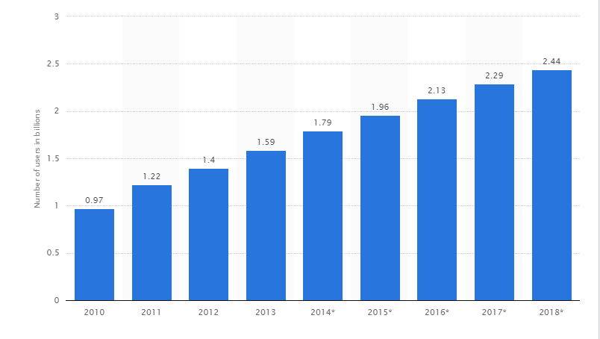

*Figure 1.4-1: Number of social network users worldwide from 2010 to 2018 (in billions)*

According to statistics from the Digital Marketing is youth aged 15 to 24 is subject to the most internet users, with 5 popular activity is reading news, searching for information, listen to music, study and chatting (66% ).

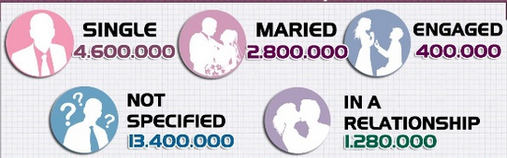

*Figure 1.4-2:* [*Relationship status of Facebooks users in Vietnam*](http://www.slideshare.net/lehoangha304/facebook-market?related=1)

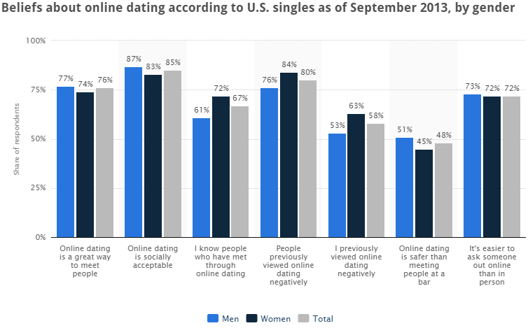More than 4.5 million users of Facebook in Vietnam are single[[2]](#footnote-2).

*Figure 1.4-3:* [*Beliefs about dating online dating according to U.S. singles*](http://www.statista.com/statistics/316481/us-beliefs-online-dating/)

This survey was found that 72 percent of survey respondents thought it was it easier to ask someone out online than in person.

Base on those statistics, we decided to creating a social network to support people finding new friends, looking relationship and chatting with people. We called it “Aloha”.

## **1.5 Literature Review**

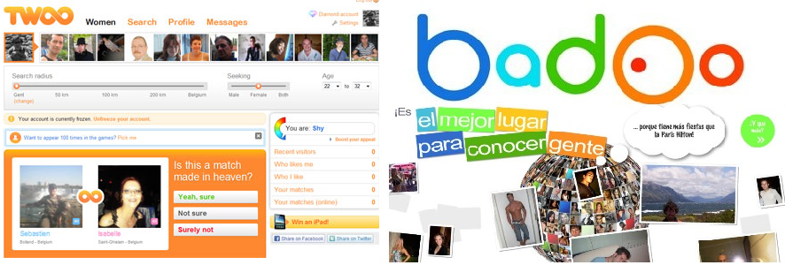Twoo and Badoo are two of the fastest growing places to chat with new people. By the numbers of users (more than 160 million users in Twoo and nearly 250 million user in Badoo), and with 11.9 million monthly active users[[3]](#footnote-3) (Twoo), we can make sure that demand of looking friend and relation online are increase.

*Figure 1.5-1: Twoo and Badoo*

By reviewing some relationship looking websites, we already have gotten main details of those.

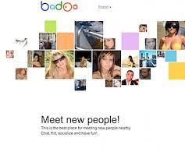

*Figure 1.5-2: Badoo*

* **Badoo**
* The main purposes are chatting, making new friends and **business**.
* Register by link with your Facebook, Microsoft, yandex, google, vk or ok.ru account. It also provides its own register form.
* Link your information from social which you have provided (like age, gender, image, avatar, location, friend, interested…).
* Has **strong verification system** to check your avatar and your account information (manual). You can verify by image (with a form given by this website), by phone, or by link with verified social account suck as Facebook, google, Instagram, twitter, linkedld. If you don’t verify your account, you will be limited many features in this website.
* You can search friend with some filters based on age, gender, interested (compare by tag) and location (by positioning).
* You can like, comment, follow profile of others; chat with them; like, comment their image, album; block or report profile which is unsuitable content.
* The system also allow people vote the best image of day, week, the person who gets the highest position will get **achievement** in his/her profile. However, there are many achievements are waiting you get like the: “the most popular person of week”, “the most friendly person of week”…
* The system provide features allow you know who visited your profile, who liked you, who you have liked.
* Has phone version, suitable for android and iOS.
* **Likeyou.vn**
* Main purposes are social, chatting, dating and making new friends.
* Allows register by linking with Facebook or by its own register form.
* Provides search engine, filter by email, name, age, sex, location… also provide advance filter to help users get the best results.

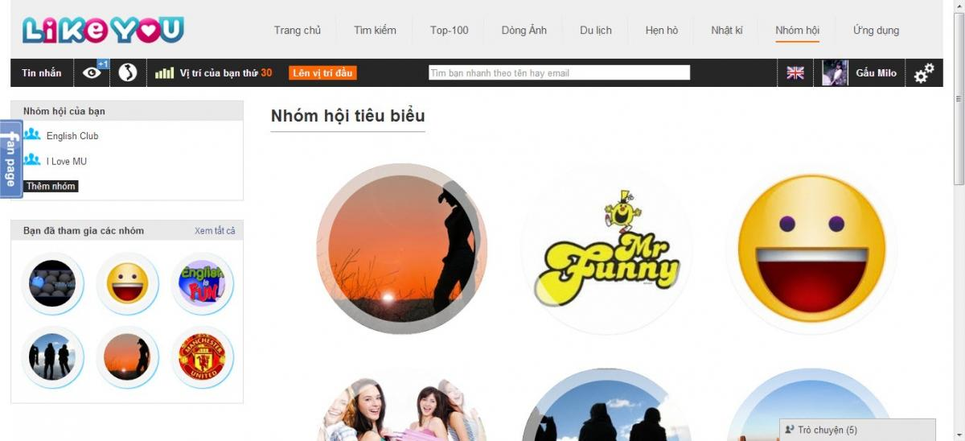

*Figure 1.5-3: Likeyou*

* Collect user’s information via available questions.
* User can chat with others user, like, comment their profile, topics; report violent or unsuitable profile. User can share their images, write diary and share with others (optional).
* By voting, the system ranks and shows top 100 best profiles to the users.
* You can create your own group and invite friends join it - same Facebook group.
* Provides some tips to date people.
* You can create your own topic to request dating. The mandatory of topic must has name, date, description, gender of target, location (optional)… and some optional information.
* The admin sets dating offline and inform to the website as topic with the location and fee to join the dating offline. User can register that dating offline at the website.
* There are other items such as relax corner, news, travels, apps games in the website.
* **Dreaminlove.com**
* Main purposes are social, chatting, dating and making new friends.
* Functionality invite friends joined the website through email
* Provides search engine, filter by age, sex, habitat, connection and keyword (Name, Nickname…) and you can request they has or hasn’t their photo. Provide advance filter to help users get the best results.
* Functionality display your friends list, online member.
* Functionality mailbox: user can receive and send mail for member of website, Can review the folder: sent messages, received messages.
* Functionality “Nice Photo”: photos with the most views will be displayed
* **Mini games**: User can play mini games of website. Can gaming with friends.
* Blogs: User can writing us blogs, Comments below the posts of other members.
* Group: The members can founded the group with its own purpose. The members of group will talk to each other in their group. User can chat group.
* User can update basic information, personal information, and partner information to check the relevance between members.
* Chat function allows 2 people chatting together.
* User can send postcard for other member to get acquainted.
* Can feedback for admin if you have the problem.
* Verify you photo.
* Link with Facebook, mail…
* **Twoo.com**
* “Inquiry” function allows users to ask, answer question from another users. Users can find some friend have conformity personality.
* Links with Facebook, google plus…
* “Representative photo browsing” function requires users make V-sign when taking picture.
* Show information like “people you like”, “people like you”, “people you know”, and “appropriate people”.
* Comments, likes photo of other people.
* Function allows users to find out personality, figure, and style… of other people
* “Chat” function allows 2 people or group of people interact with other people.
* Search by radius help users find out nearly users.
* **Flirchi.com**
* **“Secret dating” section collects many interesting and exciting story about dating.**
* **Function send random message to any 50 people.**
* “Chat” function allows 2 people chatting together. Can use emoticons in chatting.
* Gift functional: You can send gift for your friend to express concerns.
* **Function evaluate photo of other people through the level "cute", "beautiful", "luxurious", "seductive".**
* Function "People nearby". Website will take your address on google map, and display address of people that their near you in 15km radius.
* Mobile version: IOS, Android and other phone browsers.
* Activate VIP account ->business.
* Links with Facebook, mail, Vkontakte App.
* **Hentocdo.vn**
* Search function are convenient (gender, date of birth, height), data rate speed are fast
* Index page arrangement is reasonable.
* “Secret dating” section collects many interesting and exciting story about dating.
* “Movie dating” section stores information about upcoming movies on cinemas. 2 people or more can see and schedule to go to cinemas.
* “Inquiry” function allows users to ask, answer question from other users. Users can find some friend have appropriate personality.
* “Chat” function allows 2 people or group of people interact with other people.
* Hold meeting for users.
* Links with Facebook, google plus…

## **1.6 Proposal of System**

### **1.6.1 Our proposal system**

After review those characteristics of websites, they have their own advantages and disadvantages, so we came to an agreement about which functions our website should support to inherit their strong points and reduce their limitations:

BASIC FUNCTIONS:

* Allow user to connect to another social network account (Facebook, Google+, and Twitter).
* Allow user to post *“Picture”* to their personal page. Each *“Picture”* is a collection of their image description, comment, likes.
* Allow user get verified by phone, image or national ID (based on our rules)
* Allow user to view their personal information page and other uses’ page.
* Allow user to interact with other user.
* Allow user to chat with other if they accept your request chatting.
* Allow user to vote, block, or report other profiles.
* Allow user find friend by many filter.
* Show the most profile conformity with use profile by our algorithm based on user information.
* Show top profiles have most likes.
* Allow user to manage their personal information page
* Allow user to manage process their following.
* Allow user to remove follow another user
* Allow user to view all person who they are following
* Show list movie upcoming in cinemas in Vietnam

However, due to the limitation of team’s effort, we will not implement these following functions, although we are aware that they are also important to a social network

**OUT OF SCOPE FUNCTIONS**:

* Conference chatting
* Entertainment corner suck as games, share travel experiences.

Finally, we use some new approaches to solve the problems stated. Having aware of the emergence of new technologies, we aim at applying them to our project.

|  |  |  |  |  |  |  |  |  |  |
| --- | --- | --- | --- | --- | --- | --- | --- | --- | --- |
|  | | | Badoo | Likeyou | Dreaminlove | Twoo | Flirchi | hentocdo | My web |
| Mapping by question | | |  |  |  | X |  |  | X |
| Chat | 2 people | | X | X | X | X | X | X | X |
| More people | |  | X | X |  |  |  | X |
| Search | Basic search | | X | X | X | X | X | X | X |
| Advance search | |  | X | X | X |  | X | X |
| Search by positioning | | X |  |  |  | X |  | X |
| Make friend | | | X | X | X |  |  |  |  |
| Blogs | | |  |  | X |  |  |  |  |
| Comment | | Comment profile | X | X | X | X |  | X | X |
| Comment photo | X | X | X |  |  |  | X |
| Dating | | |  | X |  |  |  | X |  |
| Following-follower | | |  | X | X | X | X | X | X |
| Album photo | | | X | X | X | X | X | X | X |
| Block user | | | X | X | X | X | X | X | X |
| Report user | | | X | X | X | X | X | X | X |
| Feedback | | | X | X | X | X | X | X | X |
| Decentralized user | | | X | X | X | X | X | X | X |
| Top | | User |  | X | X | X | X |  | X |
| Like photo |  | X | X |  |  |  |  |
| Find out personality, figure, and style… of other people | | |  |  |  | X |  |  | X |
| Link with other social web (facebook, google…) | | | X | X | X | X | X | X | X |
| Version for mobile (Android, IOS…) | | | X | X |  | X | X |  |  |
| Verify avatar | | | X |  | X | X |  | X | X |

*Table 1.6.1: Comparison between Aloha and some other website*

### **1.6.2 Introduction about our proposal system**

The core idea of the system is helping people getting new friends and suggest the best fit with them to advance a relationship. The information are completely made by user and process by system. Therefore users are no longer wasting their time to search information. Base on provided information, the systems also can choose the best fit with each user. With the verification system, the user also feels more safely and comfortably.

# **2. Software project management**

## **2.1 Software process model**

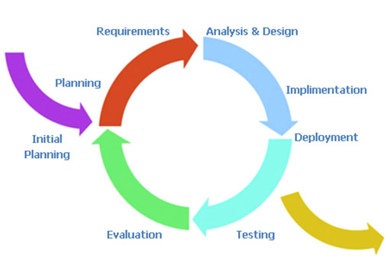

*Figure 2.1: Iterative and Incremental software process model*

We choose Iterative model for development process of this project. Iterative is a life cycle model does not attempt to start with a full specification of requirements. The development starts by specify and implement a part of the software, then it will be reviewed to take advantages and disadvantages of the product. This process is then repeated to produce a new version of the software at the end of each iteration of the model.

This model have some advantages that we feel appropriate for our project:

* Some functions can be developed early & quickly.
* Easy & less costly to change requirements.
* Results are obtained early and periodically.
* Parallel development can be planned.
* Testing and debugging during smaller iteration is easy.
* During life cycle software is produced early which facilitates user evaluation and feedback.

## **2.2 Project organization**

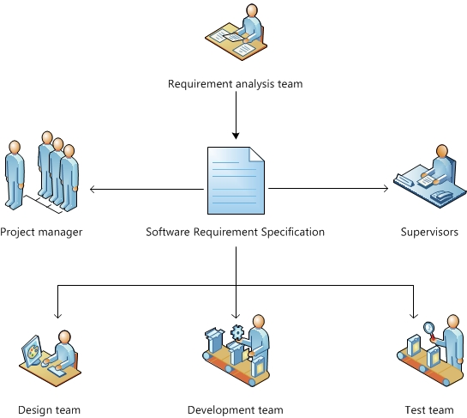

*Figure 2.2: Project organization*

### **2.2.1 Organization structure**

|  |  |
| --- | --- |
| **Role** | **Responsibility** |
| Project Manager | Planning and defining scope, developing schedules, allocating resources, coordinating communication, generally responsible for keeping the team’s focus on main goal, and tries to keep the project team focused on the right goal at a time. |
| Technical Leader | Responsible for the underlying architecture for the software program, assigning tasks, mentoring people, reporting and updating regular associates RAG status. Also technical leader is a reference book for other software programmers. |
| Business Analyst | Eliciting requirement, analyzing and documenting requirements, communicate requirements, identifying solution and verifying solution meets the requirements, leads and coordinates use-case modeling. Outline the system’s functionality. |
| Developer | Involve to code product. |
| Test Leader | Responsible for test execution, including test set-up and test run, evaluation of test run and error recovery, defect logging and test results recording. |
| Designer | Involve to design product |

*Table 2.2.1 Organization structure*

### **2.2.2 Tools and Technique**

**Tools:**

* Microsoft Office 2013.
* Astah, Enterprise Architect.
* Chrome version 43 or higher, Firefox version 38 or higher.
* Sublime Text 3, Atom
* Bitbucket

**Technique:**

**Node.js®**: is a platform built on Chrome's JavaScript runtime for easily building fast, scalable network applications. Node.js uses an event-driven, non-blocking I/O model that makes it lightweight and efficient, perfect for data-intensive real-time applications that run across distributed devices.

**Expressjs**: web application framework for node.

**CSS**: style sheet language used for describing the presentation semantics (the look and formatting) of a document written in a markup language.

**JavaScript**: interpreted computer programming language. It was originally implemented as part of web browsers so that client-side scripts could interact with the user, control the browser, communicate asyn-chronously, and alter the document content that was displayed.

**MongoDB**: is an open-source, document database designed for ease of development and scaling. The Manual introduces key concepts in MongoDB, presents the query language, and provides operational and administrative considerations and procedures as well as a comprehensive reference section.

## **2.3 Project management plan**

### **2.3.1 Task**

Refer to document <ALOHA_WBS.mpp>

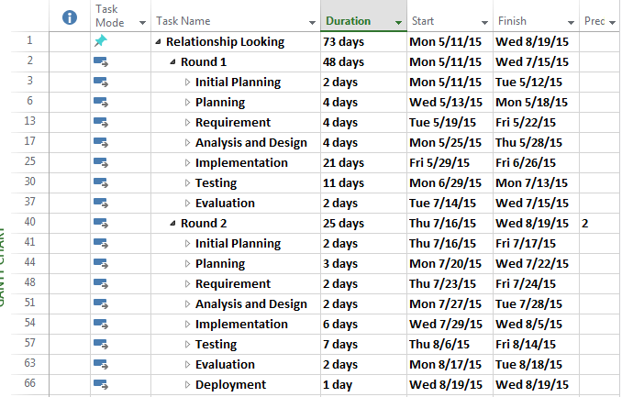

*Figure 2.3.1: Preview WBS*

### **2.3.2 Meeting minutes**

All meeting minutes will be written follow this template:

|  |  |  |  |
| --- | --- | --- | --- |
| MEETING MINUTES | | | |
| Project Name |  | **Project Code** |  |
| Project Manager |  | **Secretary** |  |
| Date |  | **Time** |  |
| Venue |  | | |
| Subject |  | | |

**Attendees**

|  |  |  |  |
| --- | --- | --- | --- |
| No | Name | Position | Attendance |
| 1 |  |  |  |
|  |  |  |

**Agenda**

|  |
| --- |
|  |

**Content**

|  |
| --- |
|  |

*Table 2.3.2: Meeting minutes*

### **2.3.3 Coding conventions**

In common RL project reference to: <http://www.w3schools.com/js/js_conventions.asp>

### **2.2.4 Risk management plan**

|  |  |  |  |  |  |  |  |
| --- | --- | --- | --- | --- | --- | --- | --- |
| No | Risk  Description | Root Cause | Avoidance  Plan | Contingency  Plan | Probability | Impact | Status |
| 1 | Overestimate or under estimate time of project | -Wrong estimate about time of each phases. | - Create detail plan for each project’s phase.  - Breakdown project to some mile-stone releases. Main function development is high priority  - Get the team more involved in planning and estimating. Get early feed-back and address slips directly with stakeholders.  - Consult supervisor’s advice | - Implement task in parallel or overlapping them  - Overtime to push progress faster | High | High |  |
| 2 | Run over budget | -Spend too much | - Saving  - Reasonable spending | - Make a contributions | Low | Medium |  |
| 3 | Member do not have enough knowledge to follow project | -Member does not have skill about technologies | - Training  - Encourage member learn from others | - Working in group | Medium | Medium |  |
| 4 |  | -Personal  Overwhelming or lazy  -Weather | - Closely monitor  - Allocation of reasonable working time, concerned about member | - Overtime  - Increase work performance  - Mobilize others members | High | High |  |
| 5 | Identified missing features |  | - Brainstorming between members  -Team meeting to define and discuss about all features in project | - Team meeting with supervisor to determine whether features are implemented or not  - If features is must executed, Project manager create implement plan for this feature and push progress quickly | Medium | High |  |
|  | Have some problem with team member such as: absent, overtime, conflict, healthy… |  |  |  |  |  |  |
| 6 | Poor Productivity | -Low team member’s motivation  -Time lost | - Concentrate on creating good plan and deadline for each feature, estimate reasonable time for each project phase  - Organize team building so that team member can get well to each other | - Short iterations, right people on team, coaching and team development.  - Conduct a meeting so that the team members can express their opinions and find out solutions | Medium | High |  |

*Table 2.2.4: Risk management plan*

### **2.2.5 Communication plan**

**Team communication:**

- Planning Phase: meeting face to face three time per week on Monday, Wednesday, Friday’ evening. Meeting face to face is the most effective way for team member to understand each other. With face to face meeting, we can solve problem easily. Output is Meeting Minute.

- Implement Phase: all team member have to working in group about 20 hours per week, to focus to implement, share knowledge and resolve hard issues.

- Communication channel:

+ Phone: require mobile phone.

+ Email: Gmail.

+ Instant message: Skype, Facebook.

- Manage File: using Facebook group to share all documents such as deliverable documents, team rules, meeting minute, snip code …

- Report: all members have to report weekly to PM. The report include: what’s he or she have done in week, and what’s he or she scheduled for next week, what issues he or she occurred, and what other member can help

- Kick off project and team-building to improve team spirit

**Communication with supervisor:**

- Team meets the supervisor every week on Friday to get the advices for issues, and reports what team had done and plan for next weeks.

- When having troubles in project, team leader collect ideas from members and send email to get instructions from supervisor.

# **3. Software requirement specification**

## **3.1 Purpose**

The main purpose of the requirement document is provides the information of the project from many perspectives. Readers can find out about the overview description or detail information in this document.

The information is the fully describing about the software system such as functional requirements, non-functional requirements, design constrains and any other necessary information.

This document is the software requirement specification of the project in order to develop the software, it includes two main parts: User Requirement Specification and System Requirements Specification:

* User Requirement Specification:
  + Provides the general information about the software system.
  + The project manager and supervisors should read this part because they can partly base on it to negotiate with each other about some particular problems.
* System Requirements Specification:
  + Provides the detail information about the software system. This part captures the complete software requirements for the system, and then it is important for software designer, software developer, machine maker and manufacturer, tester and maintainer.
  + This part is also for the project manager because it can help him to monitor all the activities of the project effectively.

## **3.2 Overview Description**

### **3.2.1 Product perspective**

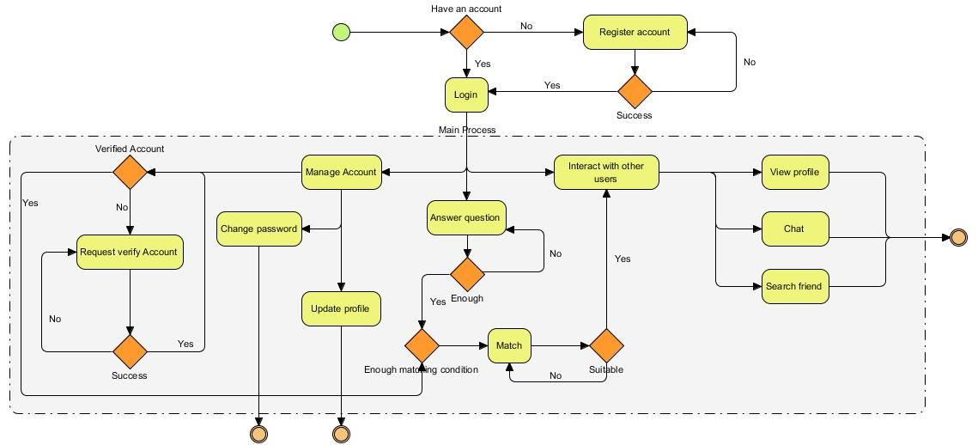

*Figure 3.2.1: Product perspective*

**Explain**: When a user enters a path of Aloha.org, the login screen of the system will appear. User can login into system if he/she has an account. If user hasn’t an account, he/she must register if he/she want to use this website. Every member of system can use function like Manage account (include change password, update profile) and interact with other users by address, radius (include view profile, chat, search). But if user want to search suitable people then he/she must verify account and answer at least 30 question of this system. If the user does not have enough that 2 conditions then he/she can’t search suitable people. System will check if user has been not verified account, system will notice user that he/she must verify account. He/she must send request verify account to Admin. If Admin approve this request, the account is verified else user must send other request to Admin. Similarly, if user wasn’t answer enough 30 question, he/she must answer continue until enough 30 question.

### **3.2.2 Product Features**

#### **3.2.2.1 User classification**

Aloha will be an online system to help people connecting with other and find out the best fit with them by our algorithm base on the information that is provided by users via our question bank. This product is promising to be a useful, friendly, easy-to-use application.

Aloha includes 2 separated parts that using the same database. They are **Main Application** and **Administration Application.**

|  |  |
| --- | --- |
| **Actor** | **Description** |
| Main application user | Include guest, Registered user, member, advance member |
| Administration Application | Admin |
| Guest | Visitor of website who hasn’t logged in website. |
| Registered user | Who owned account in website and logged in website. The account isn’t verified. Inherit use cases from Guest and has some own functions. |
| Member | Who owned account in website and logged in website. The account is verified but answer too less question in their profile (bellow 300 point). Inherit use cases from Registered user and has some own functions. |
| Advance member | Who owned account in website and logged in website. The account is verified and profile is satisfying to use all website functions. Inherit use cases from Member and has some own functions. |
| Admin | Who manage system directly include manage user, report, question bank… |

*Table 3.2.2.1: User classification*

#### **3.2.2.2 Main application**

**Main Application** is Web application whose name is Aloha. This website has 5 main function groups below:

* Account management: include user account management
* Profile management: include manage album, request verify, update their question bank.
* Interact with other user: search, view, chat, and report, follow, vote or block other profiles.
* **Matching**: suggest the best fit to the user base on their information.
* Join offline event: Can request joint offline events which is held by Admin.

|  |  |  |  |  |
| --- | --- | --- | --- | --- |
| Actor  Main  Group | Guest | User | | |
| Registered User | Member | Advance  Member |
|  | Login |  | | |
|  | Logout | | |
| **Account management** | Register account | Verify account information | | |
| **Profile management** |  | Upload, delete image, avatar | | |
|  | Request verify |  | |
|  | Answer question, Edit Answer | | |
|  |  | | Request add new question |
| **Interact with other user** |  | Search, view, other profile, chat, follow other profiles. | | |
|  |  | Block user  Vote user | |
| **Matching** |  |  |  | Accept or reject the suggestion. |
| **Join offline event** |  |  | Join offline events which is held by Admin | |

*Table 3.2.2.2: User application*

#### **3.2.2.3 Administration application**

There are 4 main functions for admin only in **Administration application**:

* Account management: update account information.
* Manage user: manage report, feedback, ban, verify.
* Manage event: Create new offline event and view detail.
* Manage question: Create new, update, delete question and approve advanced member request

|  |  |
| --- | --- |
| Actor  Main  Group | Admin |
|  | Login  Logout |
| **Account management** | Update account information |
| **Manage user** | * Manage user’s report. * Manage ban list: ban user, unban user. * Manage verification: approve, reject. |
| **Manage event** | * Create new event and inform to the website. * View detail of event: number of member register, name.. |
| **Manage question** | * Create new, update, delete question * Approve or reject advanced member request |

*Table 3.2.2.3: Administration application*

### **3.2.3 User Characteristics**

#### **3.2.3.1 Website’ user**

* People interested in chatting, finding friend or looking a relationship.
* Be able to use Internet and computer at basic level, not required IT specialize.

#### **3.2.3.2 Admin**

* Be able to use Internet and computer at basic level, can work right after 2-hour-training.
* Has knowledge about management, creative, agility, equity and be able to work full time.

### **3.2.4 Constraints, Assumptions and Dependencies**

#### **3.2.4.1 Constraints**

The Internet connection is a constraint for the application. Since the application fetches data from the database over the Internet, it is crucial that there is an Internet connection for the application to function.

#### **3.2.4.2 Assumptions and dependencies**

Website Aloha run on server local-host

## **3.3 Required specifications**

### **3.3.1 Interface requirements**

#### **3.3.1.1 User Interfaces**

* Main Application
  + User interface should be easy to understand, interested image and easy use, friendly.
  + The color use to design user interface is elegant, not flashy.
  + There is not much item.
  + The text is big enough and Vietnamese.
  + Screen at least 1366dp x 768dp (normal).
* Administration Application
  + Simple interface, no need to graphic design, easy to use.
  + The font is big enough, easy to read.

#### **3.3.1.2 Hardware interfaces**

Internet connection with minimum speech 512kbit/s is required with all of computers.

* Client computer (User)
  + Must have the peripheral devices such as mouse, keyboard and monitor.
  + Minimum configuration (for web browser): 512MB Ram, 200MB of hard disk, Processor Intel Pentium (1M Cache, 2.10 GHz, 800 MHz FSB).
* Client computer (Admin)
  + Must have the peripheral devices such as mouse, keyboard and monitor.
  + Minimum configuration (for ADA): 512MB Ram, 400MB of hard disk, Processor Intel Core 2 Duo (4M Cache, 2.20 GHz, 800 MHz FSB).
* Application server
  + Must have the peripheral devices such as mouse and keyboard.
  + Minimum configuration (for MAA): 1GB of RAM, 1.5GB of hard disk, Processor Intel Core i3 (3M Cache, 1.80 GHz).
* Data server for Database
  + Minimum configuration: 160GB of hard disk.

#### **3.3.1.3 Software interfaces**

* Application server side
  + An IIS Web server will accept all requests from the client.
* Data server side
  + A development database will be hosted locally using MongoDB.
* Client Side (User)

An OS is capable of running an Admin web browser which supports HTML version 3.5 or higher.

#### **3.3.1.4 Communications interfaces**

* The HTTP protocol will be used to facilitate communications between the client and application server.

### **3.3.2 Functional Requirements**

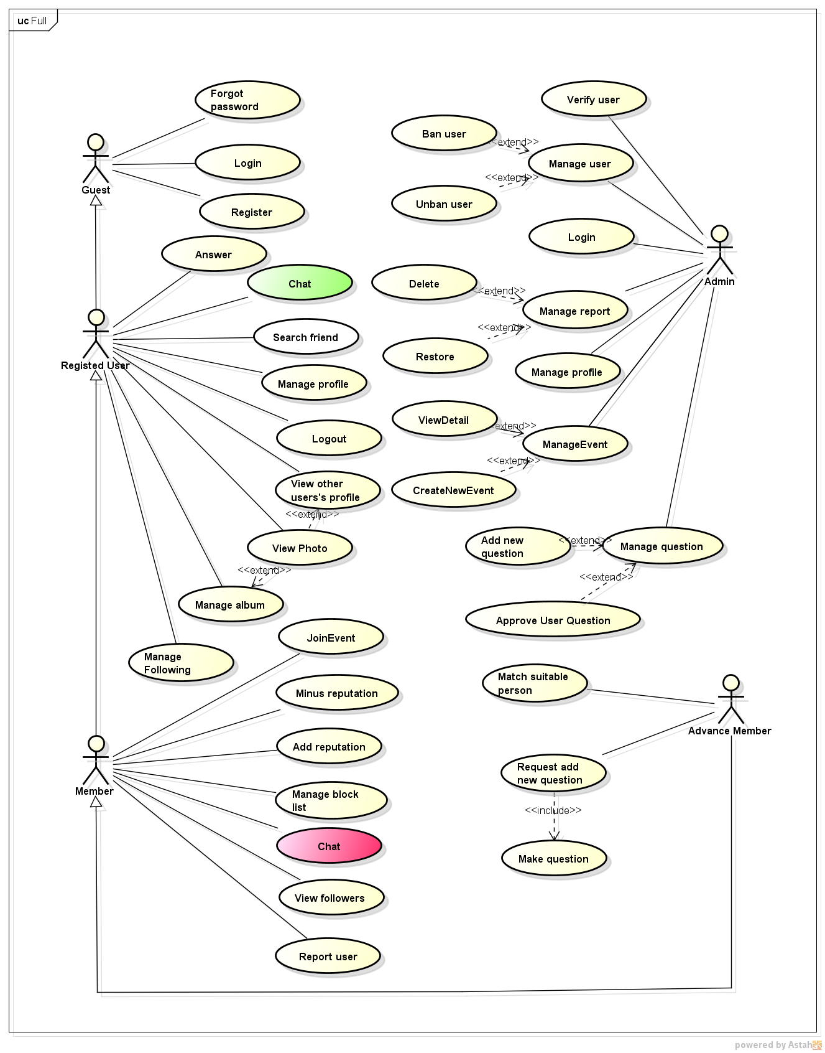

*figure 3.3.2: use case diagram of aloha system*

|  |  |
| --- | --- |
| **Primary Actor** | **Use Cases** |
| Guest | UC-1: Register |
| Guest | UC-2: Login |
| Guest | UC-3: Forgot Password |
| Registered User | UC-4: Logout |
| Registered User | UC-5: Request Confirm Account |
| Registered User | UC-6: Update Personal Information |
| Registered User | UC-7: Answer |
| Registered User | UC-8: Update answers |
| Registered User | UC-9: Search Friend |
| Registered User | UC-10: View other user profile |
| Registered User | UC-11: Add following |
| Registered User | UC-12: Remove following |
| Registered User | UC-13: Chat |
| Registered User | UC-14: View Photo |
| Registered User | UC-15: Upload photo |
| Registered User | UC-16: Delete image |
| Registered User | UC-17: Like Photo |
| Registered User | UC-18: Comment |
| Registered User | UC-19: Delete Comment |
| Member | UC-20: Add reputation |
| Member | UC-21: Minus reputation |
| Member | UC-22: Report user |
| Member | UC-23: Add user to block list |
| Member | UC-24: Remove user from block list |
| Member | UC-25: Chat |
| Member | UC-26: Join Event |
| Member | UC-27: View follower |
| Advanced Member | UC-28: Request add new question |
| Advanced Member | UC-29: Match suitable people |
| Admin | UC-30: Login |
| Admin | UC-31: Create new event |
| Admin | UC-32: View event details |
| Admin | UC-33: Verify user |
| Admin | UC-34: Ban User |
| Admin | UC-35: Unban User |
| Admin | UC-36: Manage report |
| Admin | UC-37: Restore information |
| Admin | UC-38: Approve user question |
| Admin | UC-39: Add new question |

#### **3.3.2.1 Guest**

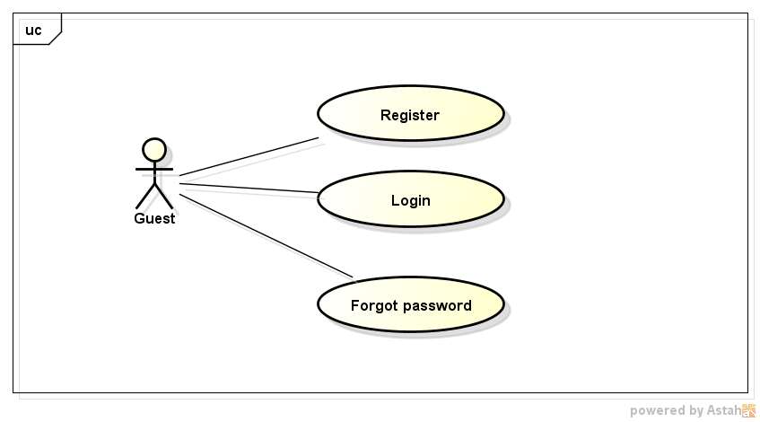

*Figure 3.3.2.1: Use case diagram of Guest*

##### **3.3.2.1.1 Register**

|  |  |  |  |
| --- | --- | --- | --- |
| UC ID and Name: | UC-1: Register | | |
| Created By: | ThangDD | Date Created: | 02/06/2016 |
| Primary Actor: | Guest | Secondary Actors: | N/A |
| Trigger: | The Guest wants to register new account. | | |
| Description: | The Guest uses this function to register account via Facebook’s account or by Aloha’s form. | | |
| Preconditions: | **PRE-1.1.** The Guestaccesses website on browser via Internet.  **PRE-1.2.** The Guest has Facebook account or an email. | | |
| Post conditions: | System informs register successful and redirects to the logged in page. | | |
| Normal Flow: | Register   1. The Guest click to button “*Đăng ký*”. 2. Aloha redirects to the register page. 3. If the Guest click to “*Đăng ký với Facebook*”:    1. Pop up appears and asks for Facebook’s authentication. **(see E1.1**)    2. The Guest clicks on “OK”. (**See E1.2**)    3. Go to step 5. 4. The Guest fills all mandatory information:    1. The Guest clicks on “Đăng ký”(**See E1.3**)    2. Go to step 5. **(See E1.4)** 5. Aloha shows information which filled by user or provided by Facebook and ask to the Guest confirms. 6. The Guest Click on button “Xác nhận”.(**See AF1.0**) 7. Aloha redirect to Homepage and update guest’s status as logged status with registered account. (**See E1.5**) | | |
| Alternative Flows: | AF1.0: The Guest click on button “Sửa lại”   1. System redirect to the Register Page. | | |
| Exceptions: | E1.1 - Cannot communicate with the Facebook   1. Pop-up display error message “Cannot connect to Facebook. Please try again”   E1.2 : The Guest clicks on button “Cancel”   1. Pop up is closed.   E1.3: The Guest click on button “Hủy bỏ”   1. Alert to confirm cancelling the registration. 2. The guest accepts alert. 3. Aloha redirects to Homepage.   **E1.4:** Alerts to the Guest and requests refill  E1.5: System cannot add new account to the database.  1. Aloha displays error message “An error occurred, please try again later”. | | |
| Priority: | High | | |
| Frequency of Use: | High | | |
| Other Information: | N/A | | |
| Assumptions: | N/A | | |

##### **3.3.2.1.2 Login**

|  |  |  |  |
| --- | --- | --- | --- |
| UC ID and Name: | UC-2 : Login | | |
| Created By: | SangNV | Date Created: | 02/06/2016 |
| Primary Actor: | Guest | Secondary Actors: | N/A |
| Trigger: | The Guest wants to login Aloha. | | |
| Description: | The Guest uses this function to login Aloha. | | |
| Preconditions: | **PRE-2.1.** The Guestaccesses website on browser via Internet.  **PRE-2.2.** The Guest has a registered account. | | |
| Post conditions: | System logged in Aloha | | |
| Normal Flow: | Login   1. If the Guest click to “Đăng nhập với Facebook” :    1. Pop up appears and asks for Facebook’s authentication. **(see E2.0**)    2. The Guest clicks on “OK”. (**See E2.1**)    3. Go to step 4 (**See AF2.0**) 2. The Guest fills email to textbox “Email”, password to textbox “Mật khẩu” 3. The Guest click on button “Đăng nhập” 4. System validates information, redirects to Homepage and update guest’s status as logged status.(**See E2.2, E2.3**) | | |
| Alternative Flows: | AF2.0 – System determines that the Facebook account doesn’t match with database.  1. Alerts this is the first time joining Aloha and redirects to the step 5 **UC-1** | | |
| Exceptions: | E2.0 - Cannot communicate with the Facebook   1. Pop-up display error message “Cannot connect to Facebook. Please try again”   E2.1 - The Guest clicks on button “Cancel”   1. Pop up is closed.   E2.2 – System determines invalid information filled.   1. Aloha displays error message *“Tài khoản hoặc mật khẩu không đúng, xin vui lòng nhập lại”* and also suggest the Guest create new account or use the case “forgot password”   E2.3 – System determines account has been banned   1. Aloha display message “Tài khoản của bạn bị tạm khóa, xin vui lòng liên hệ với admin để yêu cầu giúp đỡ”. | | |
| Priority: | High | | |
| Frequency of Use: | High | | |
| Other Information: | N/A | | |
| Assumptions: | N/A | | |

##### **3.3.2.1.3 Forgot password**

|  |  |  |  |
| --- | --- | --- | --- |
| UC ID and Name: | UC-3 : Forgot password | | |
| Created By: | SangNV | Date Created: | 02/06/2016 |
| Primary Actor: | Guest | Secondary Actors: | Admin |
| Trigger: | The Guest forgot password and wants to reset it. | | |
| Description: | The Guest uses this function to reset password Aloha when they forgot their password. | | |
| Preconditions: | **PRE-3.1.** The Guestaccesses website on browser via Internet.  **PRE-3.2.** The Guest has a registered account. | | |
| Post conditions: | System logged in Aloha | | |
| Normal Flow: | Forgot password   1. The Guest clicks on button “Quên mật khẩu” 2. System redirects to “forgotPass” page. 3. The Guest enter their email to email textbox then click on “Lấy lại mật khẩu”. (**AF3.0, E3.0**) 4. The system validates then sends the link to reset password to filled email. (**E3.1**) 5. The Guest accesses to their email and clicks to reset password’s link.(**E3.2**) 6. The Guest enters new password to the new password text box and click on “Lưu mật khẩu mới” (**E3.3**) 7. System validates new password, updates it then redirects to Homepage and update guest’s status as logged status. (**E3.4**) | | |
| Alternative Flows: | AF3.0 – The guest also forgot or lost their email but their account has been verified.   1. The Guest clicks on link “Liên hệ với admin”. 2. Pop up ticket is displayed. 3. The Guest provides to admin necessary information as email to contact, National ID number with photo. 4. The Admin approves ticket and sends link to reset password to the Guest’s email. The Admin also reply the Guest in ticket and close their ticket. (**E3.5**) 5. Go to step 5 Normal Flow | | |
| Exceptions: | E3.0 - The Guest clicks on button “Hủy bỏ”   1. System redirects to Homepage.   E3.1 – The system determines invalid information filled or email doesn’t exist in the database.   1. Shows message “Email không tồn tại!” and also suggests the Guest go to **AF 3.0**   E3.2 – The Guest determines that is not their reset password request and click to cancel request’s link.   1. System closes that reset password request.   E3.3 – The Guest clicks on button “Hủy bỏ”   1. System redirects to Homepage.   E3.4 –System determines invalid password filled   1. Request the Guest fills again.   E3.5- The Admin determines that is invalid information and reject request.   1. The Admin replies a reason to the ticket and reject request. The ticket is closed. | | |
| Priority: | High | | |
| Frequency of Use: | High | | |
| Other Information: | N/A | | |
| Assumptions: | N/A | | |

#### **3.3.2.2 Registered User**

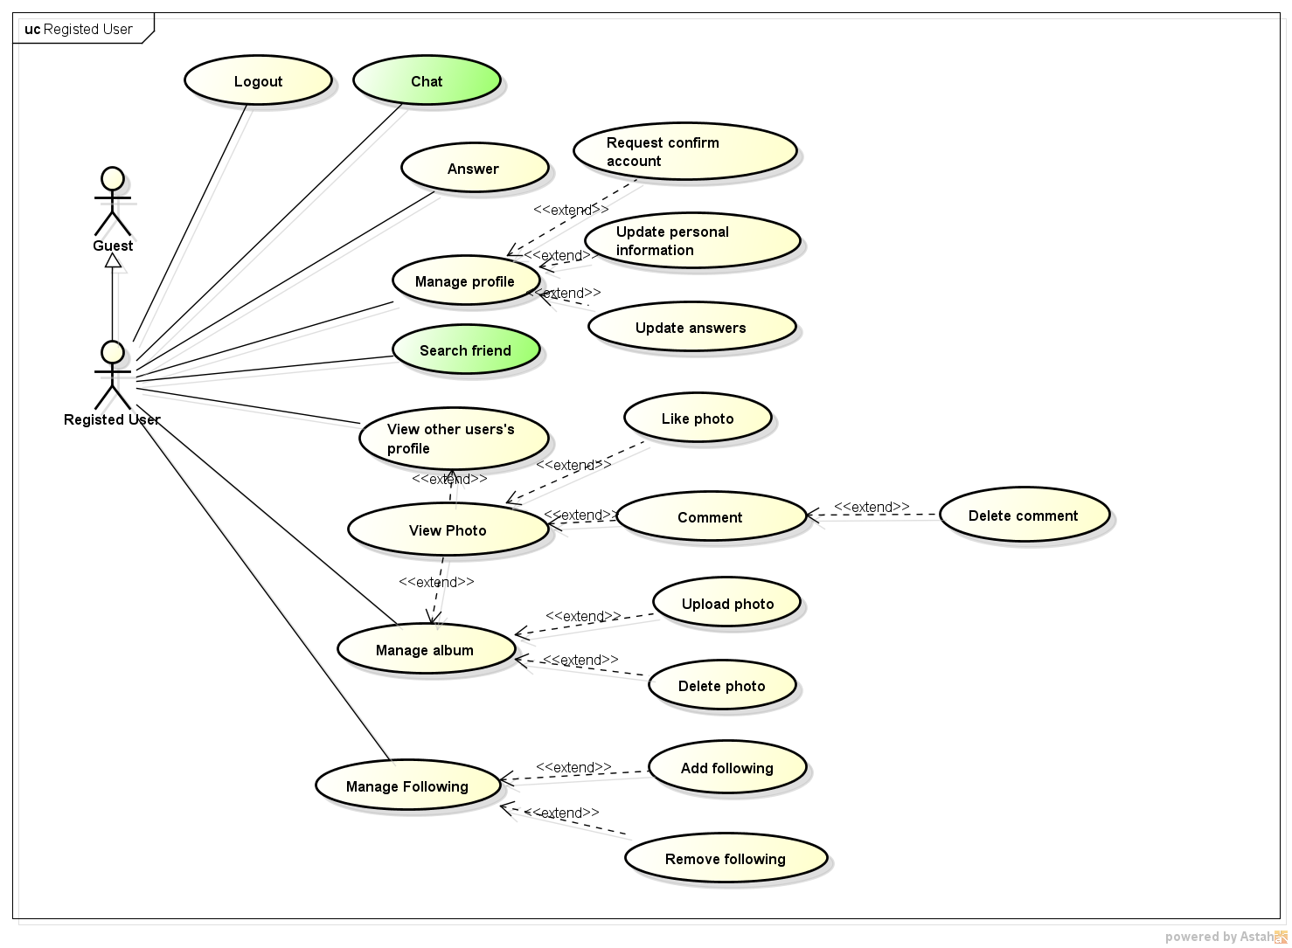

*Figure 3.3.2.2: Registered user’ use case*

##### **3.3.2.2.1 Logout**

|  |  |  |  |
| --- | --- | --- | --- |
| UC ID and Name: | UC-4: Logout | | |
| Created By: | Sang NV | Date Created: | 01/06/2015 |
| Primary Actor: | Registered User | Secondary Actors: | N/A |
| Description: | Actor wants to logout actor’s account | | |
| Preconditions: | **PRE-5.2.** UC-2 is completed. | | |
| Post conditions: | **POST-5.1.** Actor logout then redirect link to Aloha’s Homepage. | | |
| Normal Flow: | Logout   * 1. On header bar, click on *“Đăng xuất”* button at upper right corner of the screen like this image:   logout   * 1. System logout actor account and inform logout successful. The website redirect to the Aloha’s Homepage | | |
| Alternative Flows: | N/A | | |
| Exception | N/A | | |
| Priority: | High | | |
| Frequency of Use: | High | | |
| Other Information: | N/A | | |
| Assumptions: | N/A | | |

##### **3.3.2.2.2 Request confirm account**

|  |  |  |  |
| --- | --- | --- | --- |
| UC ID and Name: | UC-5: Request Confirm Account | | |
| Created By: | Sang NV | Date Created: | 02/06/2015 |
| Primary Actor: | Registered User | Secondary Actors: | N/A |
| Trigger: | Actor wants to Request Confirm Account. | | |
| Description: | Actor uses the “Request Confirm Account” function to request admin that confirm actor account. | | |
| Preconditions: | **PRE-6.2:** UC-2 is completed  **PRE-6.3:** Actor right in their own profile. | | |
| Post-conditions: | Account confirmation request will be sent to admin. | | |
| Normal Flow: | Request Confirm Account   1. Actor clicks on “Yêu cầu xác nhận tài khoản” mini-tab in their own profile. 2. Aloha will displays “Yêu cầu xác nhận tài khoản” tab, this tab have primary fields like the image: 3. Actor clicks on “Browse” button of the “Tải ảnh chụp Chứng Minh Thư Nhân Dân của bạn!” fields. 4. Aloha will display upload photo window. 5. Actor chooses image file to upload. 6. Actor clicks on “Open” button.(**E6.0**) 7. Actor clicks “tải ảnh lên” button. 8. Aloha will display the image that actor selected.**(E6.1)** 9. Actor inputs information on the “Điền số chứng minh thư nhân dân của bạn” fields. 10. Actor clicks on “Gửi yêu cầu” button. 11. Aloha validates request then inform that request successful, redirects to the profile page.(**E6.2**) | | |
| Alternative Flows: | N/A | | |
| Exceptions: | E6.0 : Actor clicks on button “Cancel”   1. Upload photo window is closed. 2. Return to step 2.   E6.1: Cannot communicate with the application server   1. Aloha displays error: “Cannot connect to server”. 2. Actor clicks on *“Ok”* button and Aloha reload this page.   **E6.2**: System determines invalid infomation uploaded or filled  1. Show error message and request to reupload. | | |
| Priority: | High. | | |
| Frequency of Use: | Low | | |
| Business Rules: | N/A | | |
| Other Information: | N/A | | |
| Assumptions: | N/A | | |

##### **3.3.2.2.3 Update personal information**

|  |  |  |  |
| --- | --- | --- | --- |
| UC ID and Name: | UC-6: Update Personal Information | | |
| Created By: | Sang NV | Date Created: | 02/06/2015 |
| Primary Actor: | Registered User | Secondary Actors: | N/A |
| Trigger: | Actor wants to Update Personal Information. | | |
| Description: | Actor will Update Personal Information. | | |
| Preconditions: | **PRE-7.1:** UC-2 is completed  **PRE-7.2:** Actor right in their own profile. | | |
| Post-conditions: | The Personal information will be save into database and displayed on “Thông tin cá nhân” tab. | | |
| Normal Flow: | 3.0 Update Personal Information   1. Actor clicks on the “Thông tin cá nhân” tab. 2. Aloha will be display the “thông tin cá nhân” tab. 3. Actor clicks on edit button. 4. Aloha will be display the “cập nhật thông tin cá nhân” tab to actor can input information follow available form. 5. Actor inputs information into the fields that actor want update information. 6. Actor clicks on “Lưu” button.**(E7.0)** 7. New Personal Information will be save to the database and displayed the “Thông tin cá nhân” tab with information is updated.**(E7.1)** | | |
| Alternative Flows: | N/A | | |
| Exceptions: | E7.0: Actor clicks on “Hủy” button. (step 6)  1. Information filled is not updated. System redirect to step 2 Normal Flow.  E7.1 – System determines invalid information filled.   * 1. Show error message and request refill. | | |
| Priority: | High | | |
| Frequency of Use: | High | | |
| Other Information: | N/A | | |
| Assumptions: | N/A | | |

##### **3.3.2.2.4 Answer**

|  |  |  |  |
| --- | --- | --- | --- |
| UC ID and Name: | UC-7: Answer | | |
| Created By: | Thang DD | Date Created: | 03/06/2015 |
| Primary Actor: | Registered Users | Secondary Actors: | N/A |
| Trigger: | Actor wants to answer for some question to implement more than information about themselves. | | |
| Description: | Actor will answer for questions of Aloha about themselves. | | |
| Preconditions: | Actor login on Aloha via internet | | |
| Post-conditions: | The answers that actor implement will be save into database and displayed on “Thông tin cá nhân” page. | | |
| Normal Flow: | Answer question in Homepage   1. Actor answers question on Homepage. 2. System update into database and next question   Answer question in User profile page   1. Actor clicks on the “Thông tin cá nhân” tab. 2. Aloha will be display the “thông tin cá nhân” tab. 3. Actor clicks on “Câu hỏi” tab. 4. Aloha will be display the answer tab. 5. Actor will answer question with information about the answer that actor accept and importance of question 6. Actor clicks on “Trả lời” button 7. Aloha update into database and next question | | |
| Alternative Flows: | AF8.0 – Actor click on button “Tiếp”   1. System updates actor’s information and display new random question 2. Go to step 3 Normal Flow | | |
| Exceptions: | E8.0 - System determines invalid answer is summited.  1**.** Show error message and requests retake. | | |
| Priority: | High | | |
| Frequency of Use: | Medium | | |
| Other Information: | If actor is lost network connectivity in process, system doesn’t anything. | | |
| Assumptions: | N/A | | |

##### **3.3.2.2.5 Update answer**

|  |  |  |  |
| --- | --- | --- | --- |
| UC ID and Name: | UC-8: Update answers | | |
| Created By: | Sang NV | Date Created: | 03/06/2015 |
| Primary Actor: | Registered Users | Secondary Actors: | N/A |
| Trigger: | Actor wants to update answer that he/she was answered. | | |
| Description: | Actor will answer for questions of Aloha about themselves. | | |
| Preconditions: | **PRE-8.1:** UC-2 is completed.  **PRE-8.2:** Actor right in their own profile. | | |
| Post-conditions: | The answers that actor implement will be save into database and displayed on “Thông tin cá nhân” page. | | |
| Normal Flow: | Answer Question   1. Actor clicks on “Câu hỏi” tab. 2. Aloha will display “Câu hỏi” tab with current information and a random question. 3. Actor chooses their answer and click on button “Trả lời”**(AF8.0)** 4. System update actor’s information and refresh current Actor’s screen.(**E8.0**) | | |
| Alternative Flows: | AF8.0 – Actor click on button “Tiếp”   1. System updates actor’s information and display new random question**(E8.0)** 2. Go to step 3 Normal Flow | | |
| Exceptions: | E8.0 - System determines invalid answer is summited.  1**.** Show error message and requests retake. | | |
| Priority: | High | | |
| Frequency of Use: | Medium | | |
| Other Information: | If actor is lost network connectivity in process, system doesn’t anything. | | |
| Assumptions: | N/A | | |

##### **3.3.2.2.6 Search friend**

|  |  |  |  |
| --- | --- | --- | --- |
| UC ID and Name: | UC-9: Search Friend | | |
| Created By: | Sang NV | Date Created: | 03/06/2015 |
| Primary Actor: | Registered User | Secondary Actors: | N/A |
| Trigger: | The actor wants to search the other users. | | |
| Description: | The Actor will search other users on “Tìm bạn” page. | | |
| Preconditions: | **PRE-9.1.** UC-2 is completed. | | |
| Post-conditions: | **POST-9.1.** Aloha will displays list of other users that us consist with condition search of Actor.  Aloha will show list of people when actor click on search by paging. Each page have at least 10 people. | | |
| Normal Flow: | 5.0. Search Friend   1. Actor clicks on “Tìm kiếm” page after login Aloha. 2. Aloha will display “Tìm kiếm” page. 3. Actor clicks on “Sửa” button 4. Display fields (min age,max age, radius) to actor finds other people 5. Fills information to the filters search.(**AF9.0**) 6. Actor clicks on “Đồng ý” button. 7. Aloha will display list of other users that us consist with condition search of Actor.(**E9.0**) | | |
| Alternative Flows: | AF9.0- Actor does not fill any information to the filters.  1. Default search will be executed with filters are genders, location and ages.  2. Go to step 5 Normal Flows | | |
| Exceptions: | E9.0 – Does not exist users matching the search criteria.   1. Aloha displays message “No results that you want search”. | | |
| Priority: | High | | |
| Frequency of Use: | High | | |
| Other Information: | N/A | | |
| Assumptions: | N/A | | |

##### **3.3.2.2.7 View other user’s profile**

|  |  |  |  |
| --- | --- | --- | --- |
| UC ID and Name: | UC-10: View other user profile | | |
| Created By: | Sang NV | Date Created: | 03/06/2015 |
| Primary Actor: | Registered User | Secondary Actors: | N/A |
| Trigger | Actor wants to see other user profile. | | |
| Description: | Actor views other user profile. | | |
| Preconditions: | **PRE-10.1.** UC-2 is completed. | | |
| Post-conditions: | Aloha shows another user profile to actor’screen. | | |
| Normal Flow: | View other user profile.   1. Actor clicks on avatar of other user. 2. Aloha will display the profile of this user. | | |
| Alternative Flows: | AF10.1. View other user profile on “TOP thành viên” page.   1. Actor clicks on “TOP thành viên” page. 2. Aloha will display “TOP thành viên” page with list of other user that they’re prominent members of the Aloha. 3. Actor clicks on avatar of one user. 4. Aloha will display the profile of this user.   AF10.2. View other user profile after use function Search friend in “Tìm Bạn” page.   1. Actor clicks on “Tìm bạn” page. 2. Aloha will display “Tìm bạn” page. 3. Actor inputs information that actor want it is condition search. 4. Actor clicks on “Tìm kiếm” button. 5. Aloha will display list of other users that us consist with condition search of Actor. 6. Actor clicks on avatar of one user. 7. Aloha will display the profile of this user. | | |
| Exception | N/A | | |
| Priority: | High | | |
| Frequency of Use: | High | | |
| Other Information: | N/A | | |
| Assumptions: | N/A | | |

##### **3.3.2.2.8 Add following**

|  |  |  |  |
| --- | --- | --- | --- |
| UC ID and Name: | UC-11: Add following | | |
| Created By: | SangNV | Date Created: | 02/06/2016 |
| Primary Actor: | Registered User | Secondary Actors: | N/A |
| Trigger: | Member wants add a user to their following list. | | |
| Description: | The Member uses this function to add a user to their following list. | | |
| Preconditions: | **PRE-11.1.** UC-2 is completed. | | |
| Post conditions: | Use’s nick name updated in Member’s following list. | | |
| Normal Flow: | Add following   1. User clicks on button “Danh sách đang theo dõi”**(AF11.0)** 2. System shows all users in following list to member’s screen. 3. User clicks to button “Thêm theo dõi”. 4. Pop up requests name of users who is Member wants to follow. 5. Member enters name of user wants to follow and click to button “Thêm”.**(E11.1)** 6. System validates user’s name then add user to Member following list. The current screen of Member is refreshed **(E11.2)**. | | |
| Alternative Flows: | AF11.0: Member current views another user’s profile. (SD3.2.2.6)   1. Member clicks on button “Follow”. 2. An alert is displayed to confirm. 3. Member clicks on button “Đồng ý”.**(E11.3)** 4. System adds user to Member following list and redirects to Member following list page. | | |
| Exceptions: | E11.0: Member click on button “Hủy bỏ”   1. Popup is closed.   E11.2: System determines that user name is invalid   1. If user doesn’t exists    1. Show message “Người dùng không tồn tại”, then ask for try again.    2. Go to step 4 Normal Flow. 2. If user already available in Member following list    1. Show message to inform that this user already in following list.    2. Redirect to Member following list page.   E11.3: Member clicks on button “Hủy bỏ”   1. Pop-up is closed. | | |
| Priority: | Medium | | |
| Frequency of Use: | Low | | |
| Other Information: | N/A | | |
| Assumptions: | Member is actor uses this case.  User is another registered user, member or advance members. | | |

##### **3.3.2.2.9 Remove following**

|  |  |  |  |
| --- | --- | --- | --- |
| UC ID and Name: | UC-12 : Remove following | | |
| Created By: | SangNV | Date Created: | 02/06/2016 |
| Primary Actor: | Registered User | Secondary Actors: |  |
| Trigger: | Member wants to remove user from following list. | | |
| Description: | The Member uses this function to remove user from following list | | |
| Preconditions: | **PRE-12.1.** UC-2 is completed. | | |
| Post conditions: | User in Member’s following list is removed. | | |
| Normal Flow: | Remove user from block list   1. User clicks on button “Danh sách đang theo dõi”. 2. System shows all users in following list to member’s screen.   (Show in UC-11)   1. User clicks to button “Bỏ theo dõi” match with user whose wants to remove from following list. **(E12.1)** 2. Alert is displayed to confirm. 3. Member clicks on button “Đồng ý”. **(E12.2)** 4. System removes that user from Member’s following list. The current screen of Member is refreshed. | | |
| Alternative Flows: | N/A | | |
| Exceptions: | E12.1: The block list of Member is empty   1. Display your current follwong list is empty   E12.2: Member click on button “Hủy bỏ”   1. Pop-up is closed. | | |
| Priority: | Medium | | |
| Frequency of Use: | Low | | |
| Other Information: | N/A | | |
| Assumptions: | Member is actor use this case.  User is another registered user, member or advance members. | | |

##### **3.3.2.2.10 Chat**

|  |  |  |  |
| --- | --- | --- | --- |
| UC ID and Name: | UC-13: Chat | | |
| Created By: | Sang NV | Date Created: | 03/06/2015 |
| Primary Actor: | Registered User | Secondary Actors: | N/A |
| Trigger | Actor wants to chat with other user. | | |
| Description: | Actor will conducting send chat request to user that actor want chat. If This user to agree chat request then conducting chat. | | |
| Preconditions: | **PRE-13.1.** UC-2 is completed. | | |
| Post-conditions: | Conducting chat successfully. | | |
| Normal Flow: | Chat   * 1. Actor clicks on avatar of one other users.   2. Aloha will display profile of this user.   3. Actor clicks on “Gửi yêu cầu chat” button.   4. Aloha will send the chat request for user that actor want chatting. If this user clicks on “chấp nhận” button. Then chat window will be switched on. Unless, clicks “từ chối” button. The chat request dialog box at recipient chat request like this image:   chat   * 1. The recipient chat request click on “Chấp nhận” button.(**E13.1**)   2. Aloha will display chat window to their chat together. | | |
| Alternative Flow: | N/A | | |
| Exception | E13.1. The recipient chat request click on “Từ chối” button. (Step 5)   * 1. The recipient chat request click on “Từ chối” button.   2. The chat request is denied. | | |
| Priority: | High. | | |
| Frequency of Use: | High. | | |
| Other Information: | N/A | | |
| Assumptions: | N/A | | |

##### **3.3.2.2.11 View photo**

|  |  |  |  |
| --- | --- | --- | --- |
| UC ID and Name: | UC-14: View Photo | | |
| Created By: | Sang NV | Date Created: | 04/06/2015 |
| Primary Actor: | Registered User | Secondary Actors: | N/A |
| Trigger: | Actor wants to view a photo of own actor or other uer | | |
| Description: | Actor can see zoom of a photo | | |
| Preconditions: | **PRE-14.1.** UC-2 is completed. | | |
| Post-conditions: | View a photo successfully | | |
| Normal Flow: | View photo of yourself.   1. Actor clicks on avatar of actor 2. Aloha will be display “Trang cá nhân” Page. 3. Actor clicks on one photo in album photo. 4. Aloha will display window contain zoom this photo and manipulation with this photo. | | |
| Alternative Flows: | View photo of other user   1. In any of four page “Trang chủ”, “Tìm Bạn”, “TOP thành viên”, “Thành viên đang online”. Actor click on avatar of any other user 2. Aloha will be display “Trang cá nhân” Page of this user. 3. Actor clicks on one photo in album photo. 4. Aloha will display window contain zoom this photo and manipulation with this photo. | | |
| Exceptions: | N/A | | |
| Priority: | Medium. | | |
| Frequency of Use: | High. | | |
| Other Information: | N/A | | |
| Assumptions: | N/A | | |

##### **3.3.2.2.12 Upload photo**

|  |  |  |  |
| --- | --- | --- | --- |
| UC ID and Name: | UC-15: Upload photo | | |
| Created By: | Sang NV | Date Created: | 04/06/2015 |
| Primary Actor: | Registered User | Secondary Actors: | N/A |
| Trigger: | The actor wants upload add new photo into album photo. | | |
| Description: | The actor can upload add new photo into album photo. | | |
| Preconditions: | **PRE-15.1.** UC-2 is completed.  **PRE-15.2.** Actor is current viewing their profile. | | |
| Post-conditions: | **POST-15.1.** Upload new photo is successfully. | | |
| Normal Flow: | Upload photo   1. In Photo tab, Actor click on “Thêm hình” button. 2. Aloha will display dialog box to allow actor choose the image. 3. Actor choose the image and click on “Open” button. 4. The picture will be display in album of this actor. 5. Aloha update into database. | | |
| Alternative Flows: | N/A | | |
| Exceptions: | N/A | | |
| Priority: | High | | |
| Frequency of Use: | Medium | | |
| Other Information: | N/A | | |
| Assumptions: | N/A | | |

##### **3.3.2.2.13 Delete photo**

|  |  |  |  |
| --- | --- | --- | --- |
| UC ID and Name: | UC-16: Delete image | | |
| Created By: | Sang NV | Date Created: | 04/06/2015 |
| Primary Actor: | Registered User | Secondary Actors: | N/A |
| Trigger: | Actor wants to delete some photos in album photo. | | |
| Description: | Actor can delete some photos in album photo. | | |
| Preconditions: | **PRE-16.1.** UC-2 is completed.  **PRE-16.2.** Actor is current viewing their profile. | | |
| Post-conditions: | Delete photo successfully. | | |
| Normal Flow: | Delete Photo   1. Actor clicks on one photo in album photo. 2. Aloha will display window contain zoom this photo and manipulation with this photo. 3. Actor clicks on “Xóa ảnh” button. 4. Aloha will display confirm dialog box. 5. Actor clicks on “Tiếp tục” button.(**E16.0**) 6. This photo will be deleted. | | |
| Alternative Flows: | N/A | | |
| Exceptions: | E16.0 Click on “Hủy” button (at step 5)   1. Actor clicks on “Hủy” button 2. Aloha will reload the profile page. | | |
| Priority: | Medium. | | |
| Frequency of Use: | Low. | | |
| Other Information: | N/A | | |
| Assumptions: | N/A | | |

##### **3.3.2.2.14 Like photo**

|  |  |  |  |
| --- | --- | --- | --- |
| UC ID and Name: | UC-17: Like Photo | | |
| Created By: | Sang NV | Date Created: | 04/06/2015 |
| Primary Actor: | Registered Users | Secondary Actors: | N/A |
| Description: | A actor like a photo. | | |
| Preconditions: | **PRE-17.1.** UC-2 is completed.  **PRE-17.2.** Actor is current viewing any profile. | | |
| Post-conditions: | The number of like of the photo is incremented by 1. | | |
| Normal Flow: | Like Photo   1. Actor clicks one photo in album photo of user that actor viewing.   (SD3.2.2.10)   1. Aloha will display window contain zoom this photo. 2. Actor clicks on *“Thích hình này”* button.(**E17.0,E17.1**) 3. Aloha updates the like number of the photo, changes *“Thích hình này”* button to *“Đã thích”*. | | |
| Alternative flow: | N/A | | |
| Exception | E17.0 – The Photo was deleted before user hits like button.   * 1. Display message error “This Photo is no longer available”.   E17.1- Already like this photo  1. Label “Đã thích” is displayed instead of button “Thích hình này”. | | |
| Priority: | High. | | |
| Frequency of Use: | High. | | |
| Other Information: | N/A | | |
| Assumptions: | N/A | | |

##### **3.3.2.2.15 Comment**

|  |  |  |  |
| --- | --- | --- | --- |
| UC ID and Name: | UC-18: Comment | | |
| Created By: | Sang NV | Date Created: | 04/06/2015 |
| Primary Actor: | Registered User | Secondary Actors: | N/A |
| Trigger: | The actor wants to comment beneath a photo. | | |
| Description: | Actor can use this function to comment beneath a photo that actor want. | | |
| Preconditions: | **PRE-18.1.** UC-2 is completed. | | |
| Post-conditions: | Aloha will be saved the comment that actor post and display this comment beneath the photo. | | |
| Normal Flow: | Comment Photo   1. Actor clicks on actor‘s avatar.**(AF18.0)** 2. Aloha will display “Trang cá nhân” page of actor. 3. In photo frames, Actor clicks on one photo. 4. Aloha will display window contain zoom this photo. (SD3.2.2.10) 5. Actor comment at text fields beneath this photo. 6. Aloha will saved this comment and display at where actor just comment. | | |
| Alternative Flows: | AF18.0 Comment beneath a photo of other user.   1. Actor clicks on avatar of any other user. 2. Aloha will display “Trang cá nhân” page of this user. 3. In photo frames, Actor click on one photo. 4. Aloha will display window contain zoom this photo. 5. Actor comment at text fields beneath this photo. 6. Aloha will saved this comment and display at where actor just comment. | | |
| Exceptions: | E18.0 – Cannot communicate with the application server.   1. Aloha displays error message *“Cannot connect to server”*. 2. Actor clicks on *“Ok”* button and Aloha reload this page. | | |
| Priority: | Low | | |
| Frequency of Use: | Low | | |
| Business Rules: |  | | |
| Other Information: | N/A | | |
| Assumptions: | N/A | | |

##### **3.3.2.2.16 Delete comment**

|  |  |  |  |
| --- | --- | --- | --- |
| UC ID and Name: | UC-19: Delete Comment | | |
| Created By: | Sang NV | Date Created: | 04/06/2015 |
| Primary Actor: | Register User | Secondary Actors: | N/A |
| Trigger: | The Actor wants to delete comment beneath a photo of this actor | | |
| Description: | When have user comment not good beneath a photo of this actor about the actor. Then the actor use this function to delete this comment. The actor also use this function to delete their own comment. | | |
| Preconditions: | **PRE-19.1.** UC-2 is completed.  **PRE-19.1.** The comment is owned by actor or must be commented in actor’s photo. | | |
| Post-conditions: | Delete comment successfully. | | |
| Normal Flow: | Delete comment   1. Actor open the photo include the comment they wants to delete. 2. Aloha will display window contain zoom this photo. 3. Actor clicks on x icon on the top of the comment.(**E19.0**) 4. Aloha will display confirm dialog box. 5. Actor clicks “Xóa” button on dialog box.(**E19.1**) 6. The comment will be deleted. | | |
| Alternative Flows: | N/A | | |
| Exceptions: | E19.0 System detemines that comment and photo is not owned by this actor   1. Icon x is disabled.   E19.1 Actor clicks on button “Hủy”  1. Go to step 2 Normal Flow. | | |
| Priority: | High | | |
| Frequency of Use: | High | | |
| Other Information: | If actor is lost network connectivity in process to post content of comment, actor's comment won't be displayed. | | |
| Assumptions: | N/A | | |

#### **3.3.2.3 Member**

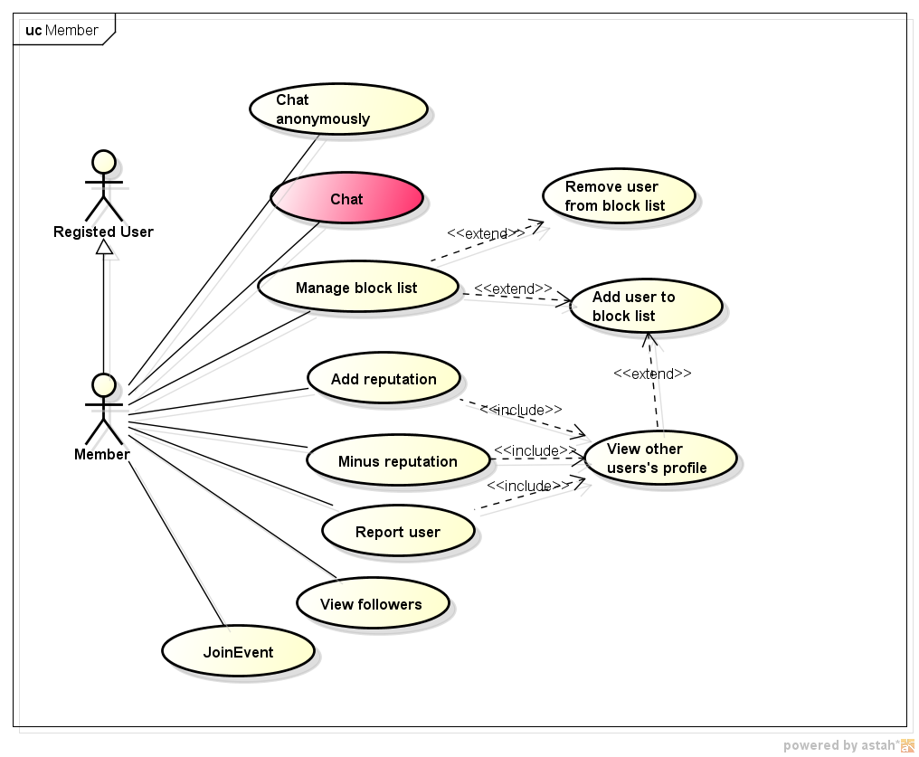

*Figure 3.3.2.3: Member’ use case*

##### **3.3.2.3.1 Add reputation**

|  |  |  |  |
| --- | --- | --- | --- |
| UC ID and Name: | UC-20: Add reputation | | |
| Created By: | ThangDD | Date Created: | 02/06/2016 |
| Primary Actor: | Member | Secondary Actors: | N/A |
| Trigger: | Member wants to vote reputation of other user up. | | |
| Description: | The Member uses this function to vote another reputation up to help them get more trusted. | | |
| Preconditions: | **PRE-20.1.** Member must be logged in to the system.  **PRE-20.2.** Member is viewing another user’s profiles. | | |
| Post conditions: | Reputation of user who is voted increase by 1. | | |
| Normal Flow: | Add reputation  1. The Member clicks to button in another user’s profile.(**E20.1**)   1. Reputation of user who is voted increase by 1. System updates their profile and refreshes Member’s screen. | | |
| Alternative Flows: | N/A | | |
| Exceptions: | E20.1 - Button  is disable because Member already vote this user.   1. Member cannot vote 2 times per 1 user. | | |
| Priority: | High | | |
| Frequency of Use: | High | | |
| Other Information: | N/A | | |
| Assumptions: | Member is actor use this case.  User is another registered user, member or advance members. | | |

##### **3.3.2.3.2 Minus reputation**

|  |  |  |  |
| --- | --- | --- | --- |
| UC ID and Name: | UC-21 : Minus reputation | | |
| Created By: | ThangDD | Date Created: | 02/06/2016 |
| Primary Actor: | Member | Secondary Actors: | N/A |
| Trigger: | Member wants to vote reputation of other user down. | | |
| Description: | The Member uses this function to vote another reputation up to decrease their trusted. | | |
| Preconditions: | **PRE-21.1.** Member must be logged in to the system.  **PRE-21.2.** Member is viewing another user’s profiles. | | |
| Post conditions: | Reputation of user who is voted decrease by 1. | | |
| Normal Flow: | Minus reputation   1. The Member clicks to button in another user’s profile.(**E21.1**) 2. Reputation of user who is voted decrease by 1. System updates their profile and refreshes Member’s screen. | | |
| Alternative Flows: | N/A | | |
| Exceptions: | E21.1 - Button  is disable because Member already vote this user.   1. Member cannot vote 2 times per 1 user. | | |
| Priority: | High | | |
| Frequency of Use: | High | | |
| Other Information: | N/A | | |
| Assumptions: | Member is actor use this case.  User is another registered user, member or advance members. | | |

##### **3.3.2.3.3 Report user**

|  |  |  |  |
| --- | --- | --- | --- |
| UC ID and Name: | UC-22 : Report user | | |
| Created By: | ThangDD | Date Created: | 02/06/2016 |
| Primary Actor: | Member | Secondary Actors: | Admin |
| Trigger: | Member wants to reports use’s profile | | |
| Description: | The Member uses this function to reports use’s profile to the Admin. | | |
| Preconditions: | **PRE-22.1.** Member must be logged in to the system.  **PRE-22.2.** Member is viewing another user’s profiles. | | |
| Post conditions: | Report is sent successful to the Admin and updated to the database. | | |
| Normal Flow: | Report User   1. Member clicks to the button  in another user’s profile. (**E22.1**) 2. Pop-up report form is displayed. 3. Member chooses types of reports and reason to report user. (**OI22.1**) 4. Member clicks on button “Report”(**E22.2**) 5. System saves report to the database and notify to the Admin. | | |
| Alternative Flows: | N/A | | |
| Exceptions: | E22.1: Button  is disabled because there is a report made by this Member about current use’s profile is available.   1. Member cannot send 2 reports per 1 user at the same time.   E22.2: User clicks on button “Cancel”   1. Pop-up is closed. | | |
| Priority: | Medium | | |
| Frequency of Use: | Low | | |
| Other Information: | OI22.1: Types of report are :   1. Fake profile 2. Spam 3. Cheat 4. Sexual content 5. Abusive content 6. Other   User should prove proof to help Admin determines that reason is valid. Otherwise the report will be reject (manual). | | |
| Assumptions: | Member is actor use this case.  User is another registered user, member or advance members. | | |

##### **3.3.2.3.4 Add user to block list**

|  |  |  |  |
| --- | --- | --- | --- |
| UC ID and Name: | UC-23 : Add user to block list | | |
| Created By: | ThangDD | Date Created: | 02/06/2016 |
| Primary Actor: | Member | Secondary Actors: |  |
| Trigger: | Member wants add a user to their block list. | | |
| Description: | The Member uses this function to add a user to their block list. | | |
| Preconditions: | **PRE-23.1.** Member must be logged in to the system.  **PRE-23.2.** Member is viewing their profile. | | |
| Post conditions: | Use’s nick name updated in Member’s block list.  The block list will sort by time that user add to block list | | |
| Normal Flow: | Add user to block list   1. User clicks on button “Danh sách chặn”**(AF23.0)** 2. System shows all users in block list to member’s screen. 3. User clicks to button “Chặn người dùng” 4. Pop up request name of users who is Member wants to block. 5. Member enters name of user wants to block and click to button “Chặn”.**(E23.1)** 6. System validates user’s name then add user to Member block list. The current screen of Member is refreshed **(E23.2)**. | | |
| Alternative Flows: | AF23.1: Member current views another user’s profile.   1. Member clicks on button . 2. An alert to confirm “Bạn có chắc chắn muốn thêm người này vào danh sách chặn?” 3. Member clicks on button “Đồng ý”.**(E23.2)** 4. System adds user to Member block list and redirects to Member block list page. | | |
| Exceptions: | E23.0: Member clicks on button “Hủy bỏ”   1. Popup is closed.   E23.1: System determines that user name is invalid   1. If user doesn’t exists    1. Show message “Người dùng không tồn tại”, then ask for try again.    2. Go to step 4 Normal Flow. 2. If user already available in Member block list    1. Show message to inform that this user already in block list.    2. Redirects to Member block list page.   E23.2: Member clicks on button “Hủy bỏ”   1. Pop-up is closed. | | |
| Priority: | Medium | | |
| Frequency of Use: | Low | | |
| Other Information: | When a user in Member block list, both of side cannot see each other’s things in the website. | | |
| Assumptions: | Member is actor use this case.  User is another registered user, member or advance members. | | |

##### **3.3.2.3.5 Remove user from block list**

|  |  |  |  |
| --- | --- | --- | --- |
| UC ID and Name: | UC-24 : Remove user from block list | | |
| Created By: | ThangDD | Date Created: | 02/06/2016 |
| Primary Actor: | Member | Secondary Actors: |  |
| Trigger: | Member wants to remove user from block list. | | |
| Description: | The Member uses this function to remove user from block list | | |
| Preconditions: | **PRE-24.1.** Member must be logged in to the system.  **PRE-24.2.** Member is viewing their profile. | | |
| Post conditions: | User in Member’s block list is removed. | | |
| Normal Flow: | Remove user from block list   1. User click on button “Danh sách chặn”. 2. System show all users in block list to member’s screen. 3. User click to button “Bỏ chặn” match with user whose wants to remove from block list. **(E24.1)** 4. Alert is displayed to confirm. 5. Member click on button “Đồng ý”. **(E24.2)** 6. System remove that user from block list. The current screen of Member is refreshed. | | |
| Alternative Flows: | N/A | | |
| Exceptions: | E24.1: The block list of Member is empty   1. Display your current block list is empty   E24.2: Member click on button “Hủy bỏ”  1. Pop-up is closed. | | |
| Priority: | Medium | | |
| Frequency of Use: | Low | | |
| Other Information: | N/A | | |
| Assumptions: | Member is actor use this case.  User is another registered user, member or advance members. | | |

##### **3.3.2.3.6 Chat**

|  |  |  |  |
| --- | --- | --- | --- |
| UC ID and Name: | UC-25 : Chat | | |
| Created By: | SangNV | Date Created: | 02/06/2016 |
| Primary Actor: | Member | Secondary Actors: |  |
| Trigger: | Member wants to chat with a user. | | |
| Description: | The Member uses this function to send instance message to another user. | | |
| Preconditions: | **P25.1**: User must logged in website and connect to the Internet. | | |
| Post conditions: | Message is sent instance to the target user. | | |
| Normal Flow: | Add following   1. User clicks on button “Chat”**(AF25.0)** 2. Pop up chat is displayed 3. If Member wants to start chatting with new user then fill their name on the textbox “Tìm kiếm” and type their name to the text box**.**    1. System show results of users name who match with filled information.**(E25.0)**    2. Member pick up a user to request starting chat.    3. Go to step 5. 4. Member select a user from chat history table to request starting chat**.(E25.1)** 5. Chat box is displayed. 6. Member send a message to start chatting. | | |
| Alternative Flows: | **AF25.0**: Member current views another user’s profile.   1. Member clicks on button “Chat”. 2. Member send a message to start chatting. | | |
| Exceptions: | **E25.0**: System can not find out the user match with filled text.  1. Show message “Không tìm thấy kết quả nào phù hợp” and request Member try again.  **E25.1**: System determines that chat history is empty   1. Show message “Không có tin nhắn nào trong hộp thư” and suggest start a chat. | | |
| Priority: | Medium | | |
| Frequency of Use: | Low | | |
| Other Information: | In this case Member can use full function of chatting like use icon, instance message. | | |
| Assumptions: | Member is actor use this case.  User is another registered user, member or advance members. | | |

##### **3.3.2.3.7 Join event**

|  |  |  |  |
| --- | --- | --- | --- |
| UC ID and Name: | UC-26 : Join Event | | |
| Created By: | SangNV | Date Created: | 21/06/2016 |
| Primary Actor: | Member | Secondary Actors: | N/A |
| Trigger: | Member wants to joint offline event created by Admin | | |
| Description: | The Member uses this function to register join a event which is created by Admin | | |
| Preconditions: | **PRE-26.1.** UC-2 is completed.  **PRE-26.2**  The event is available.  **PRE-26.3** Actor current view this event. | | |
| Post conditions: | System inform that event’s registration is successful and update database. | | |
| Normal Flow: | Join Event  **1.** Actor clicks on button “Tham gia”**.(E26.0)**   1. System infor that event’s registration is successful and update database. The current user’s screen is refreshed. | | |
| Alternative Flows: | N/A | | |
| Exceptions: | **E26.0**: System determines the number of participation is enough, or event is expire.  1. Button “Tham gia” is disable. | | |
| Priority: | Medium | | |
| Frequency of Use: | Low | | |
| Other Information: | N/A | | |
| Assumptions: | N/A | | |

##### **3.3.2.3.8 View follower**

|  |  |  |  |
| --- | --- | --- | --- |
| UC ID and Name: | UC-27 : View follower | | |
| Created By: | SangNV | Date Created: | 02/06/2016 |
| Primary Actor: | Member | Secondary Actors: | N/A |
| Trigger: | Member wants to view who is following them. | | |
| Description: | The Member uses this function view who is following them | | |
| Preconditions: | **PRE-27.1.** UC-2 is completed.  **PRE-27.2** Member is viewing their profile. | | |
| Post conditions: | System show all users are current following actor. | | |
| Normal Flow: | Add following  1**.** Actor clicks on button “Danh sách người đang theo dõi bạn”**.**  2. System shows all users in following list to member’s screen. | | |
| Alternative Flows: | N/A | | |
| Exceptions: | N/A | | |
| Priority: | Medium | | |
| Frequency of Use: | Low | | |
| Other Information: | N/A | | |
| Assumptions: | N/A | | |

#### **3.3.2.4 Advanced member**

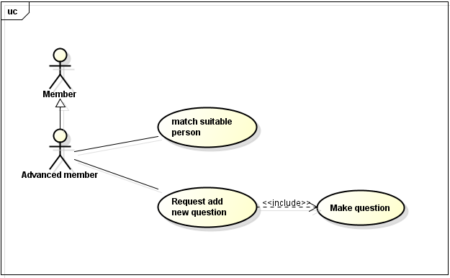

*Figure 3.3.2.4: Advanced member’ use case*

##### **3.3.2.4.1 Request add new question**

|  |  |  |  |
| --- | --- | --- | --- |
| UC ID and Name: | UC-28: Request add new question | | |
| Created By: | ThangDD | Date Created: | 01/06/2015 |
| Primary Actor: | Advanced member | Secondary Actor: | N/A |
| Trigger: | Actor wants to make question to find suitable people. | | |
| Description: | The actor is logged into system as User on browse via Internet. Users will become the advanced member if they were verified by Admin and answer at least 30 questions of Aloha. Actor clicks on “Tạo câu hỏi mới” button. Aloha will show add question dialog to actor add new question and some information about this question. | | |
| Preconditions: | **PRE 28.1** Actor logged into Aloha as User on browser via Internet.  **PRE 28.2** Actor clicks on “Tạo câu hỏi mới” button. | | |
| Post conditions: | Aloha updates actor’ information into database. | | |
| Normal Flow: | Make question successfully   1. The Actor clicks on “Tạo câu hỏi mới” button. 2. Aloha displays add question dialog. 3. The actor adds question into text area (max = 200 characters). 4. The actor adds at least 2 answer into text area (max = 200 character). 5. Click “Gửi” button. 6. Aloha asks for confirm that Actor wants to make question. 7. Actor clicks on “Đồng ý” button. 8. Aloha will updates into database and show on question management list of Admin. | | |
| Alternative Flows: | Edit question, answer and importance   1. Actor clicks on text area of question or answer to edit text 2. Actor clicks on other level of importance. | | |
| Exceptions: | **E28.0** Cannot communicate with the application server.   1. Aloha displays error message “Không thể kết nối đến hệ thống”. 2. Actor clicks on *“Đồng ý”* button and Aloha reload this page. | | |
| Priority: | Medium. | | |
| Frequency of Use: | Medium. | | |
| Other Information: | If user lose network connectivity during loading list of users verifying. There is nothing affected to the system.  Add question dialog includes Question, at least 2 answer, answer actor would accept and importance.  Importance has 3 levels: A little, normal and very.(3 levels is default of Aloha) | | |
| Assumptions: | N/A | | |

##### **3.3.2.4.2 Match suitable people**

|  |  |  |  |
| --- | --- | --- | --- |
| UC ID and Name: | UC-29: Match suitable people | | |
| Created By: | ThangDD | Date Created: | 01/06/2015 |
| Primary Actor: | Advanced member | Secondary Actor: | N/A |
| Trigger: | Actor indicates that he/she wants to make question to find suitable people. | | |
| Description: | After member answers at least 30 questions. Member become advanced member. And Aloha will use those answers to help actor find suitable people by scoring. | | |
| Preconditions: | **PRE 29.1** Actor logged into Aloha as User on browser via Internet.  **PRE 29.2** Actor clicks on “Người phù hợp” tab. | | |
| Post conditions: | Aloha updates suitable people into database. | | |
| Normal Flow: | Match suitable people successfully   1. The Actor clicks on “Người phù hợp” tab. 2. Aloha shows list of suitable people of each actor. | | |
| Alternative Flows: | N/A | | |
| Exceptions: | **E29.0** Cannot communicate with the application server.   1. Aloha displays error message “Không thể kết nối đến hệ thống”. 2. Actor clicks on *“Đồng ý”* button and Aloha reload this page. | | |
| Priority: | Medium. | | |
| Frequency of Use: | Medium. | | |
| Business Rules: |  | | |
| Other Information: | If user lose network connectivity during loading list of users verifying. There is nothing affected to the system.  Aloha scoring to find suitable people by importance.  Not = 0 point. A little = 1 point. Normal = 10 point. Very = 50 point | | |
| Assumptions: | N/A | | |

#### **3.3.2.5 Admin**

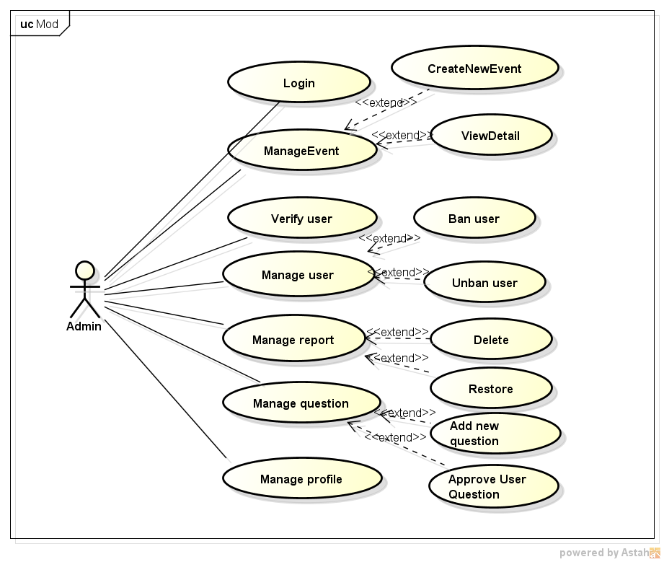

*Figure 3.3.2.5: Admin’ use case*

##### **3.3.2.5.1 Login**

|  |  |  |  |
| --- | --- | --- | --- |
| UC ID and Name: | UC-30 : Login | | |
| Created By: | ThangDD | Date Created: | 02/06/2016 |
| Primary Actor: | Admin | Secondary Actors: | N/A |
| Trigger: | The Admin wants to login Aloha. | | |
| Description: | The Admin uses this function to login Aloha. | | |
| Preconditions: | **PRE 30.1** The Adminaccesses website on browser via Internet  **PRE 30.2** The Admin has a registered account. | | |
| Post conditions: | System logged in Aloha by admin account | | |
| Normal Flow: | Login   1. Actor fills user name and password and clicks on “Đăng nhập” button. 2. Aloha load user management page. | | |
| Alternative Flows: | N/A | | |
| Exceptions: | **E30.0** System determines invalid information filled.   * Aloha displays error message “Tài khoản hoặc mật khẩu không đúng, xin vui lòng nhập lại” | | |
| Priority: | High | | |
| Frequency of Use: | High | | |
| Other Information: | N/A | | |
| Assumptions: | N/A | | |

##### **3.3.2.5.2 Create new event**

|  |  |  |  |
| --- | --- | --- | --- |
| UC ID and Name: | UC-31: Create new event | | |
| Created By: | ThangDD | Date Created: | 21/06/2015 |
| Primary Actor: | Admin | Secondary Actor: | N/A |
| Trigger: | Actor indicates that he/she wants to create an offline event. | | |
| Description: | Actor use this function to inform to users that there are an offline event and allow users registers to join. | | |
| Preconditions: | **PRE 31.1** Actor logged into Aloha as Admin on browser via Internet. | | |
| Post conditions: | The detail inforrmation event show to the “Sự kiện” corner in the website. | | |
| Normal Flow: | Create new event   1. The actor clicks to tab manage event. 2. Aloha displays Manage event page. 3. The actor clicks on “Create new event” button. 4. Aloha displays pop up request mandatory information and description about event. 5. Actor fills necessary information and click on button “create”.(E31.0) 6. System adds new event to the database and website.(E31.1) | | |
| Alternative Flows: | N/A | | |
| Exceptions: | **E31.0**: Actor clicks on button cancel  1. Popup is closed.  **E31.1**: System determines that invalid information  2. Show message and request refill. | | |
| Priority: | Medium. | | |
| Frequency of Use: | Low | | |
| Other Information: | N/A | | |
| Assumptions: | N/A | | |

##### **3.3.2.5.3 View event details**

|  |  |  |  |
| --- | --- | --- | --- |
| UC ID and Name: | UC-32: View event details | | |
| Created By: | ThangDD | Date Created: | 21/06/2015 |
| Primary Actor: | Admin | Secondary Actor: | N/A |
| Trigger: | Actor indicates that he/she wants to view event detail. | | |
| Description: | Actor uses this function to view detail of an event such as number of Registered paricipation, location, status… | | |
| Preconditions: | **PRE 32.1** Actor logged into Aloha as Admin on browser via Internet.  **PRE 32.2** There are event is created. | | |
| Post conditions: | Show detail of event to the Admin’s screen. | | |
| Normal Flow: | View event details   1. The actor clicks to tab manage event. 2. Aloha displays Manage event page. 3. The actor selects an event in the event table. 4. System shows detail of event to the actor’s screen. | | |
| Alternative Flows: | N/A | | |
| Exceptions: | N/A | | |
| Priority: | Medium. | | |
| Frequency of Use: | Low | | |
| Other Information: | N/A | | |
| Assumptions: | N/A | | |

##### **3.3.2.5.4 Verify user**

|  |  |  |  |
| --- | --- | --- | --- |
| UC ID and Name: | UC-33: Verify user | | |
| Created By: | ThangDD | Date Created: | 01/06/2015 |
| Primary Actor: | Admin | Secondary Actor: | N/A |
| Trigger: | Actor indicates that he/she wants to verify users. | | |
| Description: | When users uploadavatar, Admin must checks avatar with identity card. Admin can approve user’s avatar if that photo is valid. If invalid, Admin can rejects and requires users upload new avatar and identity card. | | |
| Preconditions: | **PRE 33.1** Actor logged into Aloha as Admin on browser via Internet and view list of users verifying. | | |
| Post conditions: | Aloha will classify users based on verify status. If Admin approves avatar (status=”Duyệt”) users will become “member”. If Admin rejects avatar (status=”Hủy”) users still “Registered user”. | | |
| Normal Flow: | View list users verifying  1. The actor accesses to the Aloha page.  2. Aloha displays homepage for Admin.  3. The actor clicks on “Verify request” tab.  4. Aloha displays list of users verifying.   1. Actor clicks on identity card number to show verify the quest of each user. 2. Aloha shows pop up to actors view verify request detail approve verify user. 3. Actor clicks on “Duyệt” button.   8. Verify status of this user will change to “Approve”. | | |
| Alternative Flows: | Press ESC when Actor wants to check avatar again (Step 5)   1. The actor press “*ESC*” button. 2. Aloha back to list of users verifying. | | |
| Exceptions: | **E33.0** Cannot communicate with the application server.   1. Aloha displays error message “Không thể kết nối đến hệ thống”. 2. Actor clicks on *“Đồng ý”* button and Aloha reload this page. 3. Actor clicks on “Hủy” button, pop up is closed. | | |
| Priority: | High. | | |
| Frequency of Use: | Medium. | | |
| Business Rules: |  | | |
| Other Information: | If user lose network connectivity during loading list of users verifying. There is nothing affected to the system.  List of users verifying have default sort by verify status. “Pending” status is always in top of list.  When users request verify avatar, verify status of those is “Pending”. | | |
| Assumptions: | N/A | | |

##### **3.3.2.5.5 Ban user**

|  |  |  |  |
| --- | --- | --- | --- |
| UC ID and Name: | UC-34: Ban User | | |
| Created By: | ThangDD | Date Created: | 01/06/2015 |
| Primary Actor: | Admin | Secondary Actors: | N/A |
| Trigger: | The actor indicates that he/she wants to ban user. | | |
| Description: | The Actor accesses to user management page, chooses user who violated terms of service by entered information, ban user. | | |
| Preconditions: | **PRE 34.1** The actor is logged into system as Admin on browse via Internet and clicks on “Quản lý người dùng” tab. | | |
| Post conditions: | Aloha updates user state into database. | | |
| Normal Flow: | Ban user successfully   1. The actor clicks on “Quản lý người dùng” tab. 2. Aloha displays list of users. 3. The actor enters username to search user who actor wants to ban. 4. The system redirects to update user account page 5. The actor selects (Trạng thái = “Ban”) and put the description to the “Ly do” TextArea. 6. The actor clicks *“Update”* button. 7. Aloha changes user state into *“Banned”* and update into database. | | |
| Alternative Flows: | N/A | | |
| Exceptions: | **E34.0** Cannot communicate with the application server.   1. Aloha displays error message. 2. Aloha reserves the information filled in the destination edited form. 3. Actor clicks on button cancel, pop up is closed. | | |
| Priority: | High. | | |
| Frequency of Use: | Medium. | | |
| Business Rules: |  | | |
| Other Information: | N/A | | |
| Assumptions: | N/A | | |

##### **3.3.2.5.6 Unban user**

|  |  |  |  |
| --- | --- | --- | --- |
| UC ID and Name: | UC-35: Unban User | | |
| Created By: | ThangDD | Date Created: | 01/06/2015 |
| Primary Actor: | Admin | Secondary Actors: | N/A |
| Trigger: | The actor indicates that he/she wants to unban a user. | | |
| Description: | The Actor accesses to user management page, choose user by unban. | | |
| Preconditions: | **PRE 35.1** The actor is logged into system as Admin on browse via Internet.  Target user was banned. | | |
| Post conditions: | Aloha updates user state into database. | | |
| Normal Flow: | Unban user successfully.   1. The Actor clicks on “Quản lý người dùng” tab. 2. Aloha displays list of users. (Screen UC-34) 3. The actor enters username to search user who is inactive account and select it. 4. The system redirects to update user account page. 5. The actor selects (Trạng thái = “UnBan”) and put the description to the “Ly do” TextArea. 6. The actor clicks *“Đồng ý”* button in pop up. 7. Aloha changes user state into *“Active”* and update into database. | | |
| Alternative Flows: | N/A | | |
| Exceptions: | **E35.0** Cannot communicate with the application server.   1. Aloha displays error message. 2. Aloha reserves the information filled in the destination edited form. 3. Actor clicks on button cancel, pop up is closed. | | |
| Priority: | High. | | |
| Frequency of Use: | Medium. | | |
| Business Rules: |  | | |
| Other Information: | N/A | | |
| Assumptions: | N/A | | |

##### **3.3.2.5.7 Manage report**

|  |  |  |  |
| --- | --- | --- | --- |
| UC ID and Name: | UC-36: Manage report | | |
| Created By: | ThangDD | Date Created: | 01/06/2015 |
| Primary Actor: | Admin | Secondary Actors: | N/A |
| Trigger: | The actor indicates that he/she wants to delete user’s information. | | |
| Description: | The Actor accesses to report management page. Report management page include list of users who was reported by other people. Then, actor choose user who actor wants to delete some information. If actor delete information of mandatory field, Aloha will change information of this filed to default. This time, Aloha will send mail to user to notify that information invalid via email address  Mandatory field:  Name/ default= ”Nguyễn Văn A”  Date of birth/ default= “1/1/1990”  Address/ default= “Hà Nội” | | |
| Preconditions: | **PRE 36.1** The actor is logged into system as Admin on browse via Internet and click on “Quản lý báo cáo” tab. | | |
| Post conditions: | Aloha updates user’ information into database and change status to “handled”. | | |
| Normal Flow: | Delete user’s information successfully.   1. The Actor clicks on “Quản lý báo cáo” tab. 2. Aloha displays list of users who was reported by other people. 3. The actor enters username to search user who actor wants to check and delete some information. 4. The actor clicks *“X”* button inside information that actor wants to delete. 5. Aloha asks for confirm that Admin wants to delete that information. 6. The actor clicks *“Đồng ý”* button in pop up. 7. Aloha changes user information and update into database. | | |
| Alternative Flows: | N/A | | |
| Exceptions: | **E36.0** Cannot communicate with the application server.   1. Aloha displays error message. 2. Aloha reserves the information filled in the destination edited form. 3. Actor clicks on button cancel, pop up is closed. | | |
| Priority: | High. | | |
| Frequency of Use: | Medium. | | |
| Business Rules: |  | | |
| Other Information: | List of report management have some information like name, user id, reason (why other people report you), people who report and report’s time. And this list only shows people who was reported by other people but Admin pending.  If account was created by Aloha, user’ email address is email that user used to register. If account was link via facebook/google+, this email address is email that user used to register facebook/google+ account. | | |
| Assumptions: | N/A | | |

##### **3.3.2.5.8 Restore information**

|  |  |  |  |
| --- | --- | --- | --- |
| UC ID and Name: | UC-37: Restore information | | |
| Created By: | ThangDD | Date Created: | 01/06/2015 |
| Primary Actor: | Admin | Secondary Actors: | N/A |
| Trigger: | The actor indicates that he/she wants to restore users’ information. | | |
| Description: | The actor is logged into system as Admin on browse via Internet.  Target user has information that was deleted by actor recently.  When users who were reported by other people and they were deleted some information by Admin, if they prove that those information is correct with Admin. Admin must restore information that was deleted. Because, When users was reported and deleted some information. They must update information. Those information must different with the information was reported and deleted. | | |
| Preconditions: | **PRE 37.1** The Actor accesses to user management page, choose user to restore information. | | |
| Post conditions: | Aloha updates user’ information into database. | | |
| Normal Flow: | Restore user’ information successfully   1. The Actor clicks on “Quản lý thông tin người dùng” tab. 2. Aloha displays list of users who was reported by other people. 3. The actor enters username to search user who actor wants to check and restore some information. 4. The actor clicks *“Phục hồi”* button inside information that actor wants to restore. “Phục hồi” button only inside information was deleted recently. 5. Aloha asks for confirm that Admin wants to restore that information. 6. The actor clicks *“Đồng ý”* button in confirmation dialog. 7. Aloha changes user information and update into database. | | |
| Alternative Flows: | N/A | | |
| Exceptions: | **E37.0** Cannot communicate with the application server.   1. Aloha displays error message. 2. Aloha reserves the information filled in the destination edited form. 3. Actor clicks on button cancel, pop up is closed. | | |
| Priority: | High. | | |
| Frequency of Use: | Medium. | | |
| Other Information: | N/A | | |
| Assumptions: | N/A | | |

##### **3.3.2.5.9 Approve user question**

|  |  |  |  |
| --- | --- | --- | --- |
| UC ID and Name: | UC-38: Approve user question | | |
| Created By: | ThangDD | Date Created: | 01/06/2015 |
| Primary Actor: | Admin | Secondary Actor: | N/A |
| Trigger: | The actor indicates that he/she wants to approve more questions from users. | | |
| Description: | The actor is logged into system as Admin on browse via Internet and clicks on “Quản lý câu hỏi” tab. List question management will show all questions that users request add new question. | | |
| Preconditions: | **PRE 38.1** Actor logged into Aloha as Admin on browser via Internet and view list of feedback. | | |
| Post conditions: | If Admin approves questions from users, those questions will update into database. | | |
| Normal Flow: | Approve question   1. The Actor clicks on “Quản lý câu hỏi” tab. 2. Aloha displays list of users who requested add new question. 3. The actor enters username to search user who actor wants to approve question. 4. The actor clicks on question to show full question. 5. The actor clicks *“Duyệt”* button below the question. 6. Aloha changes question status into “Approve” and update into database. | | |
| Alternative Flows: | N/A | | |
| Exceptions: | **E38.0** Cannot communicate with the application server.   1. Aloha displays error message “Không thể kết nối đến hệ thống”. 2. Actor clicks on *“Đồng ý”* button and Aloha reload this page. | | |
| Priority: | High. | | |
| Frequency of Use: | Medium. | | |
| Other Information: | If user lose network connectivity during loading list of users verifying. There is nothing affected to the system.  List of question management include name and user id of users who request add new question, question (question that users request), time request and factor. | | |
| Assumptions: | N/A | | |

##### **3.3.2.5.10 Add new question**

|  |  |  |  |
| --- | --- | --- | --- |
| UC ID and Name: | UC-39: Add new question | | |
| Created By: | ThangDD | Date Created: | 21/06/2015 |
| Primary Actor: | Admin | Secondary Actor: | N/A |
| Trigger: | The actor indicates that he/she wants to add new question to the database. | | |
| Description: | The actor use this function to add new question to the database. | | |
| Preconditions: | **PRE 39.1** Actor logged into Aloha as Admin on browser via Internet. | | |
| Post conditions: | New questions will update into database. | | |
| Normal Flow: | Add new question  1. The Actor clicks on “Quản lý câu hỏi” tab.  2. The system displays manage question page.  3. The actor clicks on button add new question.  4. Pop up adds new question is showed.  5. Actor fills mandatory field and click on button create.(**E39.0**)  6. System informs sucessful and add new question to database. Actor screen is refreshed.(E.1) | | |
| Alternative Flows: | N/A | | |
| Exceptions: | **E39.0**: Actor clicks on button cancel  1. Pop up is closed.  **E39.1**: System determines invalid information  1. Show message and request to refill. | | |
| Priority: | Medium. | | |
| Frequency of Use: | Medium. | | |
| Business Rules: |  | | |
| Other Information: |  | | |
| Assumptions: | N/A | | |

### **3.3.3 Screen flow**

#### **3.3.3.1 Main application**

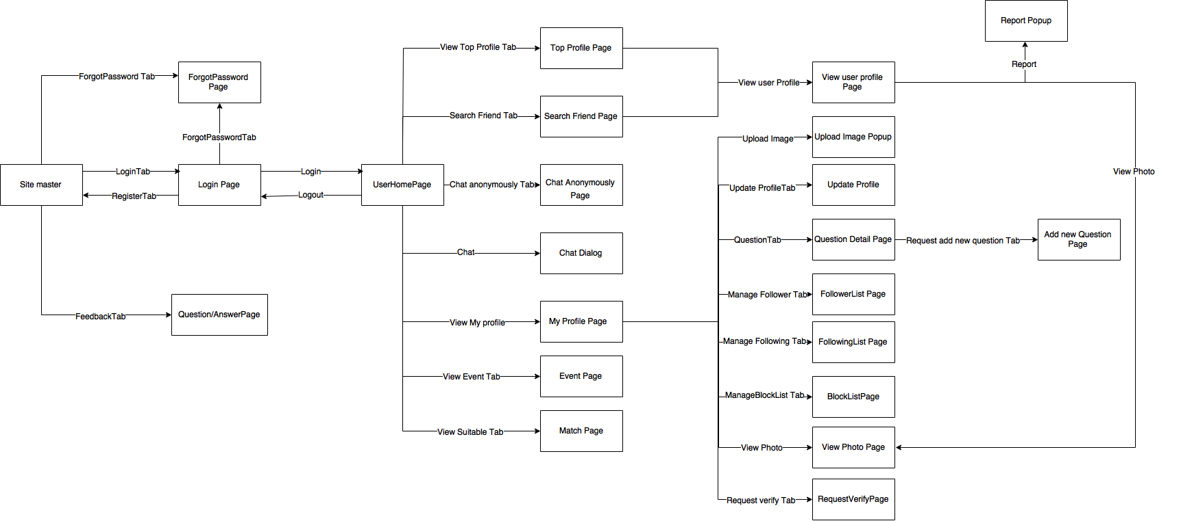

*3.3.3.1 Main application screen flow*

#### **3.3.3.2 Administration application**

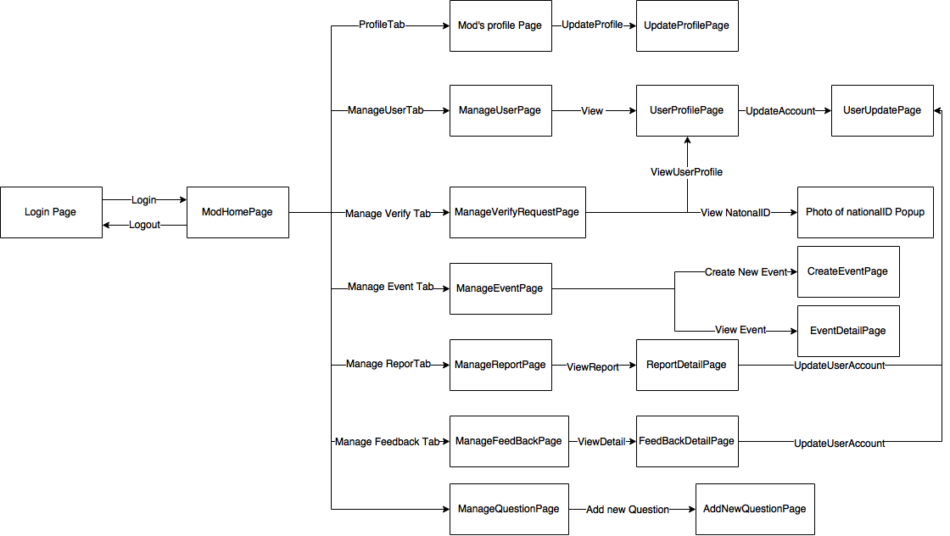

*Figure 3.3.3.2 Administration application screen flow*

### **3.3.4 Non-functional requirement**

#### **3.3.4.1 Performance**

- Screen refresh time in 2 seconds.

- Time to process any single request no longer than 5 seconds.

- When the system synchronize or update data which the server, information service, the performance will depend on the network coverage’s condition

#### **3.3.4.2 Availability**

- The server can run 24/7 and handle up to 10.000 member. People can use the system every time and everywhere with internet connection.

- If server is down by fatal error, server will be restart after at most 5 minutes.

#### **3.3.4.3 Maintainability**

- The software development phase will follow the Project Coding Convention which is designed to help the team create explicit source code.

- The development will follow the Object-Oriented Programming paradigm. This will lead to easily maintenance and upgrading of the application in the future.

#### **3.3.4.4 Security**

|  |  |  |  |  |  |
| --- | --- | --- | --- | --- | --- |
| Actor  Function | Guest | Registered  User | Verified  User | Advanced  User | Admin |
| Register | √ |  |  |  |  |
|  |  |  |  |  |  |
|  |  |  |  |  |  |
| Login | √ | √ | √ | √ | √ |
| Logout |  | √ | √ | √ | √ |
| View user profile |  | √ | √ | √ | √ |
| Search people |  | √ | √ | √ |  |
| Chat |  | √ | √ | √ |  |
| Update profile |  | √ | √ | √ |  |
| Add/Edit/Delete album |  | √ | √ | √ |  |
| View photo |  | √ | √ | √ |  |
| Follow other people |  | √ | √ | √ |  |
| Add/Minus reputation |  |  | √ | √ |  |
| View follower |  |  | √ | √ |  |
| Block user |  |  | √ | √ |  |
| Report user |  |  | √ | √ |  |
| Match suitable person |  |  |  | √ |  |
| Request add a question |  |  |  | √ |  |
| Verify user |  |  |  |  | √ |
| Manage question |  |  |  |  | √ |
| Manage feedback |  |  |  |  | √ |
| Ban/Unban user |  |  |  |  | √ |
| Manage report |  |  |  |  | √ |

*Table 3.3.4: Non-functional requirement*

### **3.3.5 Success criteria**

|  |  |  |  |
| --- | --- | --- | --- |
| No. | Success Criteria | | Description |
| 1 | Time |  | - Good estimate: The definition of a successful project includes if the project was completed on time and within budget. An accurate estimation of time and money is crucial.  - Establish an achievable project schedule and closely monitor progress of milestones. After the schedule has been set, monitor it closely and keep tight control of it. |
| 2 | Scope |  | Ensure that the product is meeting the scope which is defined in SRS. Communicate with the supervisor and all team members while the project is in progress to make sure the project is on the path to success. |
| 3 | Factor | Project Manager | The person needs to have an array of skills under his arm to use during the project.  - Provides day-to-day oversight of the project  - Verifies that tasks are completed on time  - Provides communication and coordination across the entire project team  - Tracks issues and resolution  - Provides periodic project updates  - Maintains the project plan  - Serves as the primary point of contact with the project team |
|  |  | Team Member | - Complete assigned tasks  - Report issues or delays to the Project Manager  - Participate in project updates as appropriate |

*Table 3.3.5: Success criteria*

# **4. Software design**

## **4.1 Purpose**

This chapter is to give the developer team a guidance of what the system’s architecture is, and how they should be implemented. This chapter consists of:

* Architecture overview
* Detailed design
* Detailed description of components
* Database design

## **Architecture overview**

### **4.2.1 Architecture diagram**

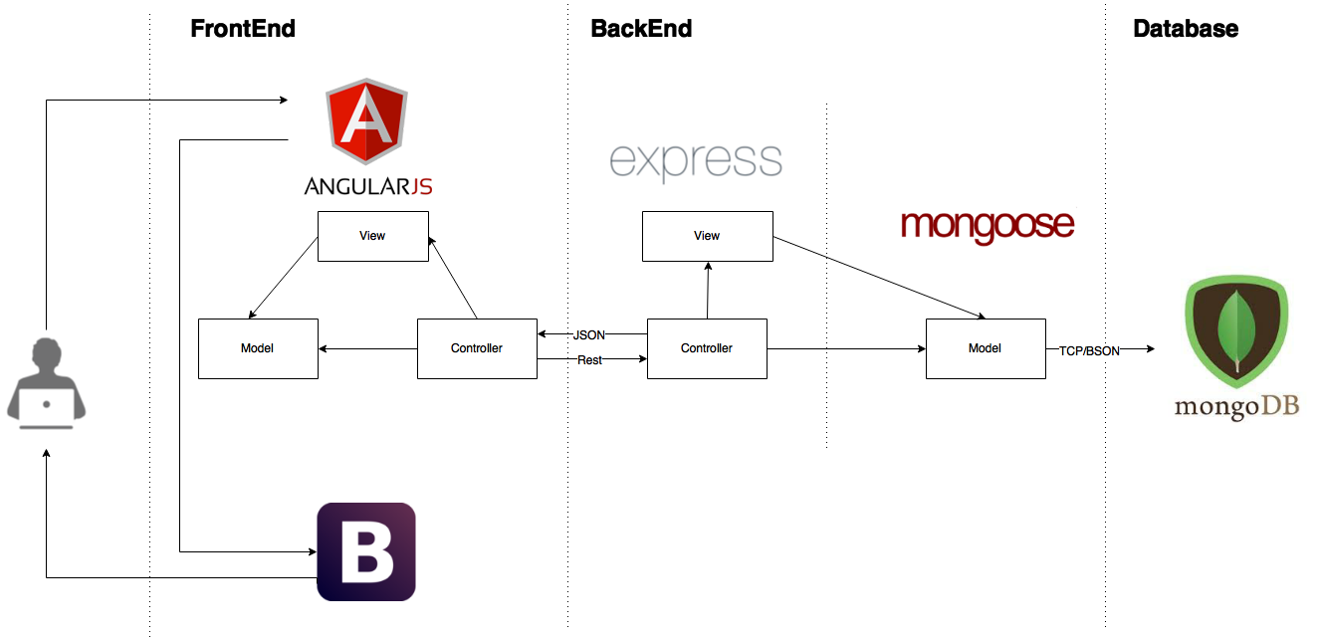

*Figure 4.2.1 Aloha architecture diagram*

**Frontend**

[AngularJS](https://angularjs.org/) is a very popular MVC application framework for building dynamic applications. It controls Bootstrap views by reacting to user input and loading data from the backend via REST services.

[Bootstrap 3](http://getbootstrap.com/) is the most popular front-end css framework for developing responsive, mobile first projects on the web. It is primarily used for creating views.

**Backend**

[Express](http://expressjs.com/) is a minimal and flexible node.js web application framework, providing a robust set of features for building single / multi-page and hybrid web applications. It provides a simple web server to host your REST API and dynamically serves the root index page.

Mongoose provides a straight-forward, schema-based solution to Admineling your application data and includes built-in type casting, validation, query building, business logic hooks and more, out of the box.

**Database**

[MongoDB](http://docs.mongodb.org/manual/) is an open-source, document-oriented database designed for ease of development and scaling. It is the backing store for Adminels that are exposed by the REST service. Mongoose is also included in the stack and helps translate data in the MongoDB database to JavaScript objects for use in your application.

**Benefits**

1. **Save Time Getting Started**

The research for combining various JavaScript libraries that work well together has been done for you. Time saved here will allow you to focus on building valuable applications for your organization.

1. **Leverage Community Experience**

The community has been building complex web applications using these JavaScript libraries for quite a while. MEAN.JS passes this experience on to you with an easily digestible template that shows you the best practices for organizing your application. Your team can avoid common pitfalls that the community endured as they applied these technologies.

1. **Fail Quickly/Cheaply**

A prototype can be rapidly created with MEAN.JS. The prototype can test the value of your application before you invest a lot in it. After you prove the value proposition you can have more confidence that further investment will be worthwhile. The MEAN.JS stack is scalable for solving many business problems. However, if your particular problem will not scale, you could plugin a different backing store or provider for your REST services. The architecture will enable this agility while also giving you early feedback on the value of your application.

1. **Unify Front/Back End**

Developers can use JavaScript on the front/back end. Code that translates from Java/C# Adminels to JavaScript is no longer needed. Developers can specialize in JavaScript, which allows more flexible resource allocation and lower training cost.

1. **Utilize Proven Technologies**

The technologies in MEAN.JS are well established and ready to handle the challenges your business faces. Several large companies are leveraging NodeJS with great success. NodeJS has allowed these companies to rapidly develop scalable solutions that are easier to maintain.

1. **Automated Testing**

The architecture is setup to support automated testing. Automated testing can greatly increase the agility and quality of your applications. Developers can know instantly that a feature broke several test cases and make corrections immediately.

1. **Stay Hip & Trendy**

The technologies in the stack are all very popular and as such recruiting resources proficient in them will be easier. In addition talented developers will be attracted to your shop to work on these newer technologies which will drastically improve your chance of success. The Google trends graph below shows how AngularJS is rapidly becoming the most popular HTML5 framework.

### **Aloha application**

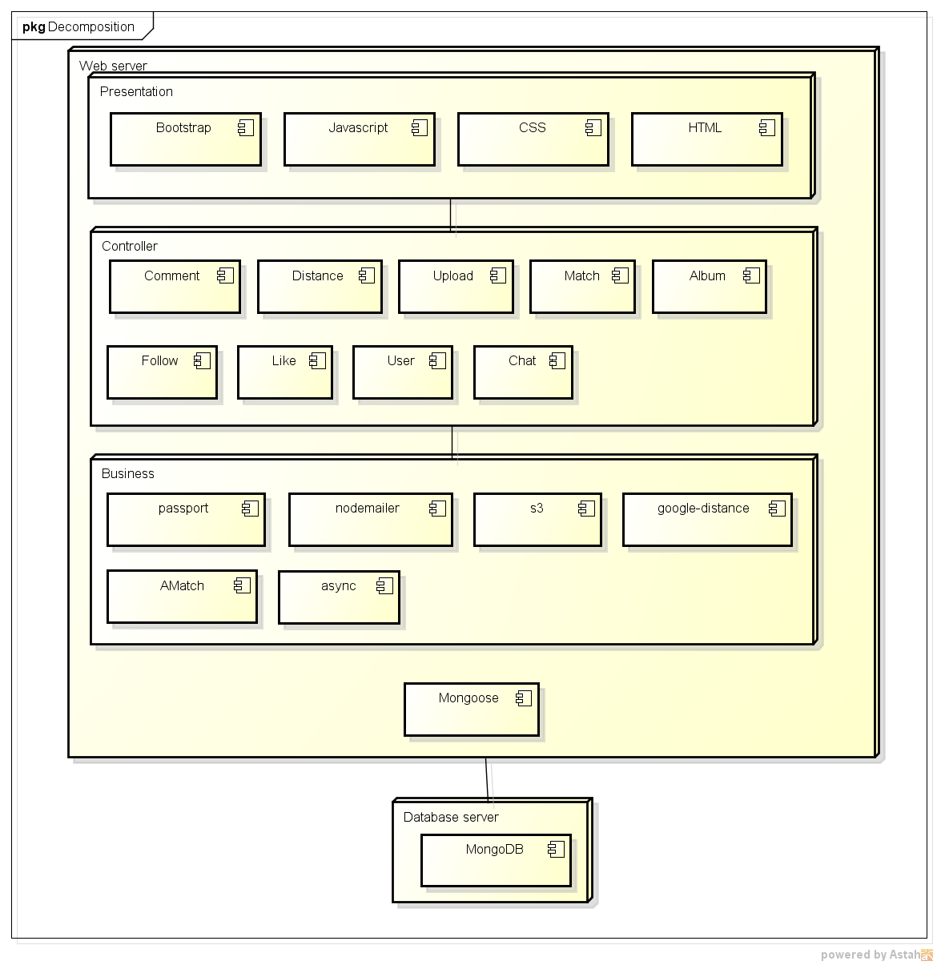

*Figure 4.2.2 Aloha website decomposition*

* Website contains interactive features for users to set up a separate node called Web Server.
* Database is located on a server called Database Server.

## **Design of Aloha**

### **Database**

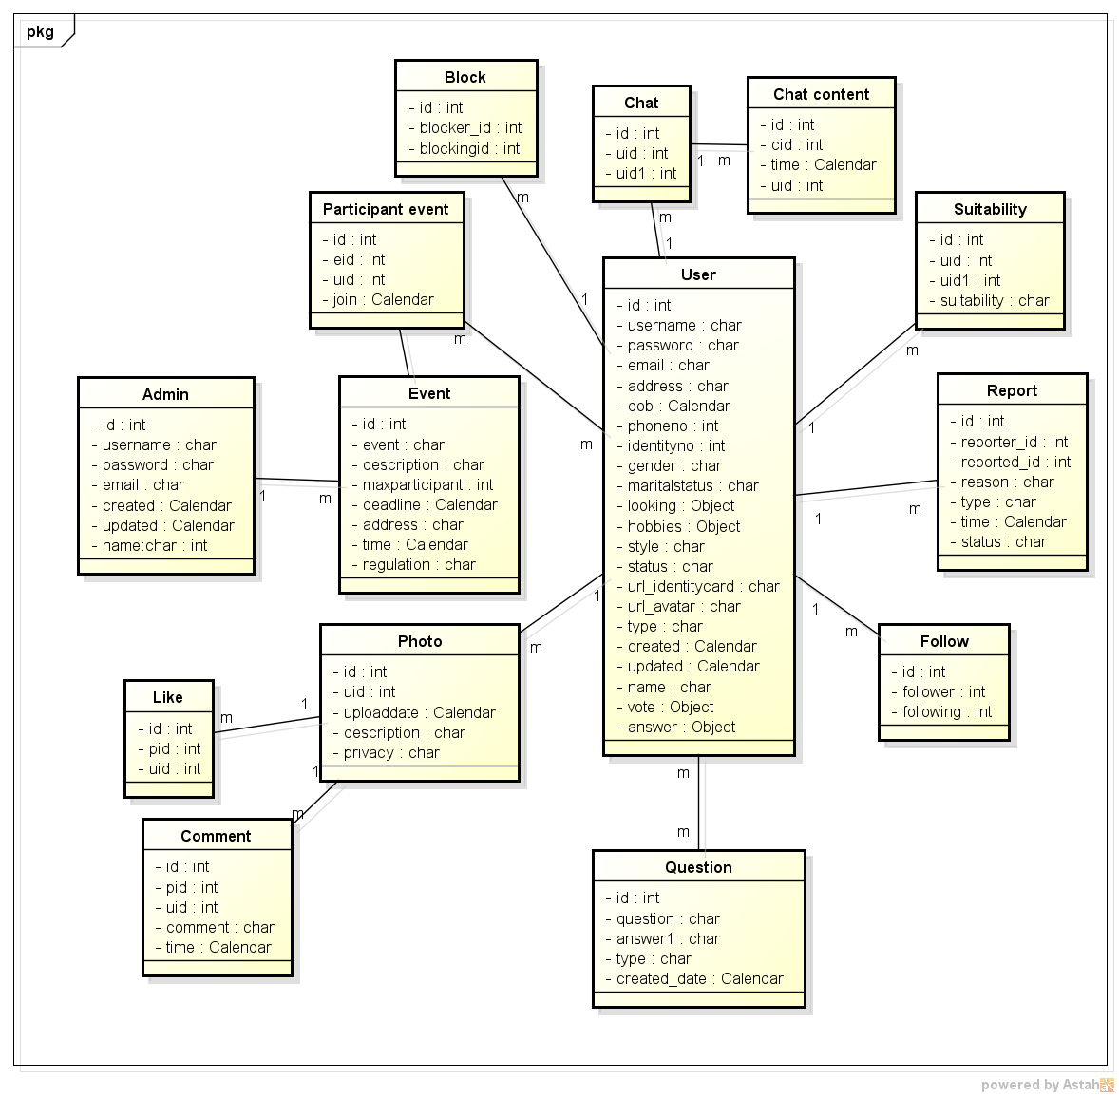

### **Table Admin**

|  |  |  |  |  |  |
| --- | --- | --- | --- | --- | --- |
| Admin: store all personal data of Admin | | | | | |
| No. | Field | Type | Key | Description | Null |
| 1 | Id | INT(10) | PK | The id of Admin | No |
| 2 | Username | VARCHAR(255) |  | Username of Admin | No |
| 3 | Password | VARCHAR(255) |  | Password of Admin (encrypt by …) | No |
| 4 | Email | VARCHAR(320) |  | Email of Admin | No |
| 5 | Name | VARCHAR(255) |  | Name of Admin | No |
| 6 | created\_at | TIMESTAMP |  | Time Admin data created | No |
| 7 | updated\_at | TIMESTAMP |  | Last time Admin data updated | No |

### **Table User**

|  |  |  |  |  |  |
| --- | --- | --- | --- | --- | --- |
| User: store all personal data of User | | | | | |
| No. | Field | Type | Key | Description | Null |
| 1 | Id | INT(10) | PK | The id of user | No |
| 2 | Username | VARCHAR(255) |  | Username of user | No |
| 3 | Password | VARCHAR(255) |  | Password of user (encrypt by …) | No |
| 4 | Email | VARCHAR(320) |  | Email of user | No |
| 5 | Address | VARCHAR(255) |  | Address of user | No |
| 6 | Date\_of\_birth | TIMESTAMP |  |  | No |
| 7 | Telephone\_number | INT(11) |  | Telephone number of User | Yes |
| 8 | Identitycard\_number | INT(9) |  | Identity card number of User | Yes |
| 9 | Gender | VARCHAR(10) |  | Gender of user (Male, Female, Other) | No |
| 10 | Marital\_status | VARCHAR(255) |  |  | Yes |
| 11 | Looking | VARCHAR(255) |  | Store(high, weight) | Yes |
| 12 | Hobbies | VARCHAR(255) |  | Store(food, music, book, movie, drama, color, sport) | Yes |
| 13 | Style | VARCHAR(255) |  | Description about style of people that user want to make friend | Yes |
| 14 | Status | VARCHAR(10) |  | Status of User (Active, Inactive) | No |
| 15 | url\_Identitycard | VARCHAR(255) |  | Identity card of user | Yes |
| 16 | url\_Avatar | VARCHAR(255) |  | Avatar of user | Yes |
| 17 | Type | VARCHAR(255) |  | Type of user (advanced, registered, verified) | No |
| 18 | Name | VARCHAR(255) |  | Name of user | No |
| 19 | Vote | VARCHAR(255) |  | Store(voter,type) | Yes |
| 20 | created\_at | TIMESTAMP |  | Time user data created | No |
| 21 | updated\_at | TIMESTAMP |  | Last time user data updated | No |
| 22 | Answer | VARCHAR(255) |  | Store(Question ID, answer, accepted answer) | Yes |

### **Table Event**

|  |  |  |  |  |  |
| --- | --- | --- | --- | --- | --- |
| Event: store data about event | | | | | |
| No. | Field | Type | Key | Description | Null |
| 1 | Id | INT(10) | PK | The id of Event | No |
| 2 | Event | VARCHAR(255) |  | Name of event | No |
| 3 | Description | VARCHAR(255) |  | Description about event | No |
| 4 | Maximum participants | INT(10) |  | The maximum number of participants | No |
| 5 | Registration deadline | TIMESTAMP |  | Registration deadline of event | No |
| 6 | Address | VARCHAR(255) |  | Address of event | No |
| 7 | Time | TIMESTAMP |  | Time of event | No |
| 8 | Regulation | VARCHAR(255) |  | Regulation of event | No |

### **Table Report**

|  |  |  |  |  |  |
| --- | --- | --- | --- | --- | --- |
| Report: store data about report | | | | | |
| No. | Field | Type | Key | Description | Null |
| 1 | Id | INT(10) | PK | The id of Report | No |
| 2 | Reporter\_ID | INT(10) | FK (reference to users ) | User ID of people who report | No |
| 3 | Reported\_ID | INT(10) | FK (reference to users ) | User ID of user who was reported | No |
| 4 | Reason | VARCHAR(255) |  | The reason why user report other user | No |
| 5 | Report\_type | VARCHAR(255) |  |  | No |
| 6 | Report\_time | TIMESTAMP |  |  | No |
| 7 | Report\_status | VARCHAR(255) |  | Include: Approve, Reject, Pending | No |

### **Table Question**

|  |  |  |  |  |  |
| --- | --- | --- | --- | --- | --- |
| Question: store data about question | | | | | |
| No. | Field | Type | Key | Description | Null |
| 1 | Id | INT(10) | PK | The id of Question | No |
| 2 | Question | VARCHAR(255) |  |  | No |
| 3 | Answer | VARCHAR(255) |  |  | No |
| 4 | Type | VARCHAR(255) |  | Type of question | Yes |
| 5 | Created\_date | TIMESTAMP |  | Created date of question | No |

### **Table Follow**

|  |  |  |  |  |  |
| --- | --- | --- | --- | --- | --- |
| Follow: store data about follow | | | | | |
| No | Field | Type | Key | Description | Null |
| 1 | Id | INT(10) | PK | Id of follow | No |
| 2 | user\_id | INT(10) | FK (reference to users) | Id of user who was followed | No |
| 3 | follower\_id | INT(10) |  | Id of user who following | No |

### **Table Participation event**

|  |  |  |  |  |  |
| --- | --- | --- | --- | --- | --- |
| Join Event: store data about participation event | | | | | |
| No | Field | Type | Key | Description | Null |
| 1 | Id | INT(10) | PK | Id of participation the event | No |
| 2 | event\_id | INT(10) | FK (reference to event) | Id of event | No |
| 3 | User\_id | INT(10) | FK (reference to user) | Id of user who join the event | No |
| 4 | Join\_date | TIMESTAMP |  | Time that user join the event | No |

### **Table Chat**

|  |  |  |  |  |  |
| --- | --- | --- | --- | --- | --- |
| Chat: store data about chat | | | | | |
| No | Field | Type | Key | Description | Null |
| 1 | Id | INT(10) | PK | Id of chat | No |
| 2 | User\_id | INT(10) | FK (reference to users) | User id of user | No |
| 3 | User\_id1 | INT(10) | FK (reference to users) | User id of user | No |

### **Table Chat content**

|  |  |  |  |  |  |
| --- | --- | --- | --- | --- | --- |
| Chat content: store data about chat content | | | | | |
| No | Field | Type | Key | Description | Null |
| 1 | Id | INT(10) | PK | Id of chat content | No |
| 2 | Chat\_ID | INT(10) | FK (reference to chat) | ID of chat | No |
| 3 | Time | TIMESTAMP |  | Time of chat content | No |
| 4 | User\_ID | INT(10) | FK (reference to users) | User ID of user who chat | No |

### **Table Block**

|  |  |  |  |  |  |
| --- | --- | --- | --- | --- | --- |
| Block: store data about block | | | | | |
| No | Field | Type | Key | Description | Null |
| 1 | Id | INT(10) | PK | Id of block | No |
| 2 | Blocker\_id | INT(10) | FK (reference to users) | User id of user who block | No |
| 3 | Blocking\_id1 | INT(10) | FK (reference to users) | User id of user who was blocked | No |

### **Table Suitability**

|  |  |  |  |  |  |
| --- | --- | --- | --- | --- | --- |
| Suitability: store data about suitability | | | | | |
| No | Field | Type | Key | Description | Null |
| 1 | Id | INT(10) | PK | Id of suitability | No |
| 2 | User\_id | INT(10) | FK (reference to users) | User id of user | No |
| 3 | User\_id1 | INT(10) | FK (reference to users) | User id of user | No |
| 4 | Suitability | VARCHAR(10) |  | Suitability between 2 users (advanced member) | No |

### **Table photo**

|  |  |  |  |  |  |
| --- | --- | --- | --- | --- | --- |
| Photo: store data about photo | | | | | |
| No | Field | Type | Key | Description | Null |
| 1 | Id | INT(10) | PK | Id of photo | No |
| 2 | User\_id | INT(10) | FK (reference to user) | User id of user who upload this photo | No |
| 3 | Upload\_date | TIMESTAMP |  | The date that user upload this photo | No |
| 4 | Description | VARCHAR(255) |  | Description about this photo | Yes |
| 5 | Status | VARCHAR(20) |  | Status of photo (Private, public) | No |

### **Table Like**

|  |  |  |  |  |  |
| --- | --- | --- | --- | --- | --- |
| Like: store data about like photo | | | | | |
| No | Field | Type | Key | Description | Null |
| 1 | Id | INT(10) | PK | Id of like | No |
| 2 | Photo\_id | INT(10) | FK (reference to photo) | ID of photo that user like | No |
| 3 | User\_id | INT(10) | FK (reference to user) | User id of user who like the photo | No |

### **Table Comment**

|  |  |  |  |  |  |
| --- | --- | --- | --- | --- | --- |
| Comment: store data about comment photo | | | | | |
| No | Field | Type | Key | Description | Null |
| 1 | Id | INT(10) | PK | Id of comment | No |
| 2 | Photo\_id | INT(10) | FK (reference to photo) | ID of photo that user like | No |
| 3 | User\_id | INT(10) | FK (reference to user) | User id of user who like the photo | No |
| 4 | Comment\_content | VARCHAR(255) |  |  | No |
| 5 | Time | TIMESTAMP |  | The time that user comment | No |

### **Common design**

#### **AMatch Algorithm and Dispatcher**

##### **Purpose**

* **Match algorithm use to help user find most suitable people.**
* **Dispatcher help use rune Match algorithm every day at 3h00.**

##### **Physical path**

* **First we need to know what is match**

“Match is to choose someone or something that is suitable for a particular person, activity, or purpose”

<http://dictionary.cambridge.org/dictionary/british/match>

* What is AMatch?

Each user want to find someone have some common to make friend, find a mate or just or share something like idol, music, movie. How to meet someone like that?

AMatch Algorithm allow we make a function that making sure that user can meet great people have so much in common with each user.

* How AMatch work?

Our goal is to help people connect with each other, help them to find people who share hobby, personality, style ... By answering the questions, user can find someone matching criteria. There will be 3 easy parts for every question:

1. User’ answer

2. Answer that user accept

3. Importance

Don’t worry, it won’t get boring, as we have questions about ethics, dating, lifestyle, sex, religion and so much more.

User will see other users’ profiles will also change a little bit. Profiles of other people will list the number of questions they’ve answered and the number of answered questions user have in common. This will allow user to see how well your answers match.

All idea of this Q&A approach is to make our system more smarter.

For example

Now we have 2 user Stephan and Jessica. They have answered 2 questions on Aloha:

Q1. How long do you want your next relationship to last?

1. One night

2. A few months to a year

3. Several years

4. The rest of my life

Q2. Do you believe in God?

1. Yes

2. No

Stephan’s answer:

Q1:

1. Stephan’s own answer: Several years

2. Answer Stephan accept: A few months to a year/ Several years

3. Importance: Very important

Q2:

1. Stephan’s own answer: No

2. Answer Stephan accept: No

3. Importance: Normal

Jessica’s answer:

Q1:

1. Jessica’s own answer: One night

2. Answer Stephan accept: One night

3. Importance: A little

Q2:

1. Stephan’s own answer: No

2. Answer Stephan accept: No

3. Importance: Normal

AMatch calculating

Now is the information of how we calculate the match between two users. All of the maths is done by our computer. That means it is fair. All we have to do for our computers to process the information and assign numerical values to preferences such as “A little”, ”Normal” or “Very important”.

|  |  |
| --- | --- |
| Importance | Point |
| Very | 50 |
| Normal | 10 |
| A little | 1 |

How much suitability between Stephan and Jessica?

Stephan satisfaction with Jessica’s responses

|  |  |  |
| --- | --- | --- |
|  | Question 1 | Question 2 |
| Answer Stephan accept | A few months to a year/ Several years | No |
| Importance | Very | Normal |
| Point | 50 | 10 |
| Jessica answer | One night | No |
| Match? | No | Yes |
| Point | 0/50 | 10/10 |

Score = sum(numerator)/sum(denominator)=(0+10)/(50+10)~~16,67%

Similarly is Jessica satisfaction with Stephan’s responses

|  |  |  |
| --- | --- | --- |
|  | Question 1 | Question 2 |
| Answer Jessica accept | One night | No |
| Importance | A little | Normal |
| Point | 1 | 10 |
| Jessica answer | A few months to a year | No |
| Match? | No | Yes |
| Point | 0/1 | 10/10 |

Score = (0+10)/(1+10)~~90.1%

Once all that number crunching is done and dusted, we have to do one fairly simple equation. To get the final match percentage for Stephan and Jessica, we just multiply their satisfactions and then calculate the square root: sqrt (90.1% \* 16.67%) = 38.67%.

Our system only calculate based on all the questions that all 2 user answer. So, accuracy depends on the number of the answer. User should answer as more as well.

Other example with more users and questions:

Now, we have 4 users is Hoang (male), Huan (male), Huyen (female), Han (female).

Huyen and Huan have answered 3 questions on Aloha (Q1, Q2, Q3)

Hoang and Huyen have answered 2 questions on Aloha (Q3, Q5)

Han and Huan have answered 3 questions on Aloha (Q2, Q3, Q4)

Han and Hoang have answered 3 questions on Aloha (Q2, Q3, Q5)

Q1. What are you looking for the most in your next relationship?

1. Someone to come home to

2. Someone to go out with

3. Someone for tonight

Q2. How often are you open with your feelings?

1. Always

2. Usually

3. Rarely

4. Never

Q3. How often do you brush your teeth?

1. Twice or more a day

2. Once a day

3. Only on days I feel like it

4. Rarely/never

Q4. Would you need to sleep with someone before you considered marrying them?

1. Yes

2. No

Q5. Could you date someone who is really messy?

1. Yes

2. No

Hoang’s answer:

Q2:

1. Hoang’s own answer: Rarely

2. Answer Hoang accept: Usually

3. Importance: Normal

Q3:

1. Hoang’s own answer: Twice or more a day

2. Answer Hoang accept: Twice or more a day

3. Importance: A little

Q5:

1. Hoang’s own answer: Yes

2. Answer Hoang accept: No

3. Importance: Normal

Huan’s answer:

Q1:

1. Huan’s own answer: Someone to come home to

2. Answer Huan accept: Someone to come home to

3. Importance: Very important

Q2:

1. Huan’s own answer: Never

2. Answer Huan accept: Usually

3. Importance: Normal

Q3:

1. Huan’s own answer: Once a day

2. Answer Huan accept: Twice or more a day

3. Importance: A little

Q4:

1. Huan’s own answer: No

2. Answer Huan accept: No

3. Importance: Very important

Huyen’s answer:

Q1:

1. Huyen’s own answer: Someone for tonigh

2. Answer Huyen accept: Someone to go out with

3. Importance: Very important

Q2:

1. Huyen’s own answer: Always

2. Answer Huyen accept: Always

3. Importance: Very important

Q3:

1. Huyen’s own answer: Once a day

2. Answer Huyen accept: Once a day

3. Importance: Normal

Q5:

1. Huyen’s own answer: No

2. Answer Huyen accept: Yes

3. Importance: A little

Han’s answer:

Q2:

1. Han’s own answer: Usually

2. Answer Han accept: Always

3. Importance: A little

Q3:

1. Han’s own answer: Twice or more a day

2. Answer Han accept: Twice or more a day

3. Importance: Normal

Q4:

1. Han’s own answer: No

2. Answer Han accept: No

3. Importance: A little

Q5:

1. Han’s own answer: No

2. Answer Han accept: Yes

3. Importance: Normal

How much suitability between Hoang and Huyen?

Hoang satisfaction with Huyen’s responses

|  |  |  |
| --- | --- | --- |
|  | Question 3 | Question 5 |
| Answer Hoang accept | Twice or more a day | No |
| Importance | A little | Normal |
| Point | 1 | 10 |
| Huyen answer | Once a day | No |
| Match? | No | Yes |
| Point | 0/1 | 10/10 |

Score = (0+10)/(1+10)~~90.1%

Similarly is Huyen satisfaction with Hoang’s responses

|  |  |  |
| --- | --- | --- |
|  | Question 3 | Question 5 |
| Answer Huyen accept | Once a day | Yes |
| Importance | Normal | A little |
| Point | 10 | 1 |
| Hoang answer | Once a day | Yes |
| Match? | No | Yes |
| Point | 0/10 | 1/1 |

Score = (0+1)/(1+10)~~9.1%

So, Huyen and Hoang match: sqrt (90.1% \* 9.1%)~~28.6%

How much suitability between Hoang and Han?

Hoang satisfaction with Han’s responses

|  |  |  |  |
| --- | --- | --- | --- |
|  | Question 2 | Question 3 | Question 5 |
| Answer Hoang accept | Usually | Twice or more a day | No |
| Importance | Normal | A little | Normal |
| Point | 10 | 1 | 10 |
| Han answer | Always | Once a day | No |
| Match? | No | No | Yes |
| Point | 0/10 | 0/1 | 10/10 |

Score = (0+0+10)/(10+1+10)~~47.6%

So, for Hoang, Han match 47.6%

Similarly is Han satisfaction with Hoang’s responses

|  |  |  |  |
| --- | --- | --- | --- |
|  | Question 2 | Question 3 | Question 5 |
| Answer Han accept | Always | Twice or more a day | No |
| Importance | A little | Normal | Normal |
| Point | 1 | 10 | 10 |
| Hoang answer | Rarely | Twice or more a day | No |
| Match? | No | Yes | Yes |
| Point | 0/1 | 10/10 | 10/10 |

Score = (0+10+10)/(1+10+10)~~95.2%

So, for Han, Hoang match 95.2%

So for Hoang, Huyen more suitable than Han.

Similarly, we can calculate the suitability between Huan and Huyen or Han.

### **4.3.17 Detail design**

#### **4.3.17.1 Guest**

##### **4.3.17.1.1 Register**

**Description**

* Actor register new account

**Class diagram**

**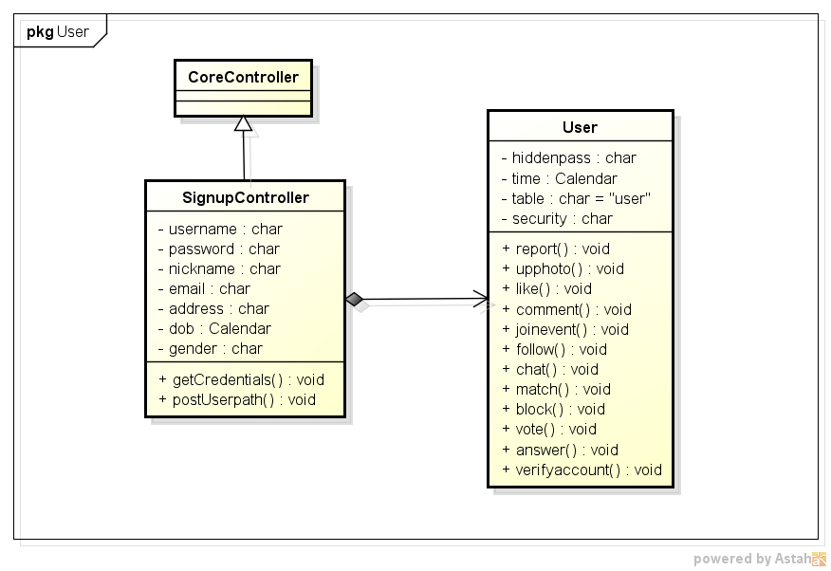**

*Figure 4.2.17.1.1.1 Register class diagram*

**Activity diagram**

**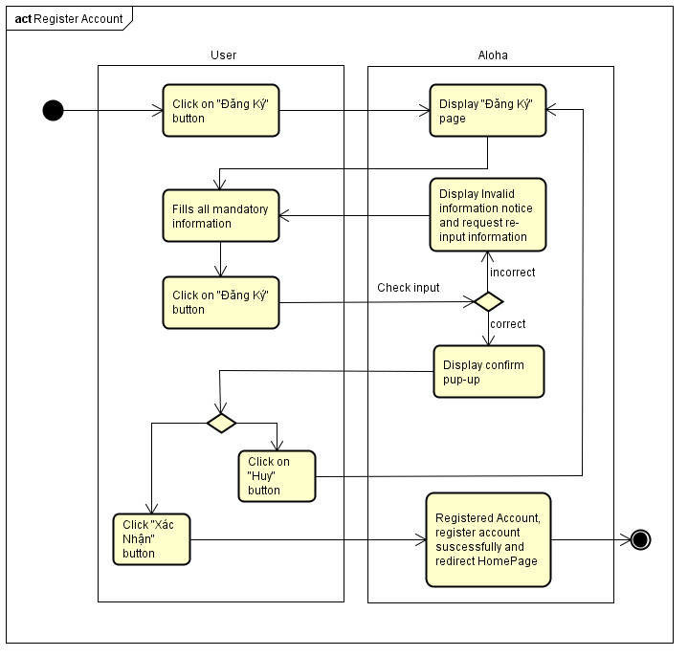**

*Figure 4.3.17.1.1.2 Register activity diagram*

**Sequence diagram**

**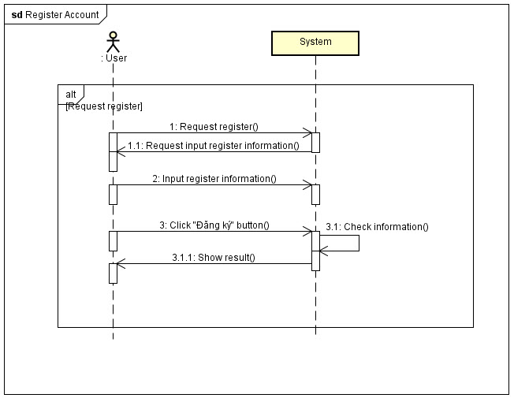**

*Figure 4.3.17.1.1.3 Register sequence diagram*

##### **4.3.17.1.2 Login**

**Description**

* Actor logins into Aloha.

**Class diagram**

**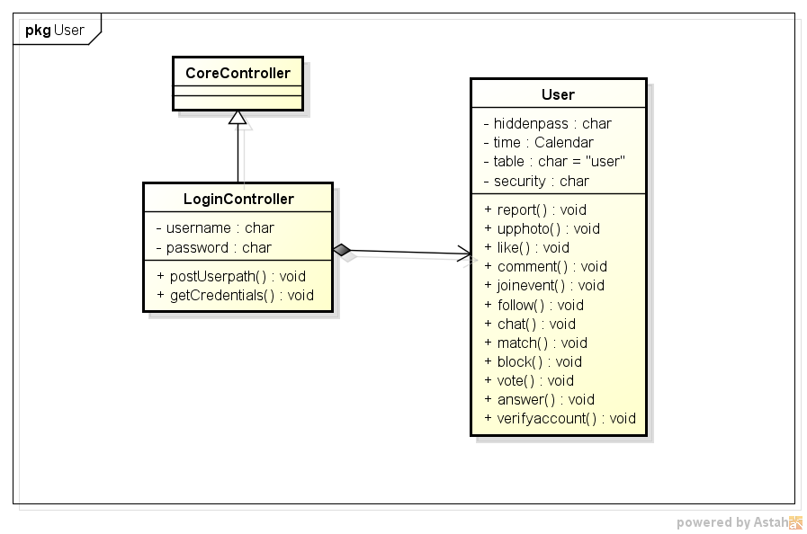**

*Figure 4.3.17.1.2.1 User login class diagram*

**Activity diagram**

**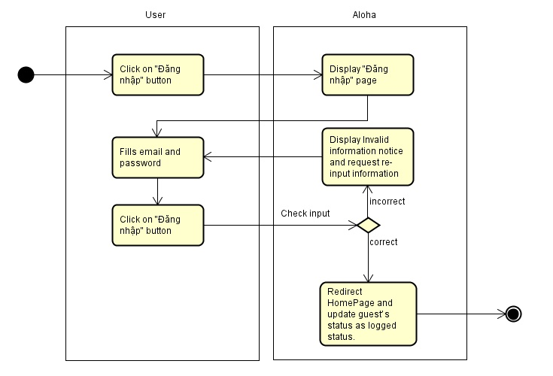**

*Figure 4.3.17.1.2.2 User login activity diagram*

**Sequence diagram**

**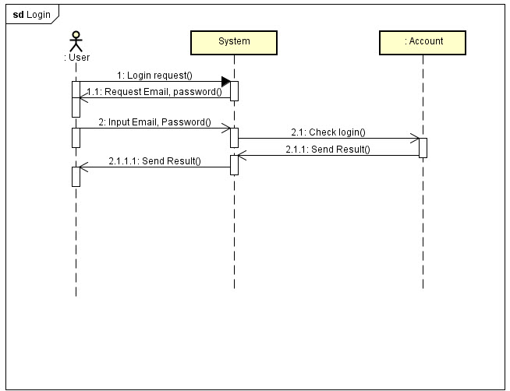**

*Figure 4.3.17.1.2.3 User login sequence diagram*

##### **4.3.17.1.3 Forgot password**

**Description**

* Actor want to find his/her password

**Class diagram**

**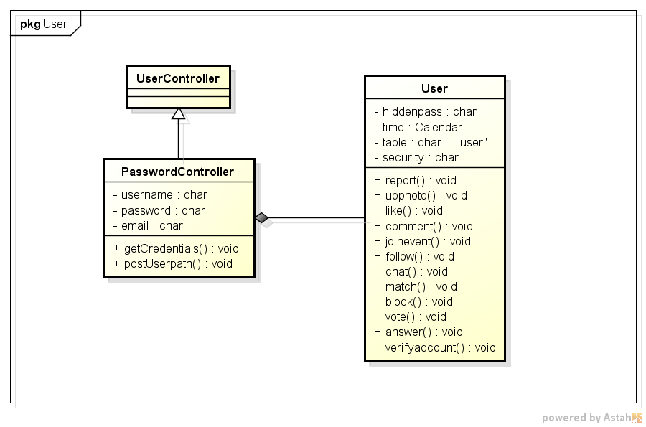**

*Figure 4.3.17.1.3.1 Forgot password class diagram*

**Activity diagram**

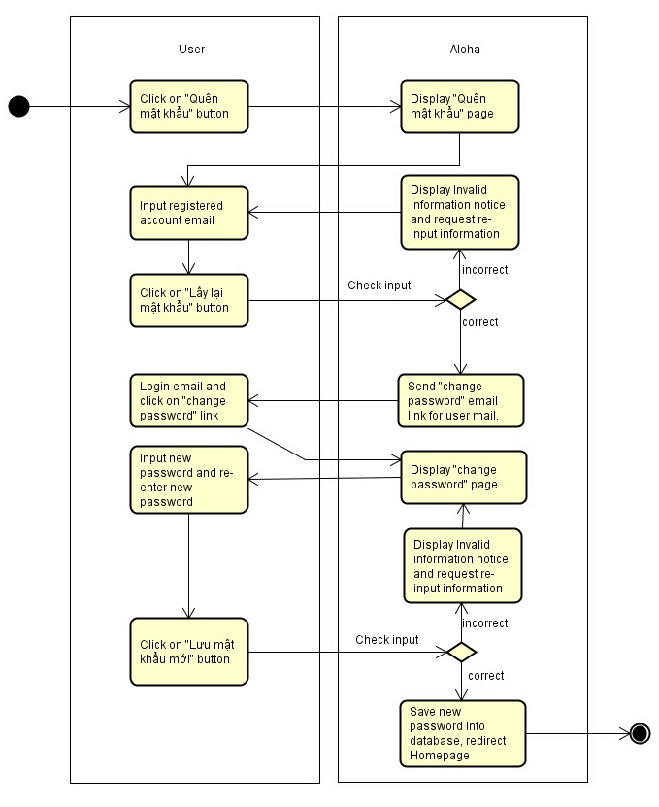

*Figure 4.3.17.1.3.2 Forgot password activity diagram*

**Sequence diagram**

**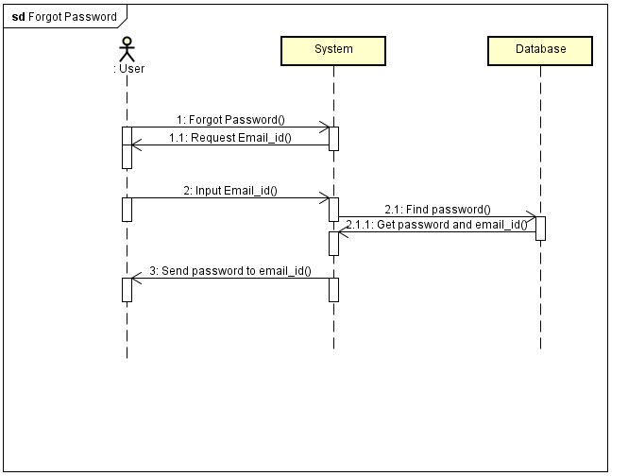**

*Figure 4.3.17.1.3.3 Forgot password sequence diagram*

#### **4.3.17.2 Registered user**

##### **4.3.17.2.1 Log out**

**Activity diagram**

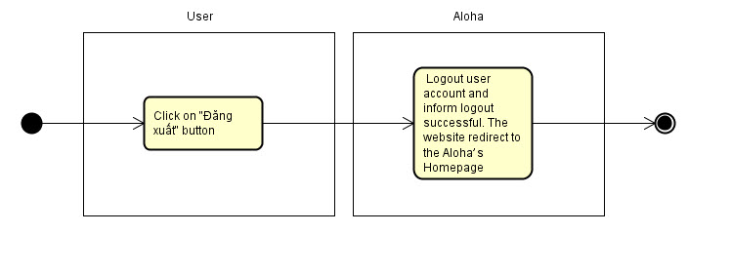

*Figure 4.3.17.2.1.1 User logout activity diagram*

**Sequence diagram**

**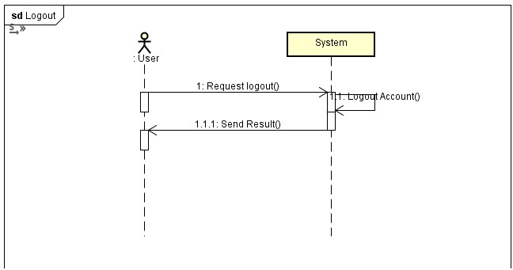**

*Figure 4.3.17.2.1.2 User logout sequence diagram*

##### **4.3.17.2.2 Request confirm account**

**Class diagram**

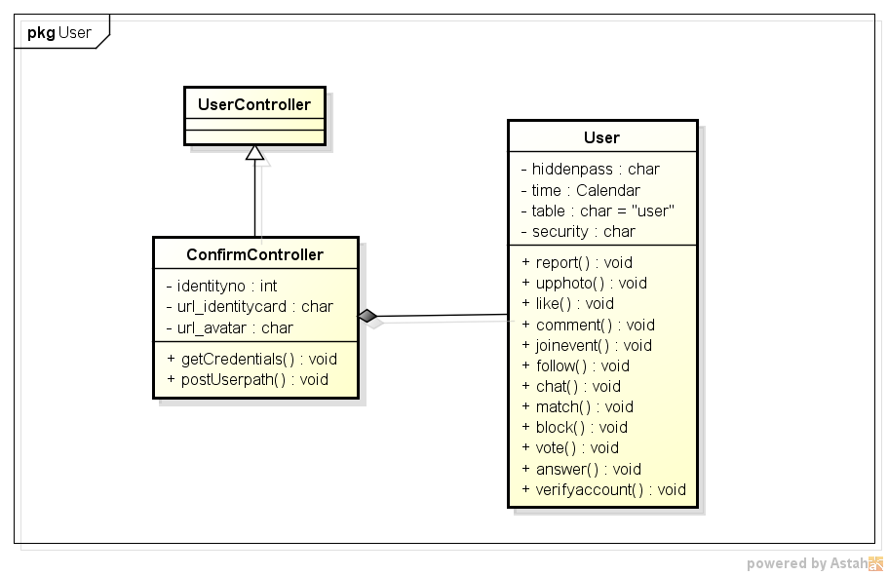

*Figure 4.3.17.2.2.1 Request confirm account class diagram*

**Activity diagram**

**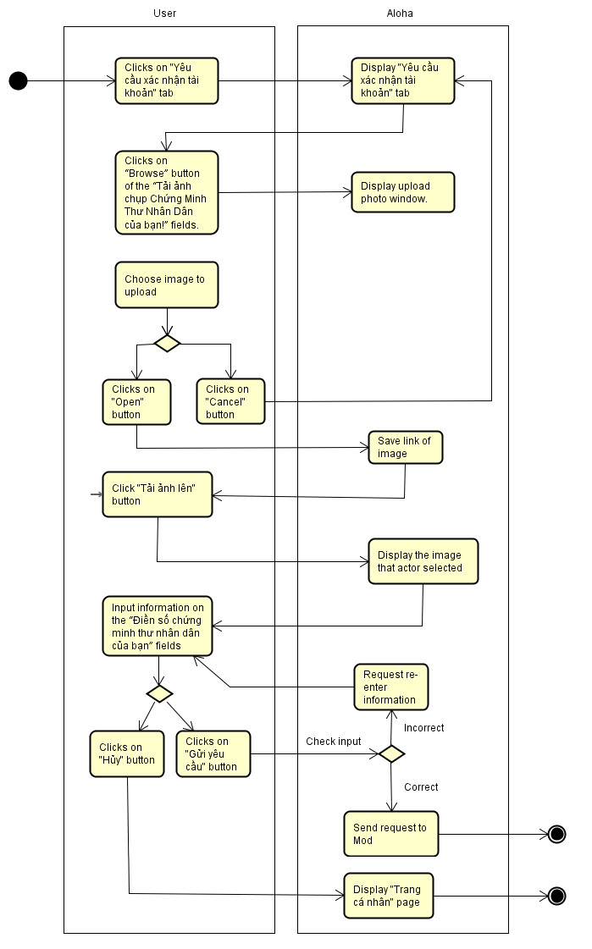**

*Figure 4.3.17.2.2.2 Request confirm account activity diagram*

**Sequence diagram**

**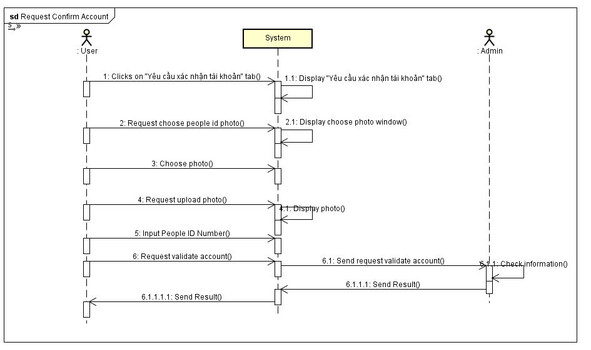**

*Figure 4.3.17.2.2.3 Request confirm account sequence diagram*

##### **4.3.17.2.3 Update personal information**

**Class diagram**

**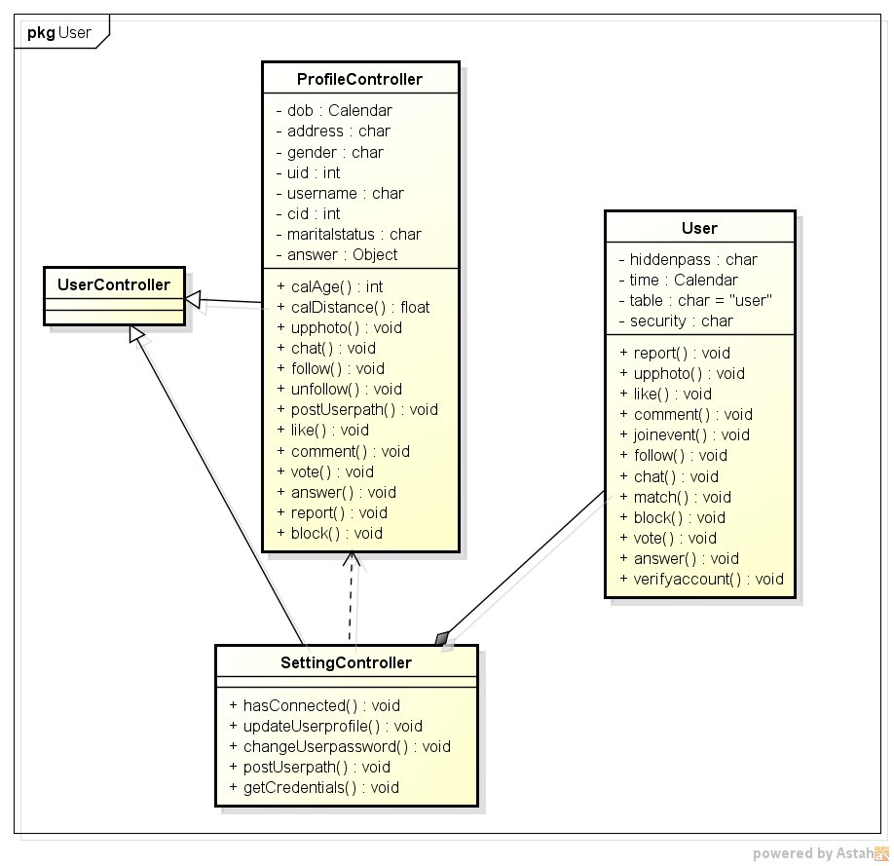**

*Figure 4.3.17.2.3.1 Update personal information class diagram*

**Activity diagram**

**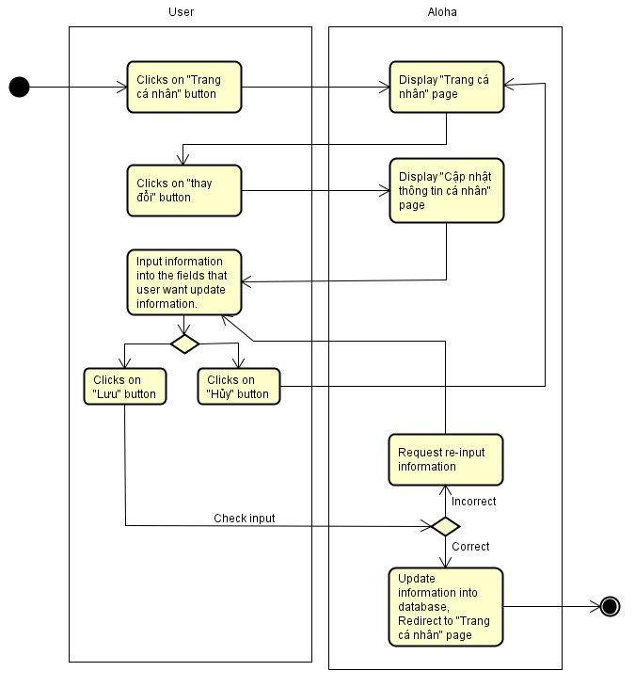**

*Figure 4.3.17.2.3.2 Update personal information activity diagram*

**Sequence diagram**

**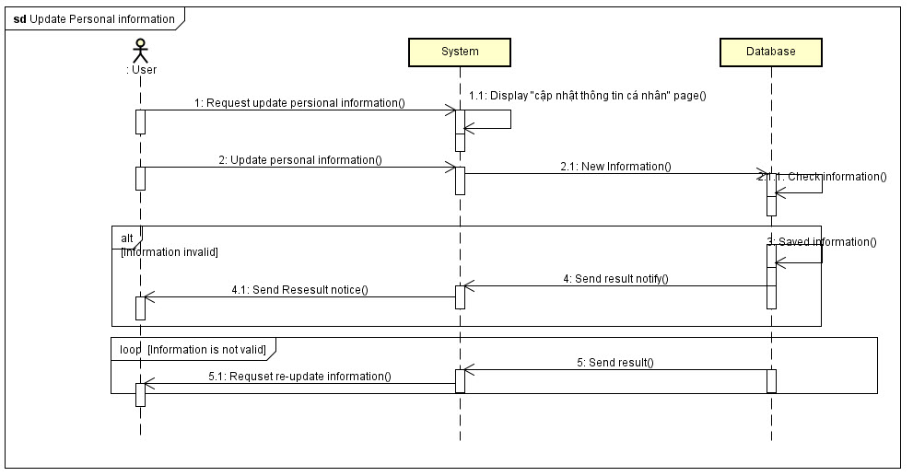**

*Figure 4.3.17.2.3.3 Update personal information sequence diagram*

##### **4.3.17.2.4 Answer**

**Class diagram**

**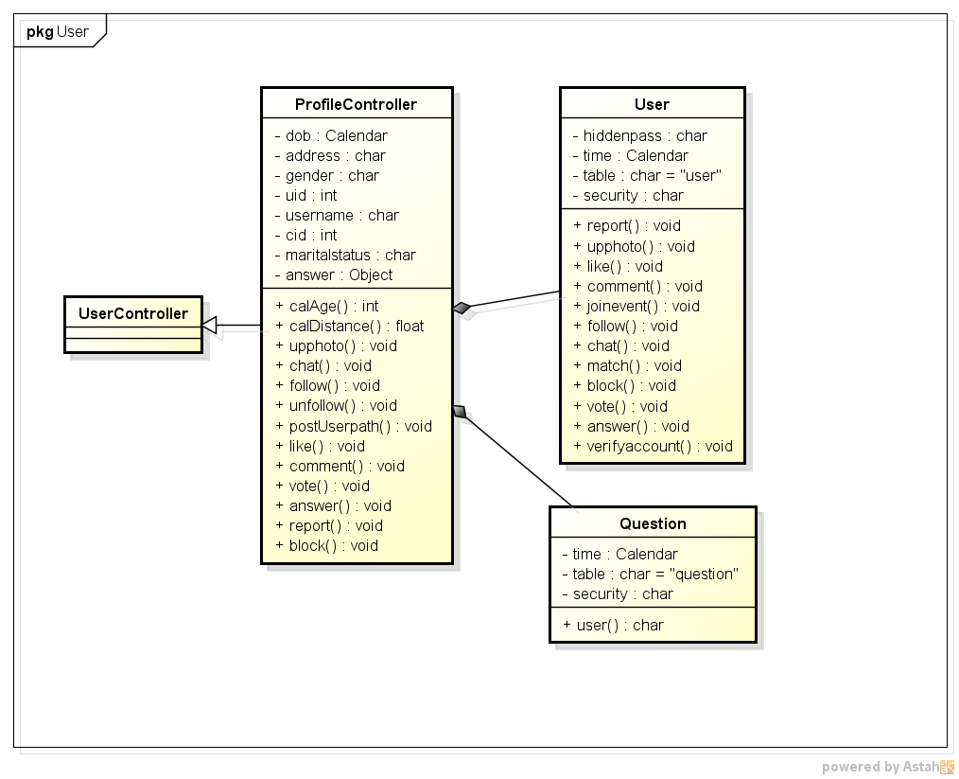**

*Figure 4.3.17.2.4.1 Answer class diagram*

**Activity diagram**

Answer question in Homepage

**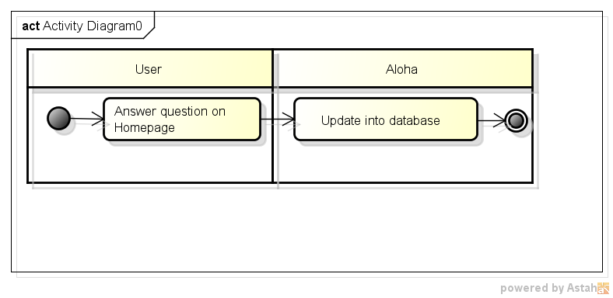**

*Figure 4.3.17.2.4.2 Answer in homepage activity diagram*

Answer question in user profile

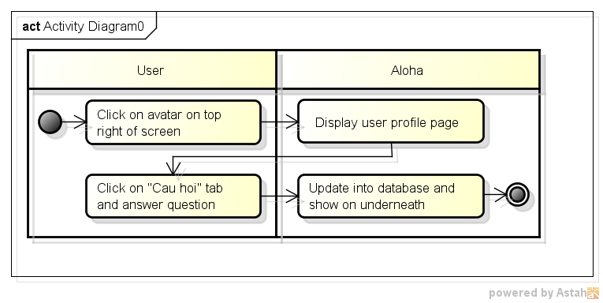

*Figure 4.3.17.2.4.3 Answer in user profile activity diagram*

**Sequence diagram**

Answer question in Homepage

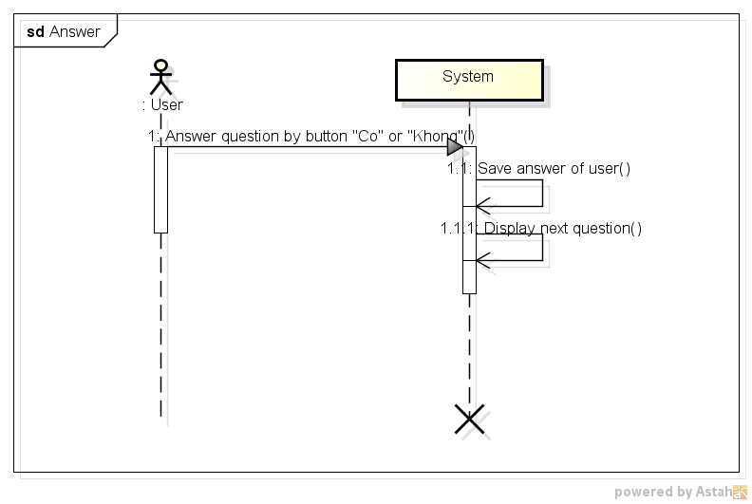

*Figure 4.3.17.2.4.4 Answer in homepage sequence diagram*

Answer question in User profile

**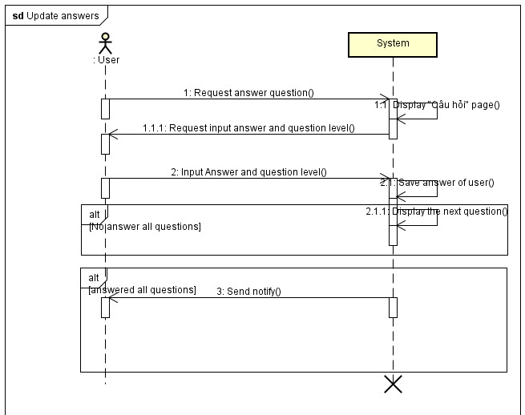**

*Figure 4.3.17.2.4.5 Answer in user profile sequence diagram*

##### **4.3.17.2.5 Update answer**

**Class diagram**

****

*Figure 4.3.17.2.5.1 Update answer class diagram*

**Activity diagram**

**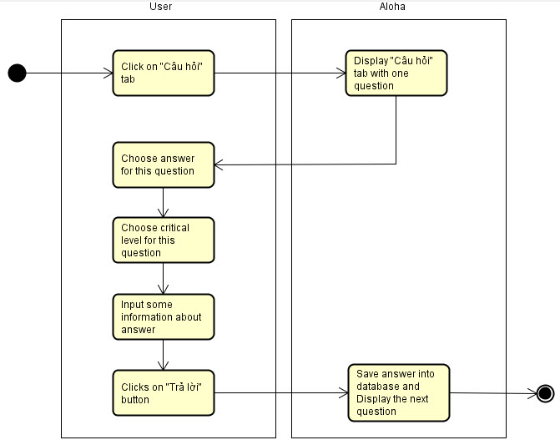**

*Figure 4.3.17.2.5.2 Update answer activity diagram*

**Sequence diagram**

****

*Figure 4.3.17.2.5.3 Update answer sequence diagram*

##### **4.3.17.2.6 Search friend**

**Class diagram**

**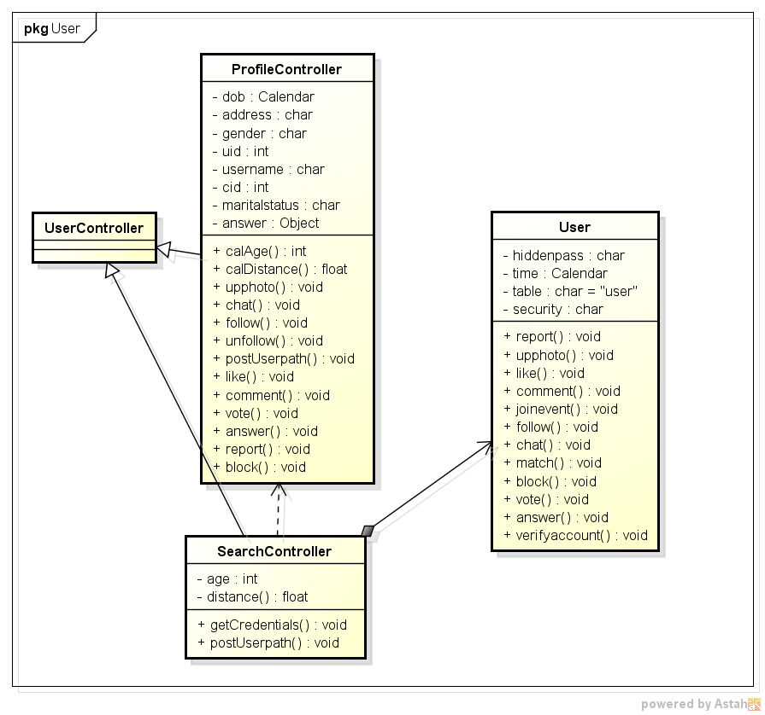**

*Figure 4.3.17.2.6.1 Search friend class diagram*

**Activity diagram**

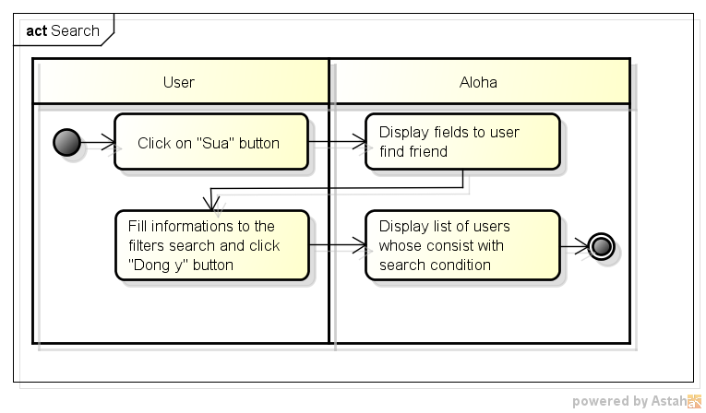

*Figure 4.3.17.2.6.2 Search friend activity diagram*

**Sequence diagram**

**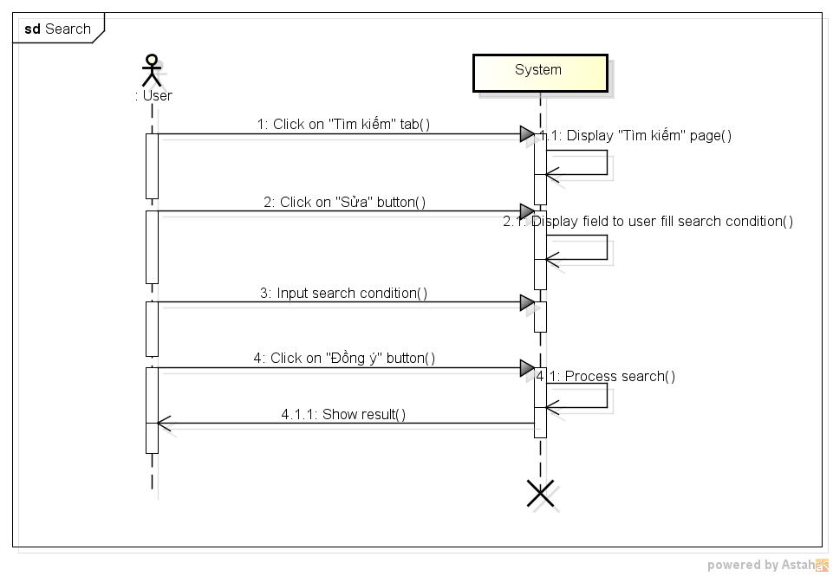**

*Figure 4.3.17.2.6.3 Search friend sequence diagram*

##### **4.3.17.2.7 View other user profile**

**Class diagram**

**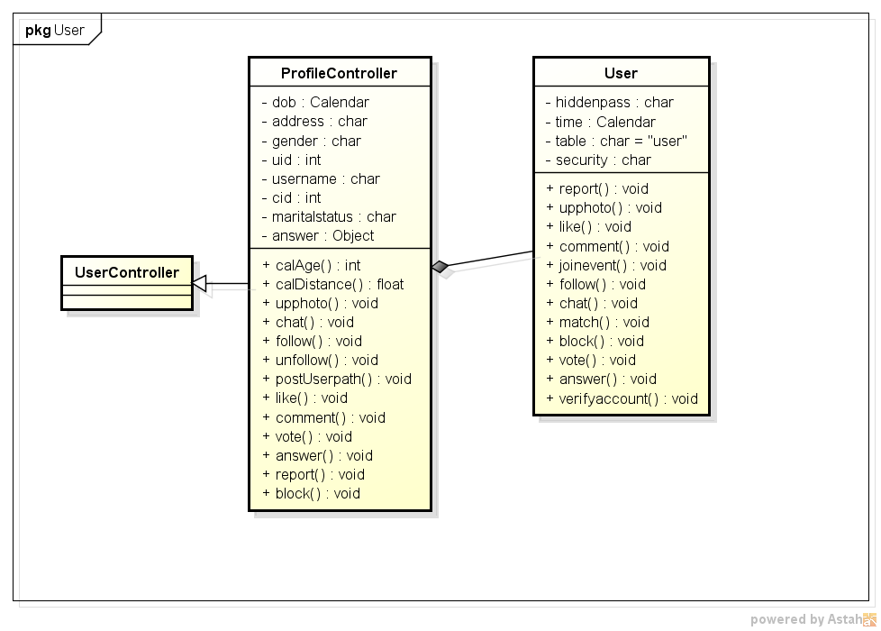**

*Figure 4.3.17.2.7.1 View other user profile class diagram*

**Activity diagram**

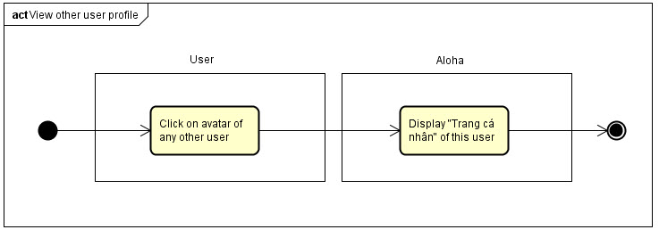

*Figure 4.3.17.2.7.2 View other user profile activity diagram*

**Sequence diagram**

**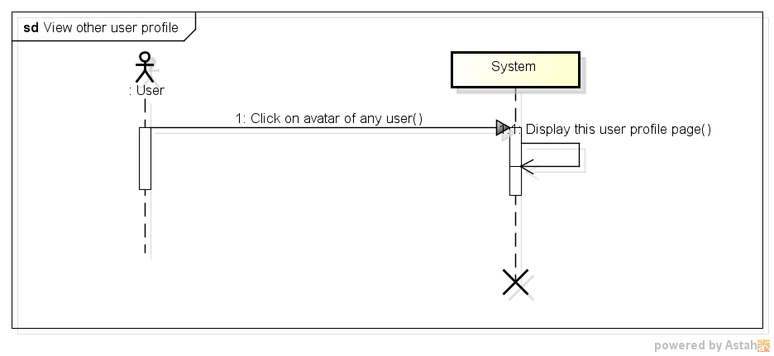**

*Figure 4.3.17.2.7.3 View other user profile sequence diagram*

##### **4.3.17.2.8 Add following**

**Class diagram**

****

*Figure 4.3.17.2.8.1 Add following class diagram*

**Activity diagram**

**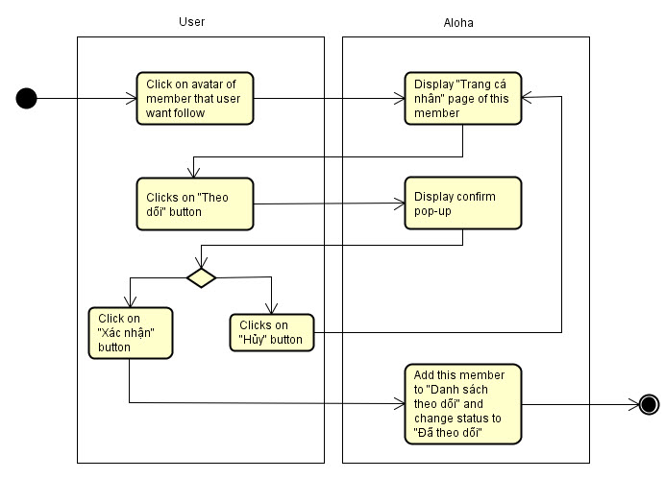**

*Figure 4.3.17.2.8.2 Add following activity diagram*

**Sequence diagram**

**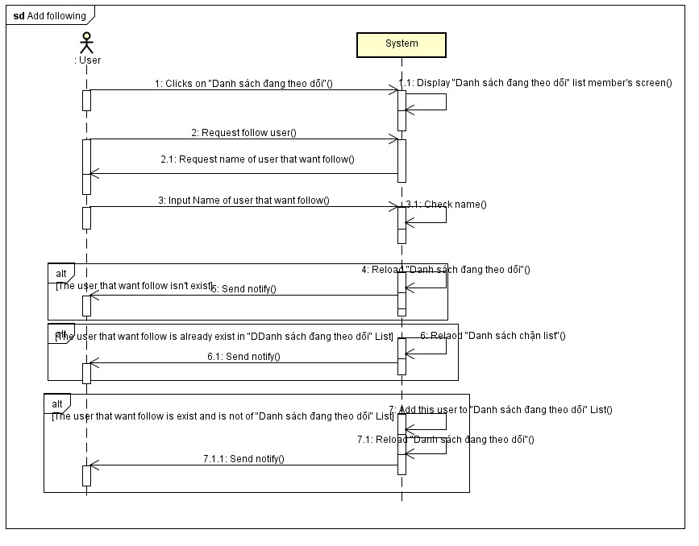**

*Figure 4.3.17.2.8.3 Add following sequence diagram*

##### **4.3.17.2.9 Remove following**

**Activity diagram**

From other user profile

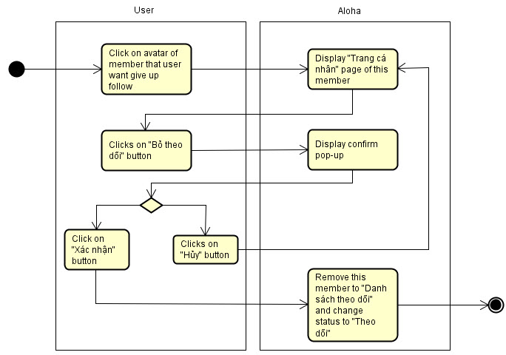

*Figure 4.3.17.2.9.1 Remove following form user page activity diagram*

From follow list

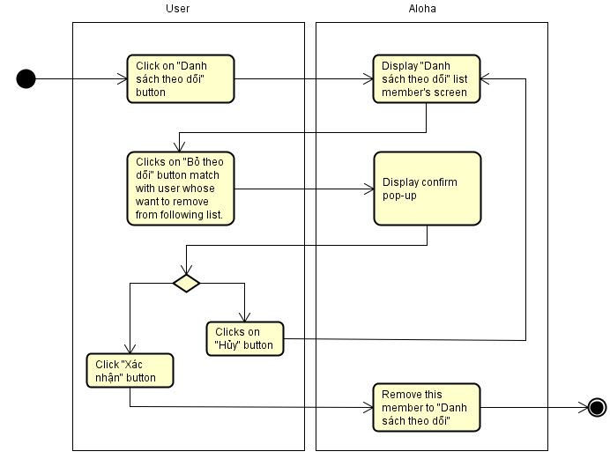

*Figure 4.3.17.2.9.2 Remove following form follow list activity diagram*

**Sequence diagram**

**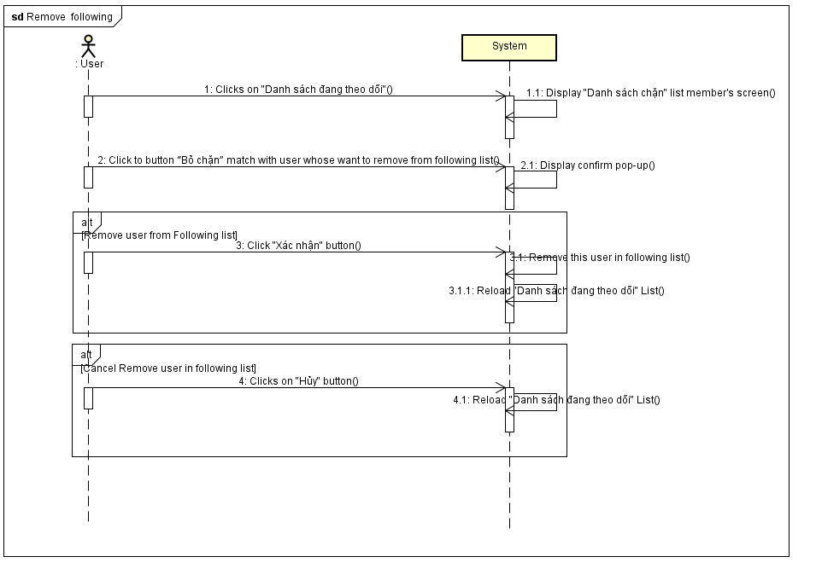**

*Figure 4.3.17.2.9.3 Remove following sequence diagram*

##### **4.3.17.2.10 Chat**

**Class diagram**

**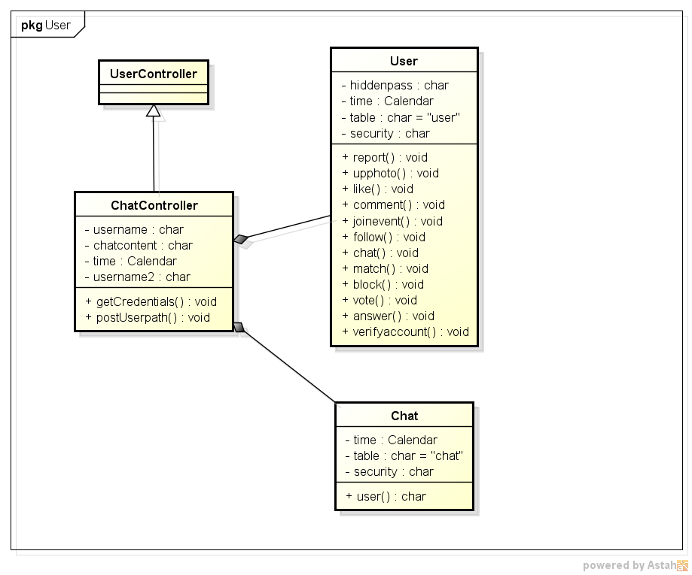**

*Figure 4.3.17.2.10.1 Registered user chat class diagram*

**Activity diagram**

**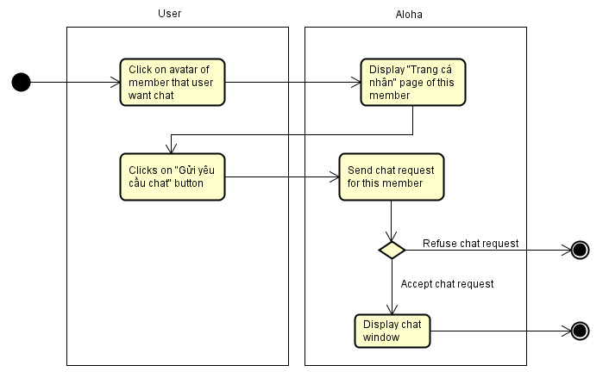**

*Figure 4.3.17.2.10.2 Registered user chat activity diagram*

**Sequence diagram**

**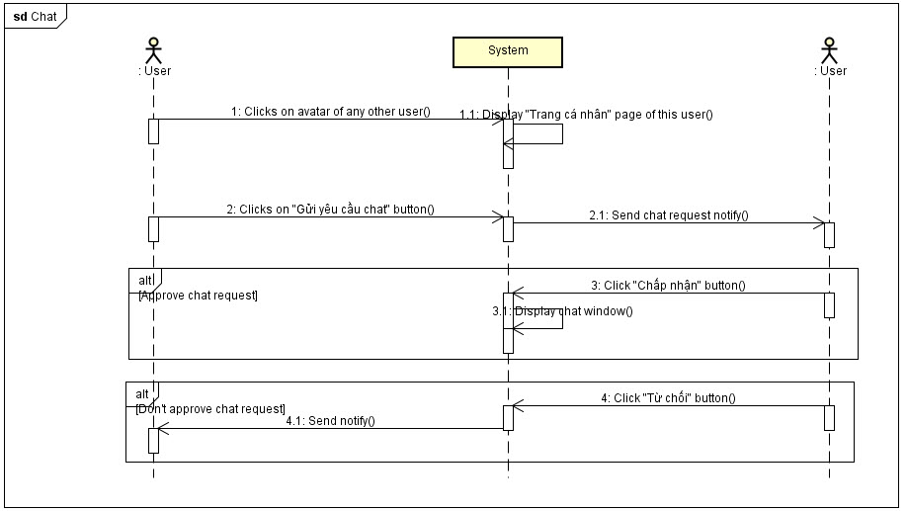**

*Figure 4.3.17.2.10.3 Registered user chat sequence diagram*

##### **4.3.17.2.11 View photo**

**Class diagram**

****

*Figure 4.3.17.2.11.1 View photo class diagram*

**Activity diagram**

View own photo

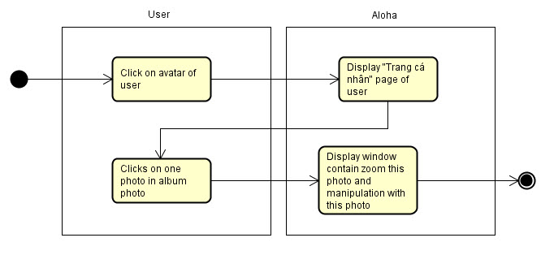

*Figure 4.3.17.2.11.2 View own photo activity diagram*

View other user’s photo

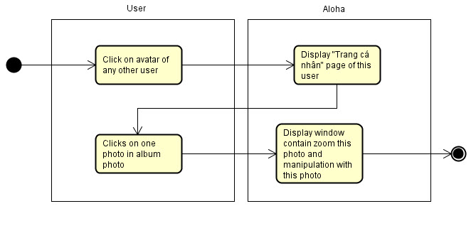

*Figure 4.3.17.2.11.3 View other user photo activity diagram*

**Sequence diagram**

View own photo

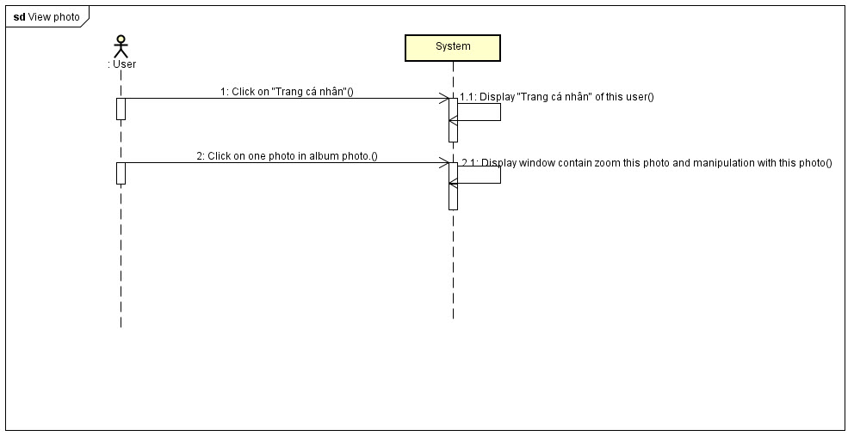

*Figure 4.3.17.2.11.4 View own photo sequence diagram*

View other user’s photo

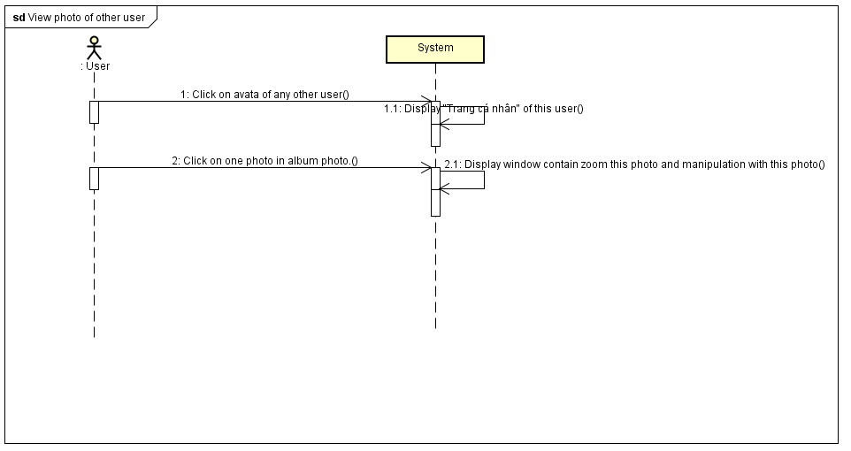

*Figure 4.3.17.2.11.5 View other user photo sequence diagram*

##### **4.3.17.2.12 Upload photo**

**Class diagram**

****

*Figure 4.3.17.2.12.1 Upload photo class diagram*

**Activity diagram**

**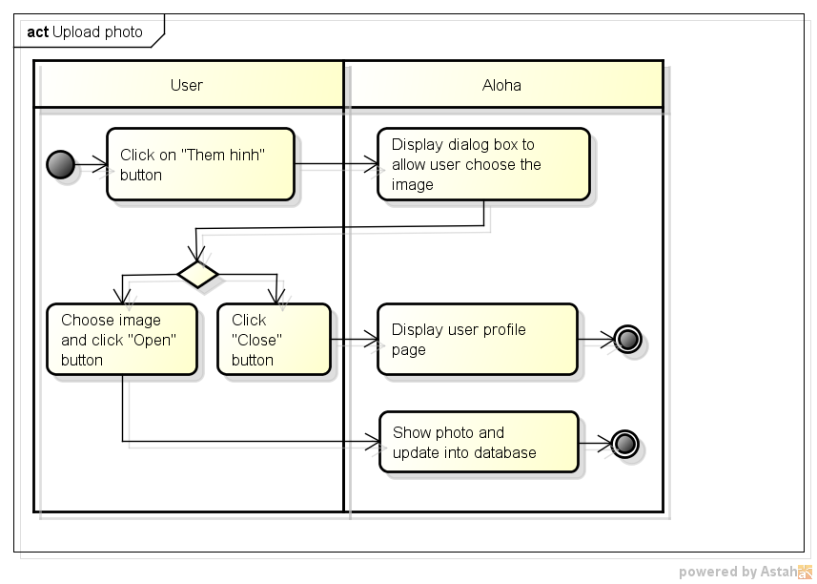**

*Figure 4.3.17.2.12.2 Upload photo activity diagram*

**Sequence diagram**

**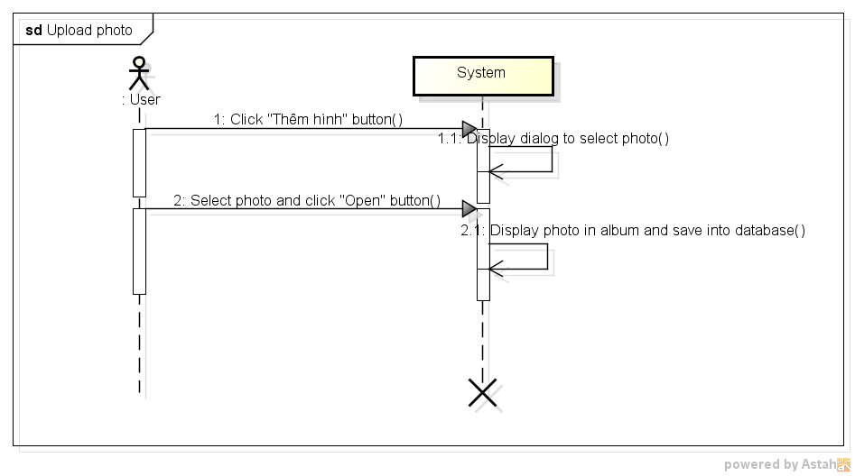**

*Figure 4.3.17.2.12.3 Upload photo sequence diagram*

##### **4.3.17.2.13 Delete photo**

**Activity diagram**

**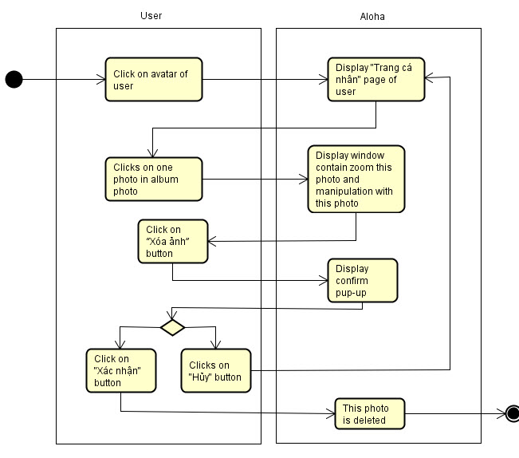**

*Figure 4.3.17.2.13.1 Delete photo activity diagram*

**Sequence diagram**

**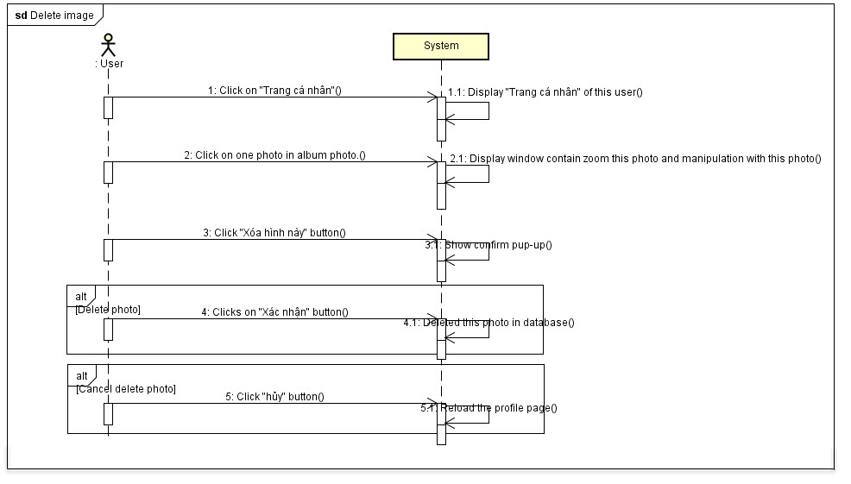**

*Figure 4.3.17.2.13.2 Delete photo sequence diagram*

##### **4.3.17.2.14 Like photo**

**Class diagram**

**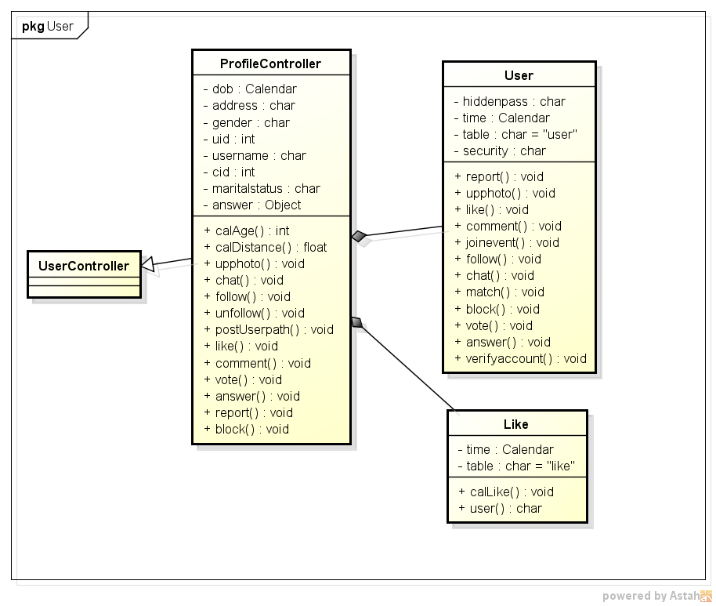**

*Figure 4.3.17.2.14.1 Like photo class diagram*

**Activity diagram**

**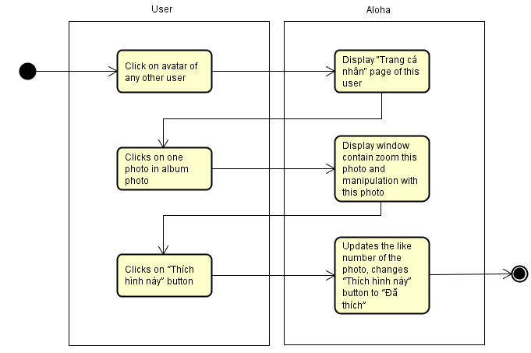**

*Figure 4.3.17.2.14.2 Like photo activity diagram*

**Sequence diagram**

**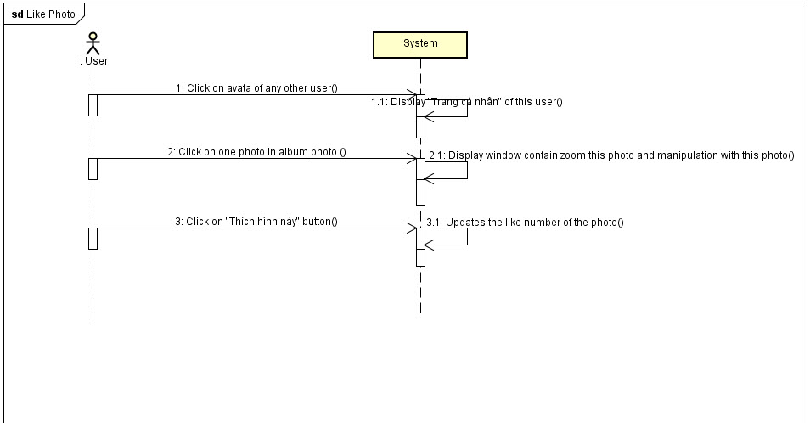**

*Figure 4.3.17.2.14.3 Like photo sequence diagram*

##### **4.3.17.2.15 Comment photo**

**Class diagram**

**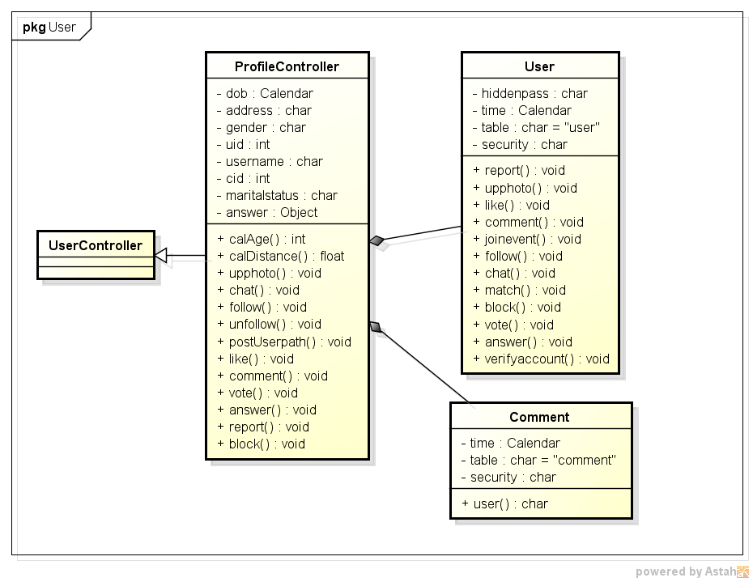**

*Figure 4.3.17.2.15.1 Comment photo class diagram*

**Activity diagram**

**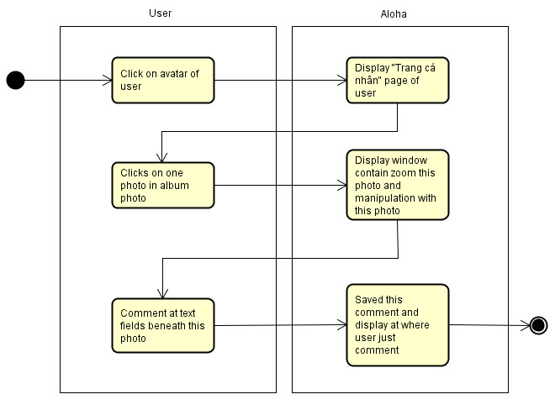**

*Figure 4.3.17.2.15.2 Comment photo activity diagram*

**Sequence diagram**

**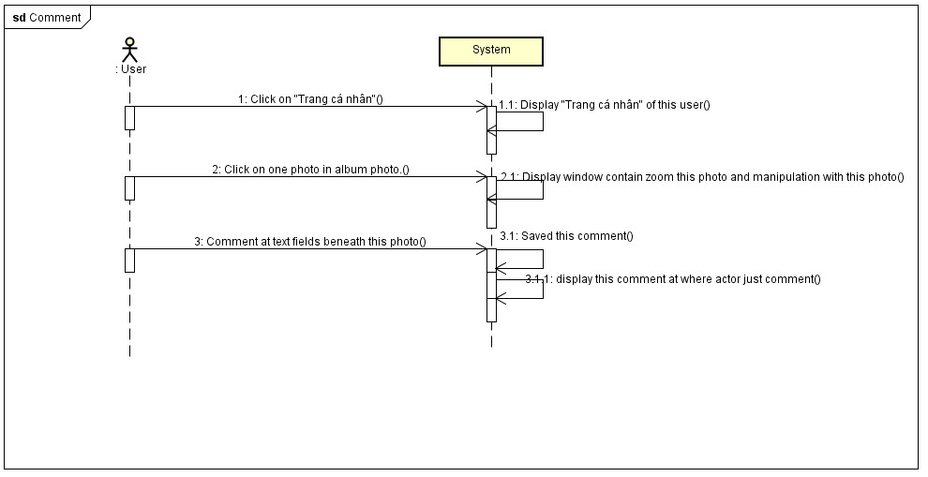**

*Figure 4.3.17.2.15.3 Comment photo sequence diagram*

##### **4.3.17.2.16 Delete comment**

**Activity diagram**

**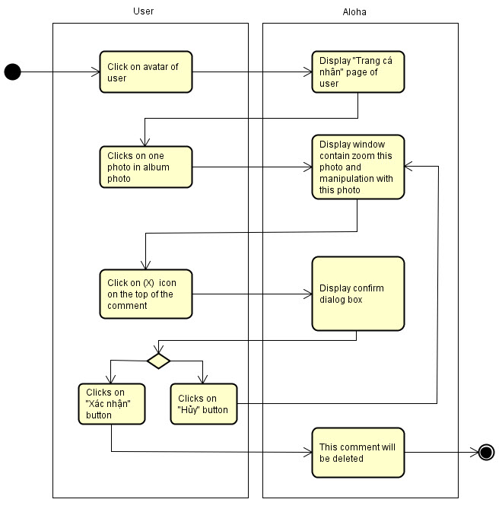**

*Figure 4.3.17.2.16.1 Delete comment activity diagram*

**Sequence diagram**

**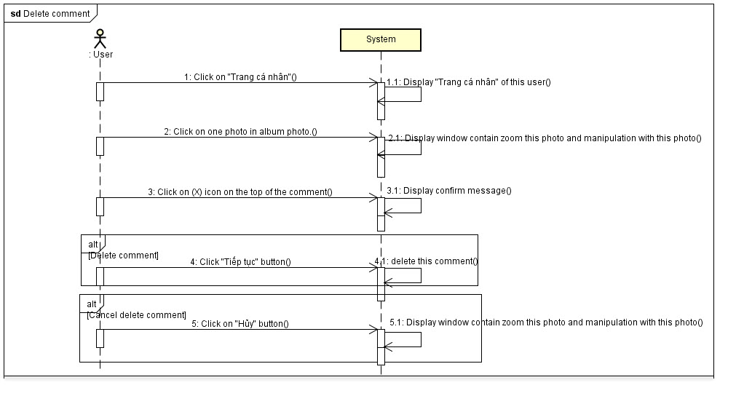**

*Figure 4.3.17.2.16.2 Delete comment sequence diagram*

#### **4.3.17.3 Member**

##### **4.3.17.3.1 Add reputation**

**Class diagram**

****

*Figure 4.3.17.3.1.1 Add reputation class diagram*

**Activity diagram**

**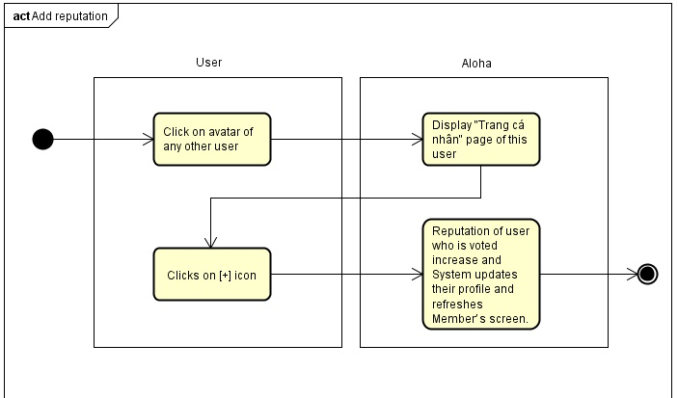**

*Figure 4.3.17.3.1.1 Add reputation activity diagram*

**Sequence diagram**

**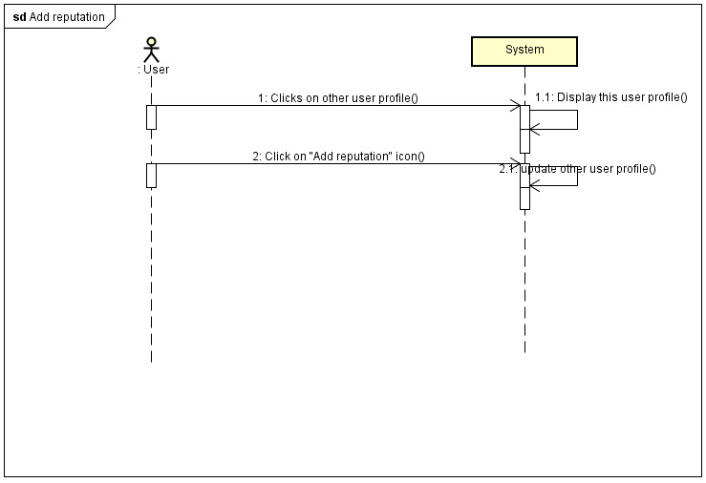**

*Figure 4.3.17.3.1.1 Add reputation sequence diagram*

##### **4.3.17.3.2 Minus reputation**

**Class diagram**

****

*Figure 4.3.17.3.2.1 Minus reputation class diagram*

**Activity diagram**

**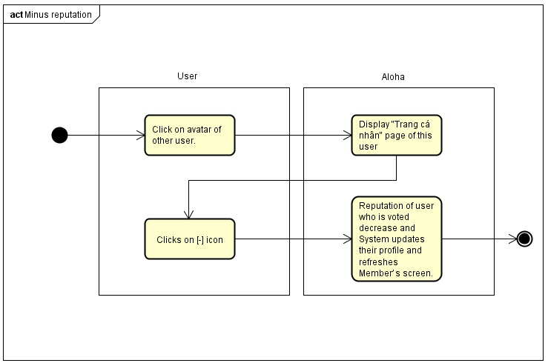**

*Figure 4.3.17.3.2.2 Minus reputation activity diagram*

**Sequence diagram**

**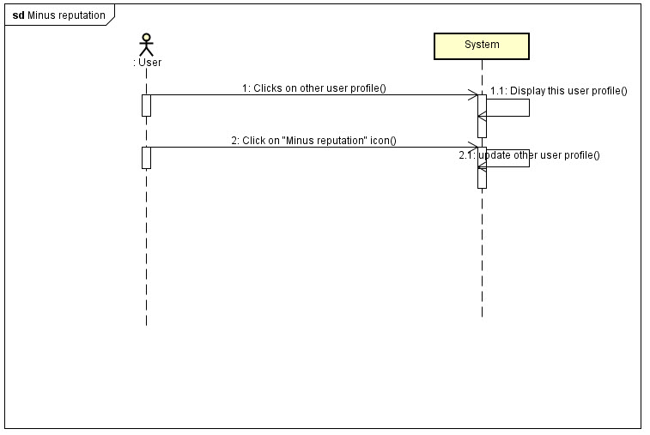**

*Figure 4.3.17.3.2.3 Minus reputation sequence diagram*

##### **4.3.17.3.3 Report user**

**Class diagram**

****

*Figure 4.3.17.3.3.1 Report user class diagram*

**Activity diagram**

**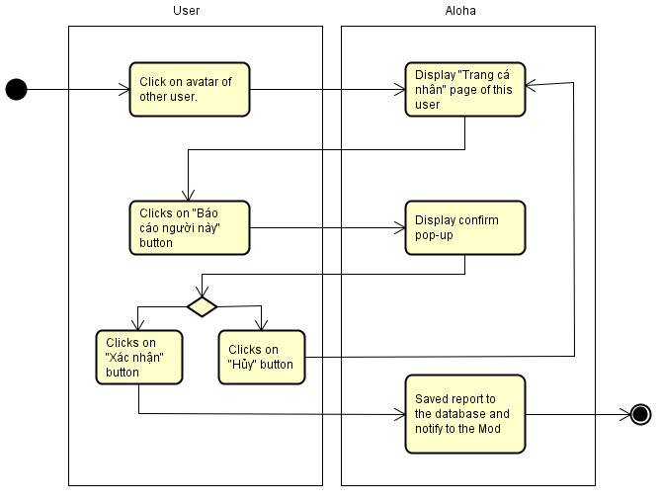**

*Figure 4.3.17.3.3.2 Report user activity diagram*

**Sequence diagram**

**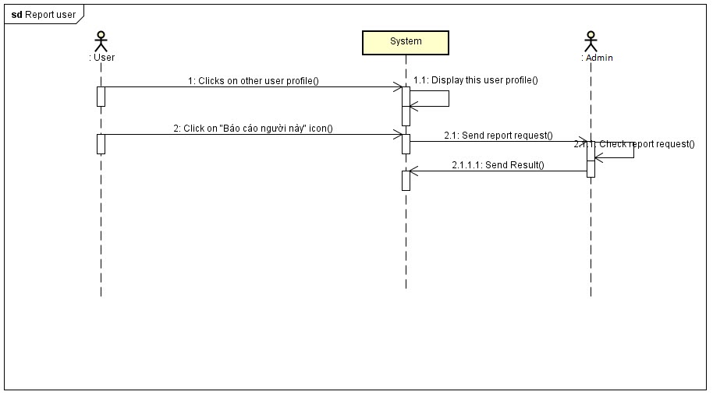**

*Figure 4.3.17.3.3.3 Report user sequence diagram*

##### **4.3.17.3.4 Add user to block list**

**Class diagram**

**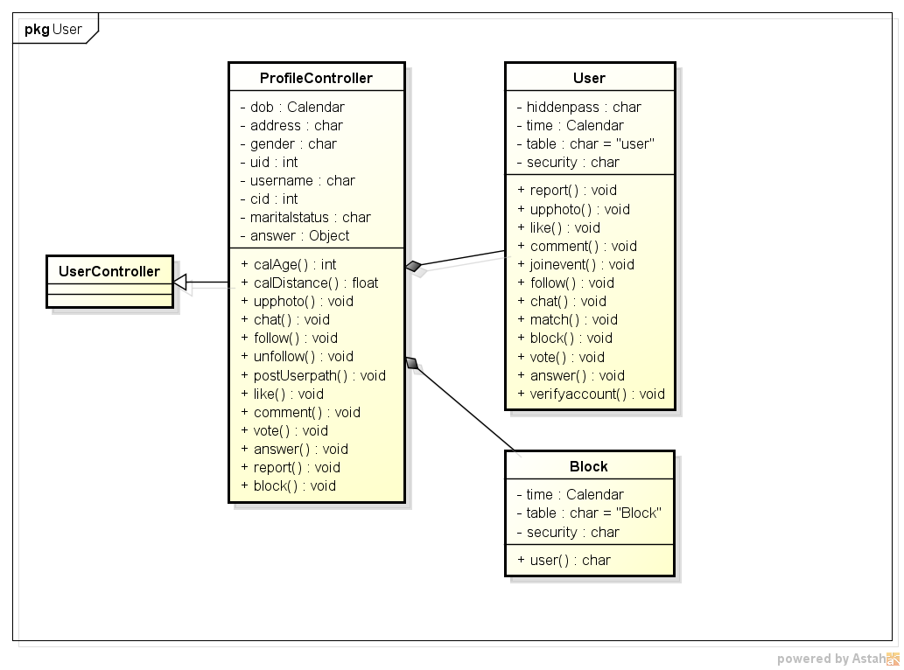**

*Figure 4.3.17.3.4.1 Add user to block list class diagram*

**Activity diagram**

**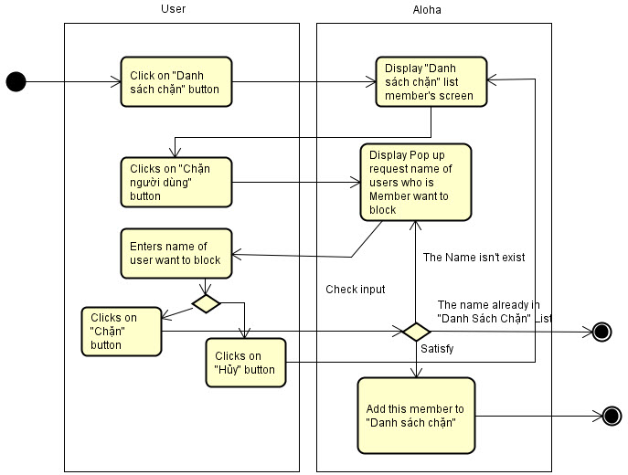**

*Figure 4.3.17.3.4.2 Add user to block list activity diagram*

**Sequence diagram**

**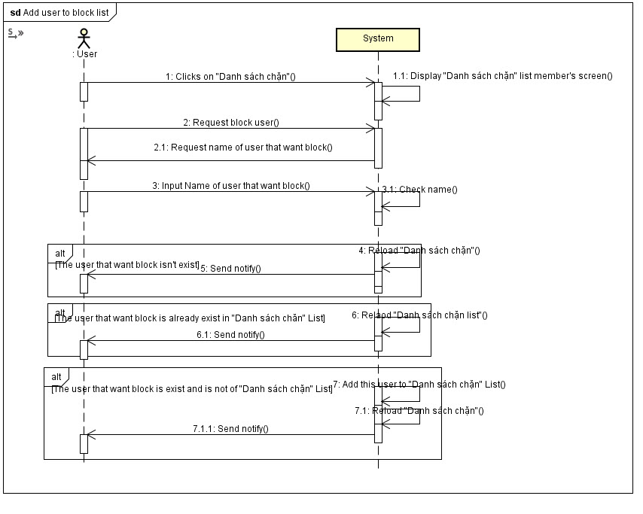**

*Figure 4.3.17.3.4.3 Add user to block list sequence diagram*

##### **4.3.17.3.5 Chat**

**Class diagram**

**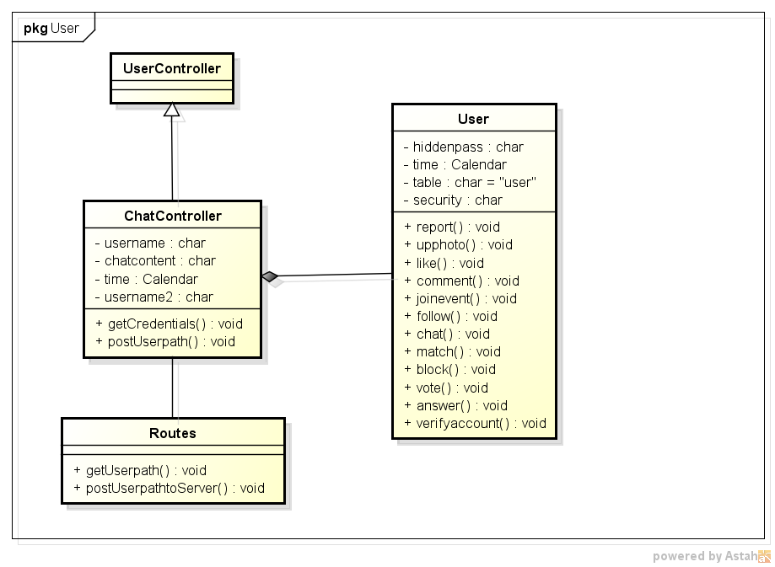**

*Figure 4.3.17.3.5.1 Member chat class diagram*

**Activity diagram**

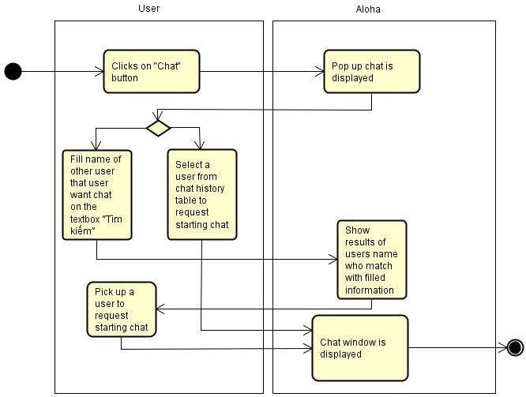

*Figure 4.3.17.3.5.2 Member chat activity diagram*

**Sequence diagram**

**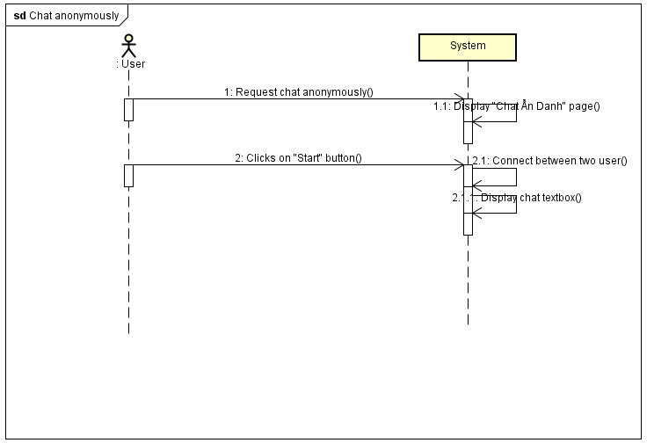**

*Figure 4.3.17.3.5.3 Member chat sequence diagram*

##### **4.3.17.3.6 Join event**

**Class diagram**

**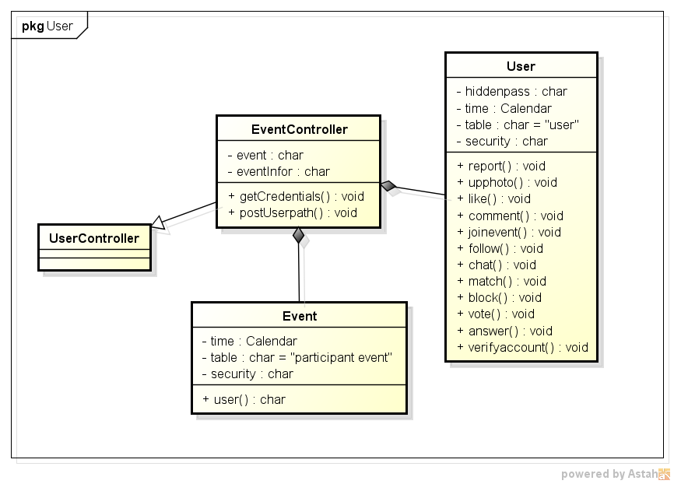**

*Figure 4.3.17.3.6.1 Join event class diagram*

**Activity diagram**

**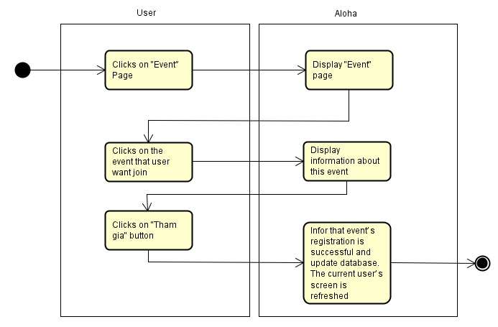**

*Figure 4.3.17.3.6.2 Join event activity diagram*

**Sequence diagram**

**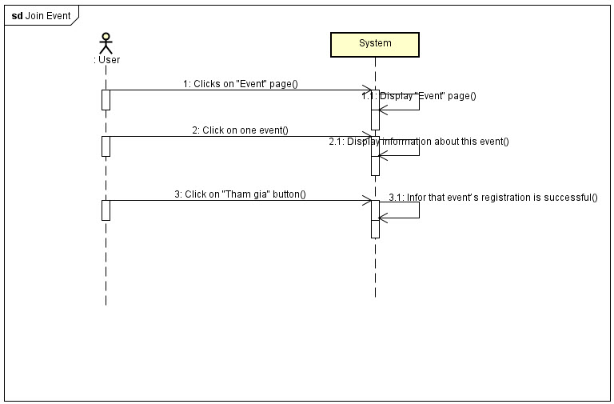**

*Figure 4.3.17.3.6.3 Join event sequence diagram*

##### **4.3.17.3.7 View follower**

**Activity diagram**

**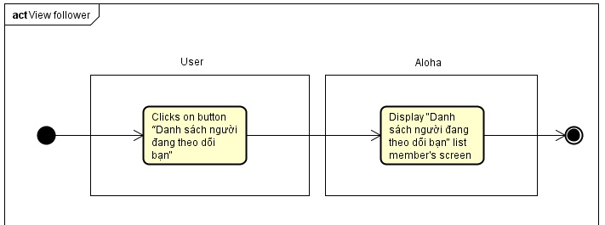**

*Figure 4.3.17.3.7.1 View follower activity diagram*

**Sequence diagram**

**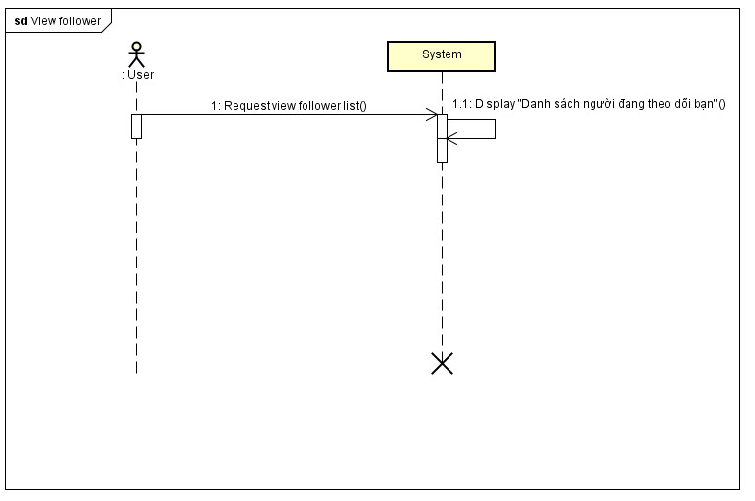**

*Figure 4.3.17.3.7.2 View follower sequence diagam*

#### **4.3.17.4 Advanced member**

##### **4.3.17.4.1 Request add new question**

**Class diagram**

**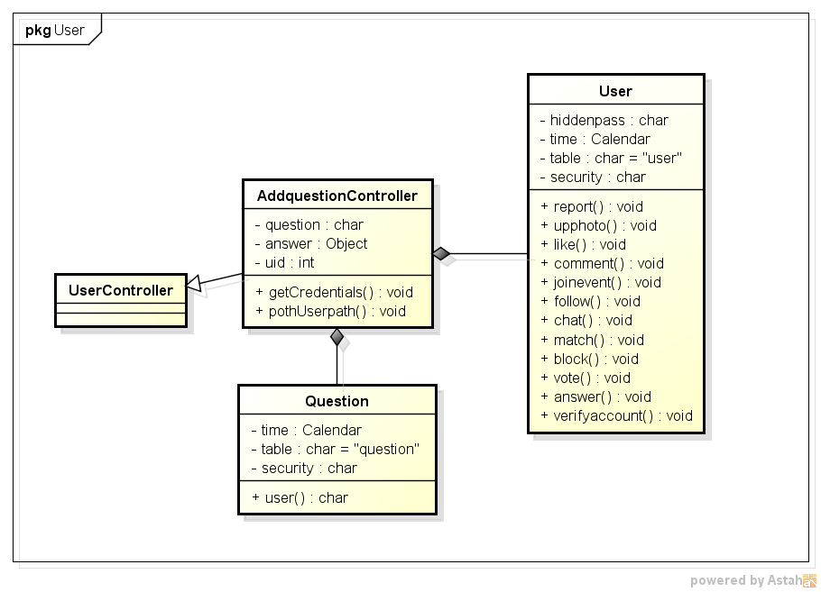**

*Figure 4.3.17.4.1.1 Request add new question class diagram*

**Activity diagram**

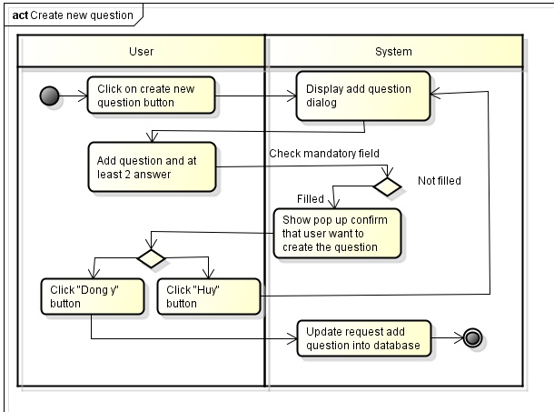

*Figure 4.3.17.4.1.2 Request add new question activity diagram*

**Sequence diagram**

**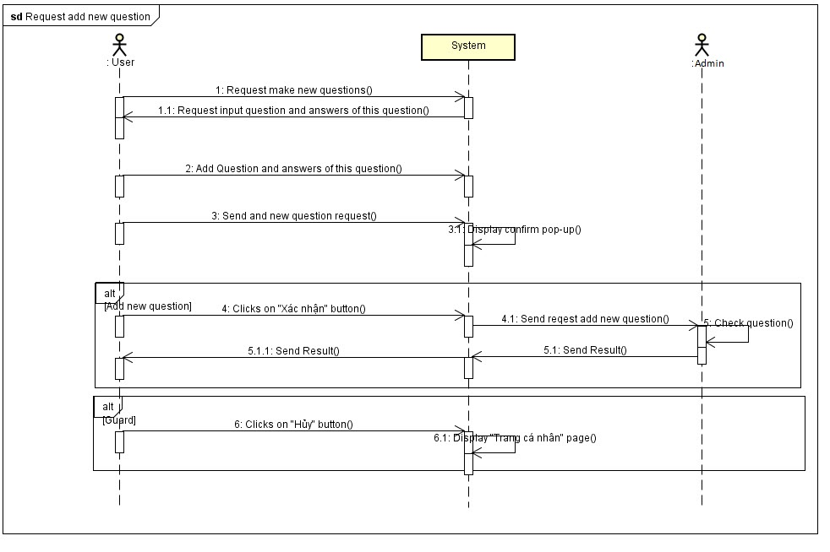**

*Figure 4.3.17.4.1.3 Request add new question sequence diagram*

##### **4.3.17.4.2 Match suitable people**

**Class diagram**

**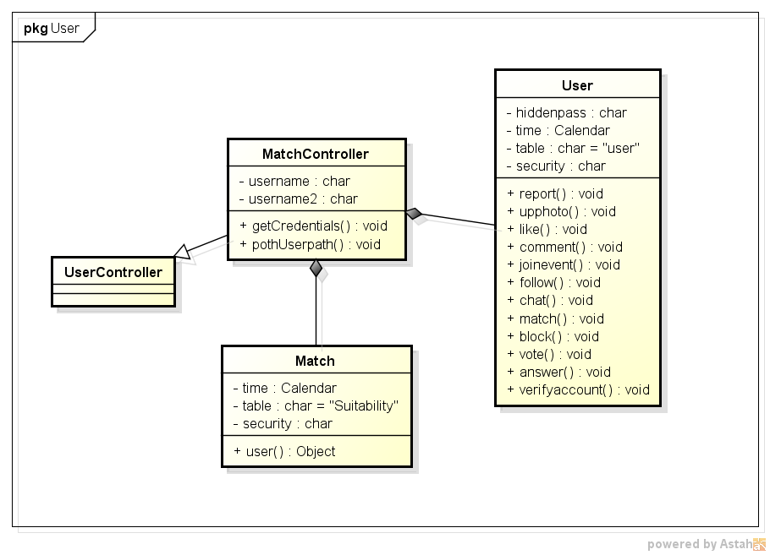**

*Figure 4.3.17.4.2.1 Match suitable people class diagram*

**Activity diagram**

**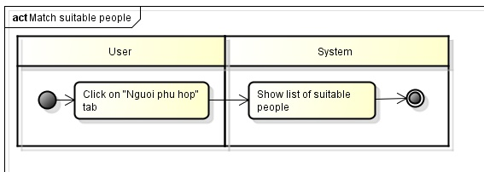**

*Figure 4.3.17.4.2.2 Match suitable people activity diagram*

**Sequence diagram**

**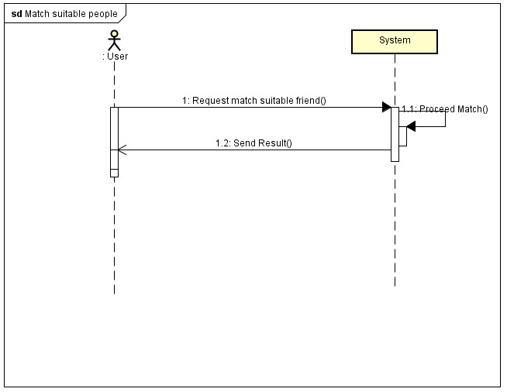**

*Figure 4.3.17.4.2.3 Match suitable people sequence diagram*

#### **4.3.17.5 Admin**

##### **4.3.17.5.1 Login**

**Class diagram**

**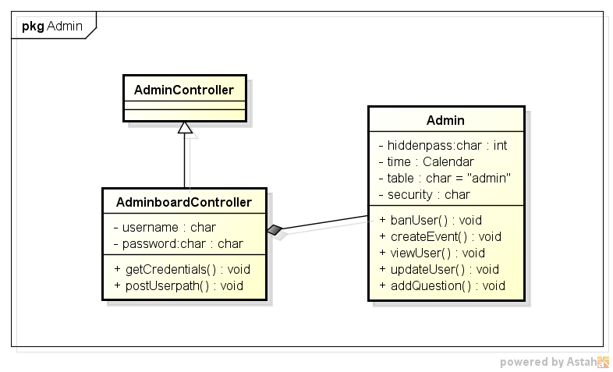**

*Figure 4.3.17.5.1.1 Admin login class diagram*

**Activity diagram**

**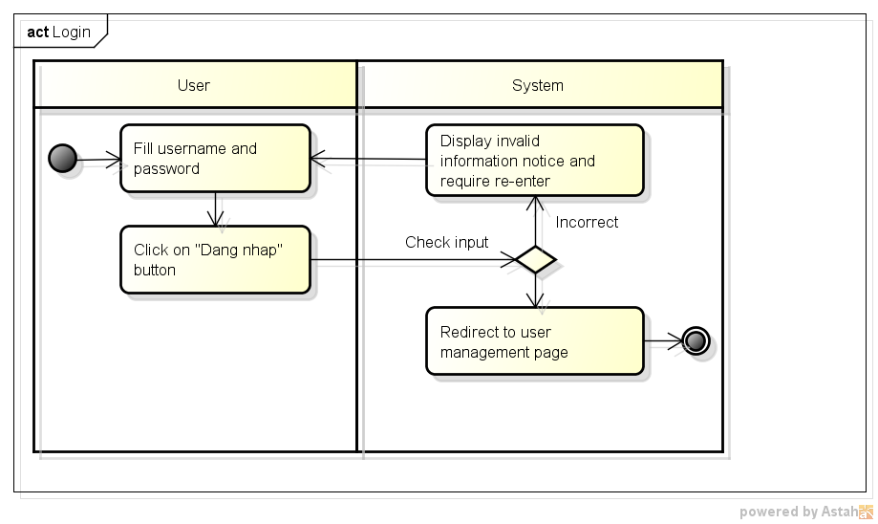**

*Figure 4.3.17.5.1.2 Admin login activity diagram*

**Sequence diagram**

**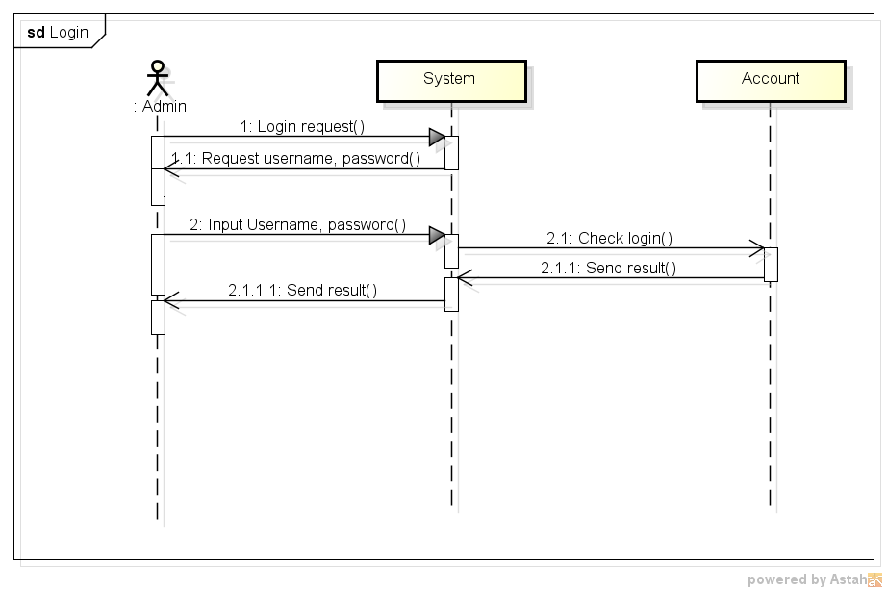**

*Figure 4.3.17.5.1.3 Admin login sequence diagram*

##### **4.3.17.5.2 Create new event**

**Class diagram**

**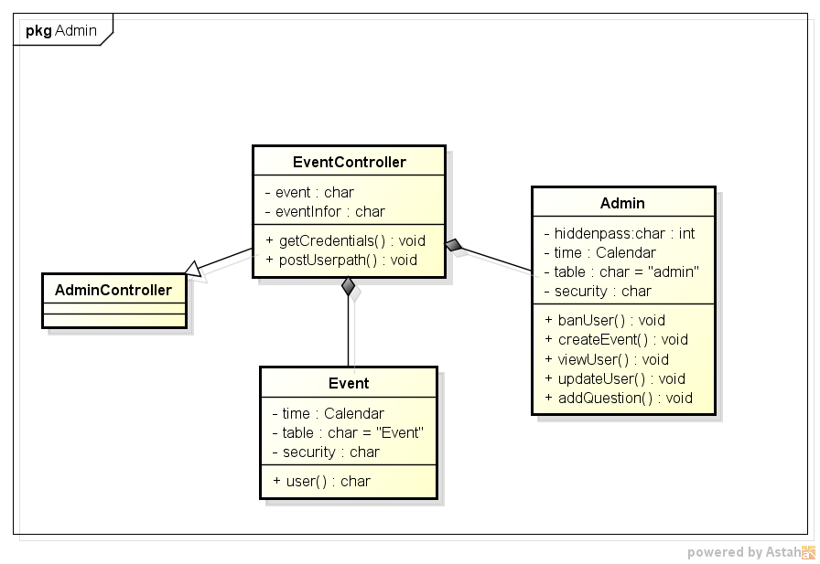**

*Figure 4.3.17.5.2.1 Create new event class diagram*

**Activity diagram**

**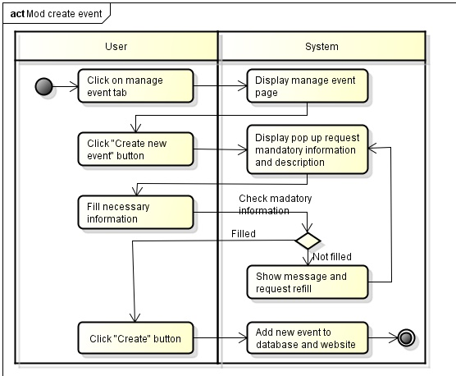**

*Figure 4.3.17.5.2.2 Create new event activity diagram*

**Sequence diagram**

**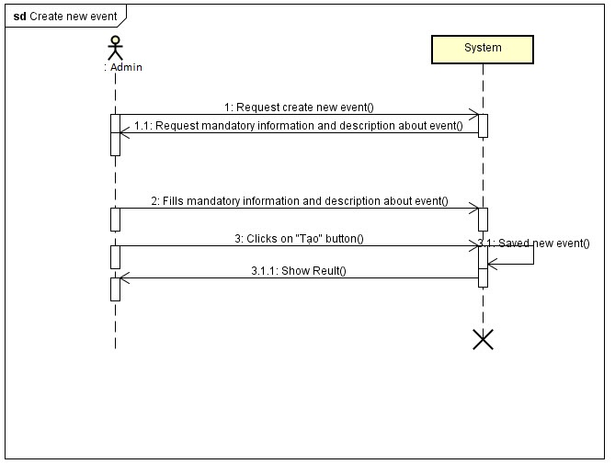**

*Figure 4.3.17.5.2.3 Create new event sequence diagram*

##### **4.3.17.5.3 View event detail**

**Class diagram**

****

*Figure 4.3.17.5.3.1 View event detail class diagram*

**Activity diagram**

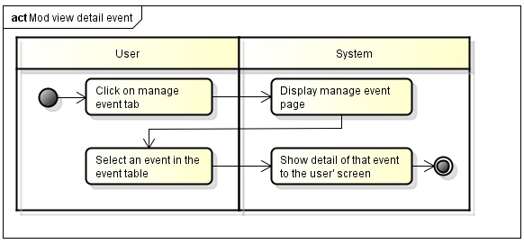

*Figure 4.3.17.5.3.2 View event detail activity diagram*

**Sequence diagram**

**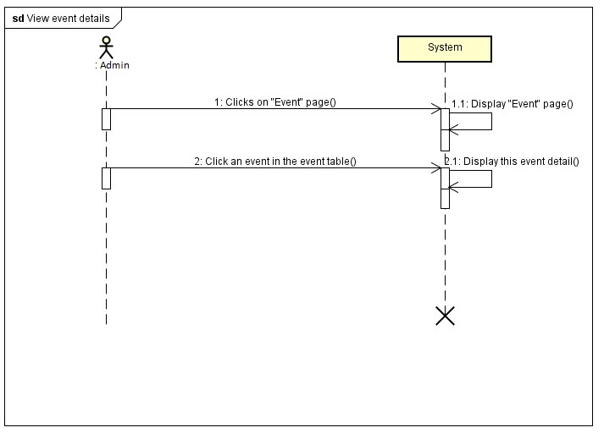**

*Figure 4.3.17.5.3.3 View event detail sequence diagram*

##### **4.3.17.5.4 Verify user**

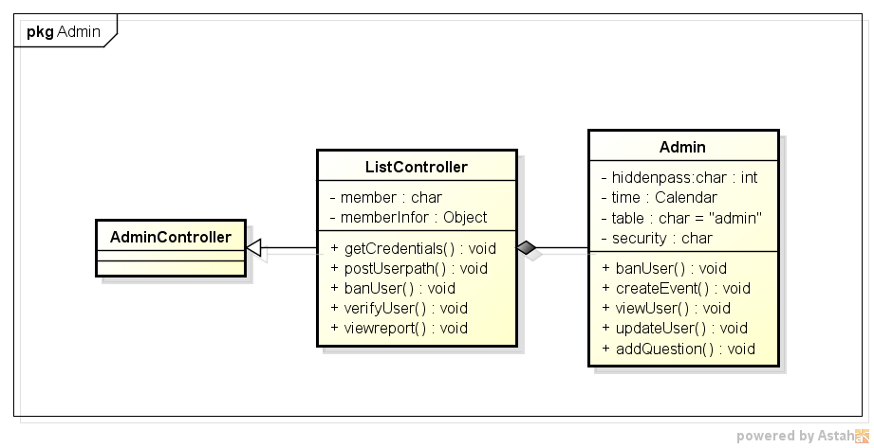

*Figure 4.3.17.5.4.1 Verify user class diagram*

**Activity diagram**

**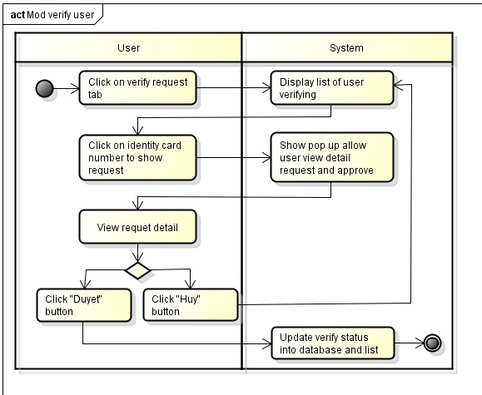**

*Figure 4.3.17.5.4.2 Verify user activity diagram*

**Sequence diagram**

**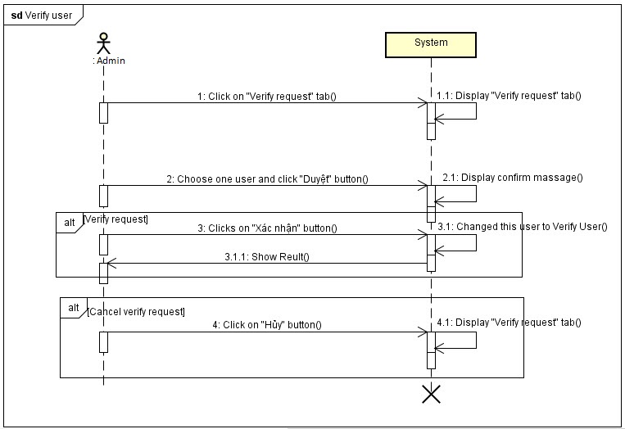**

*Figure 4.3.17.5.4.3 Verify user sequence diagram*

##### **4.3.17.5.5 Ban user**

**Class diagram**



*Figure 4.3.17.5.5.1 Ban user class diagram*

**Activity diagram**

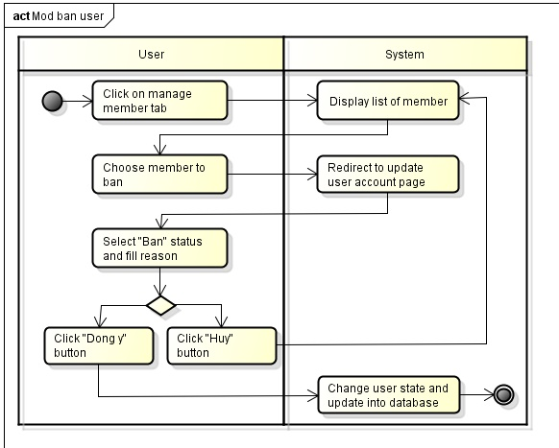

*Figure 4.3.17.5.5.2 Ban user activity diagram*

**Sequence diagram**

**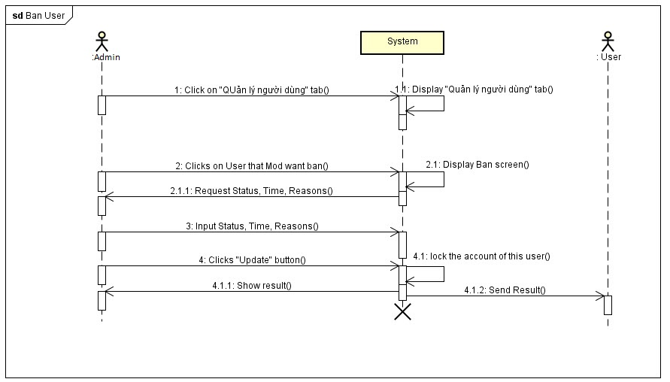**

*Figure 4.3.17.5.5.3 Ban user sequence diagram*

##### **4.3.17.5.6 Unban user**

**Class diagram**

****

*Figure 4.3.17.5.6.1 Unban user class diagram*

**Activity diagram**

**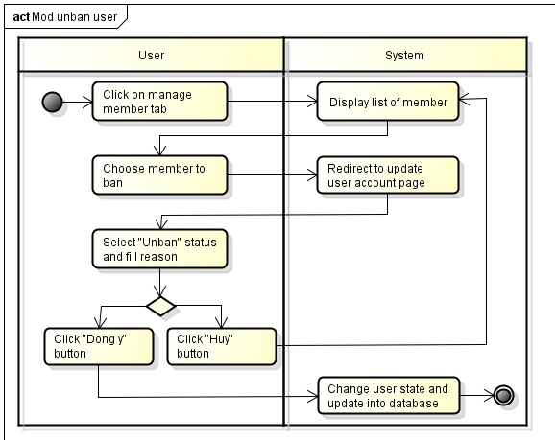**

*Figure 4.3.17.5.6.2 Unban user activity diagram*

**Sequence diagram**

**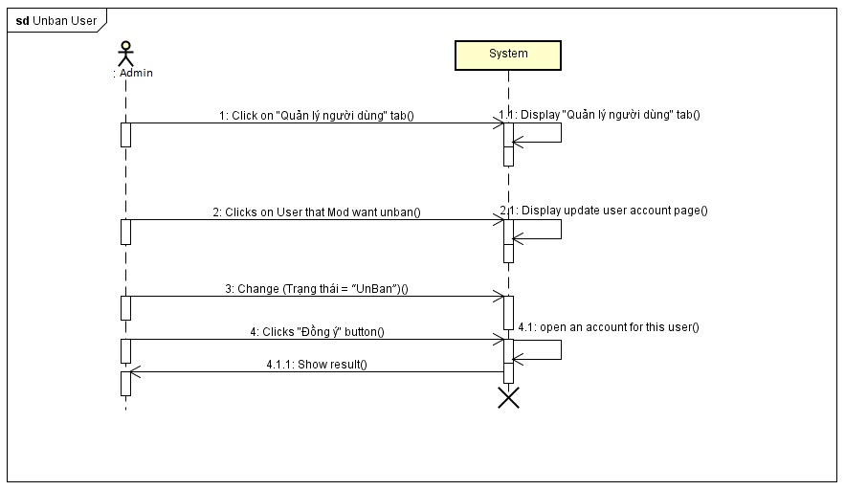**

*Figure 4.3.17.5.6.3 Unban user sequence diagram*

##### **4.3.17.5.7 Manage report**

**Class diagram**

****

*Figure 4.3.17.5.7.1 Manage report class diagram*

**Activity diagram**

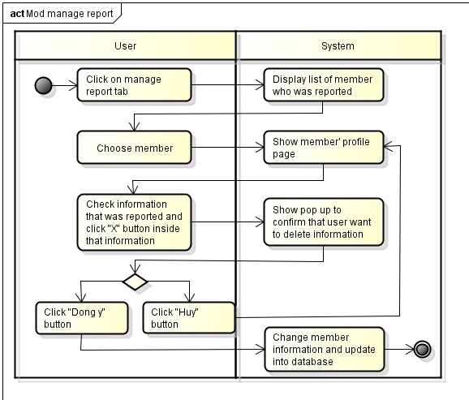

*Figure 4.3.17.5.7.2 Manage report activity diagram*

**Sequence diagram**

**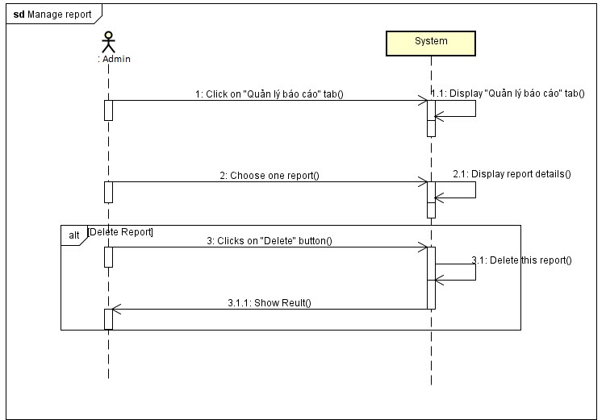**

*Figure 4.3.17.5.7.3 Manage report sequence diagram*

##### **4.3.17.5.8 Restore information**

**Activity diagram**

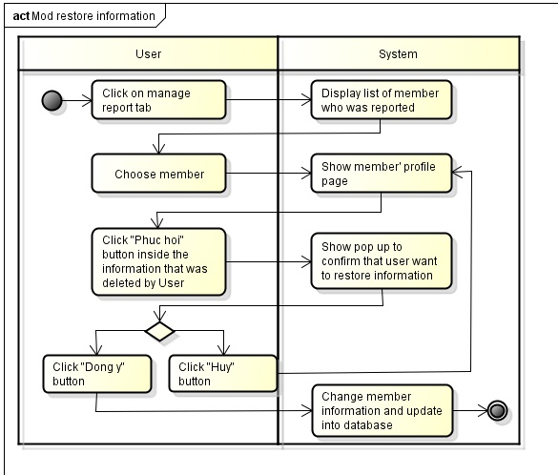

*Figure 4.3.17.5.8.1 Restore information activity diagram.*

**Sequence diagram**

**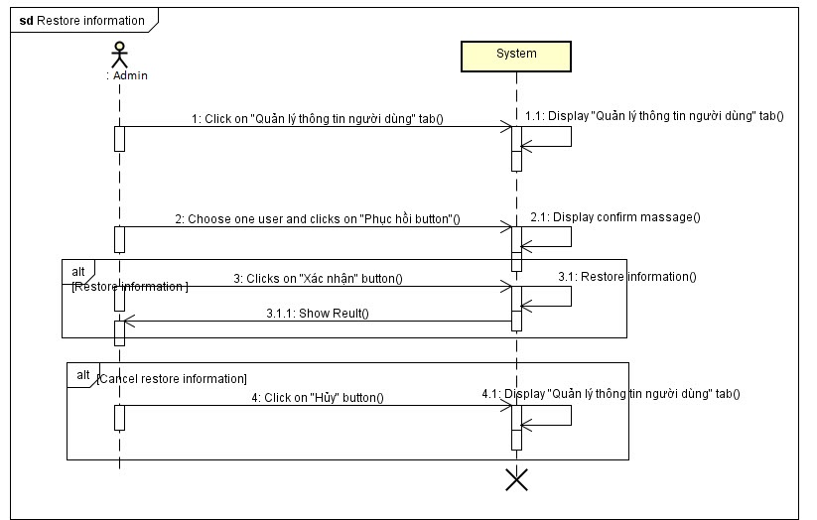**

*Figure 4.3.17.5.8.2 Restore information sequence diagram*

##### **4.3.17.5.9 Approve user question**

**Class diagram**

****

*Figure 4.3.17.5.9.1 Approve user question class diagram*

**Activity diagram**

**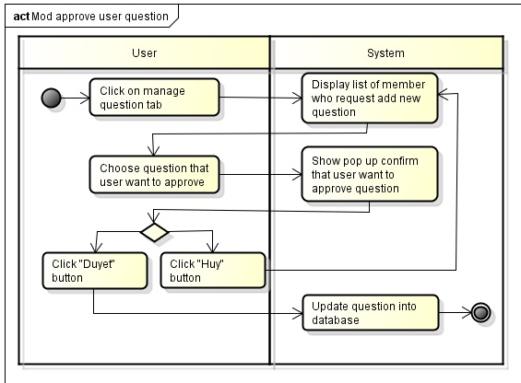**

*Figure 4.3.17.5.9.2 Approve user question activity diagram*

**Sequence diagram**

**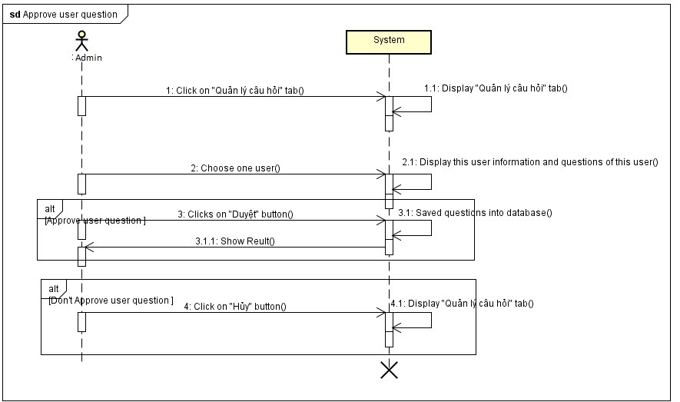**

*Figure 4.3.17.5.9.3 Approve user question sequence diagram*

##### **4.3.17.5.10 Add new question**

**Class diagram**

**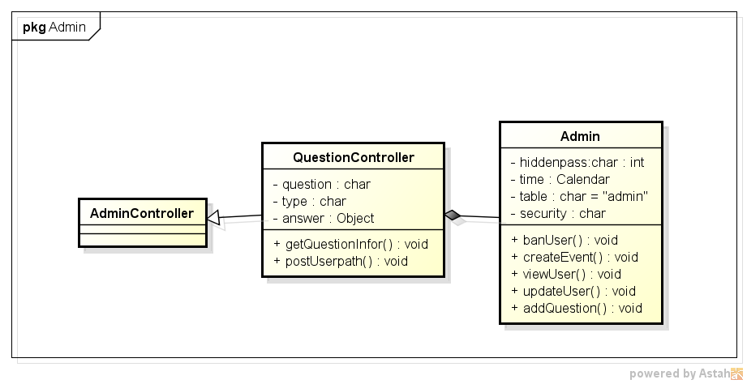**

*Figure 4.3.17.5.10.1 Add new question class diagram*

**Activity diagram**

**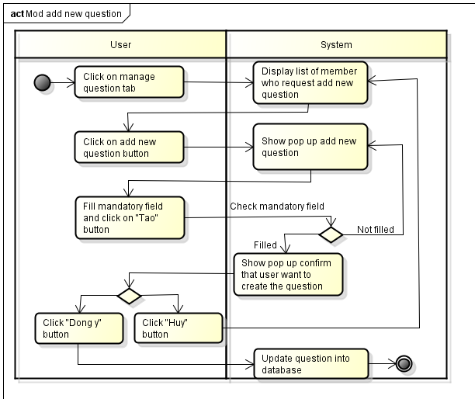**

*Figure 4.3.17.5.10.2 Add new question activity diagram*

**Sequence diagram**

**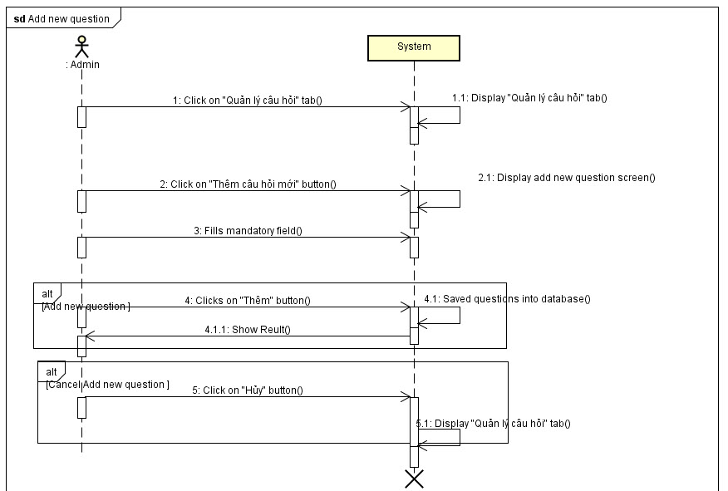**

*Figure 4.3.17.5.10.3 Add new question sequence diagram*

# **5. Software Testing Documentation**

## **5.1. Introduction**

### **5.1.1. Purpose**

The primary purpose of this report is to detect software failures so that defects may be discovered and correct to ensure that our project is thoroughly tested and resulting in a successful implementation of a new social website we are developing. It contains the following sections:

* Scope of Testing
* Testing Tool and Environment
* Resources and responsibilities
* Test strategy: Test approach, test stages
* Test schedule
* Feature to be tested
* Feature not to be tested
* Defect Log
* Test report

### **5.1.2. Scope of testing**

#### Stages of testing:

There are 4 phases in Testing Process: Unit testing, Integration testing, System testing and Acceptance testing.

|  |  |  |  |
| --- | --- | --- | --- |
| **ID** | **Test Stages** | **Description** | **The implementation** |
| **1** | **Unit testing** | Unit testing will be done by the developer and approved by the development team leader. | Developer:  Nguyễn Hoàng Nam (Team Leader) |
| **2** | **Integration testing** | Integration testing will be performed by testers. Requirements of the system will be tested in functional flow. Starting after unit testing complete for each flow.  Focuses on specific areas of uses case when all requirements are completed, integration test should be performed to ensure all components incorporate well. | Tester: Nguyễn Văn Sáng |
| **3** | **System testing** | System Testing will be performed by the tester and development team leader with assistance from the individual developers as required. No specific test tools are available for this project. Programs will enter into System/Integration test after all critical defects have been corrected. |
| **4** | **Acceptance testing** | Acceptance testing consist of Alpha Test and Beta Test will be executed by all team members, stand at end user point of view. Determine whether a system satisfies the requirements specified in the requirements analysis phase. Finding defects is not the main focus in this stage.  Acceptance testing will assess the system’s readiness for deployment and using. | All member and people with internet |

*Tale 5-1: Stages of testing’s*

#### Types of testing:

The test team has to test the following type on Google Chrome.

* GUI test
* Function test
* Performance test
* Regression test
* Acceptance test

#### Range of testing:

Team performs all functions defined in the SRS based on the approved version.

## **5.2. Test Plan**

### **5.2.1. Testing tool and environment**

#### **5.2.1.1. Testing tool**

* **Google Chrome:** Used for test size of web page and size of component on page.



*Figure 5-1: Google Chrome*

* **Mocha test:** Mocha is a feature-rich JavaScript test framework running on[*node.js*](http://nodejs.org/)and the browser, making asynchronous testing simple and fun.



*Figure 5-2: Mocha*

* **Karma Test:** Karma is the environment to run Unit Testing



*Figure 5-3: Karma*

#### **5.2.1.2. Testing Environment**

The contents of the Testing Environment is shown in the table below:

|  |  |
| --- | --- |
| **Software** | **Hardware** |
| Testing environment consist:   * Google Chrome. | Personal computer for developing with the minimum configuration:   * Windows 8.1 Professional 32-bit. * HP ProBook 4430s Inter® Core™ i5. * Install memory (RAM): 2.00GB. |

*Tale 5-2: Testing Environment*

### **5.2.2. Resources and responsibilities**

This table shows the staffing assumptions for our project:

|  |  |  |
| --- | --- | --- |
| **ID** | **Resources** | **Responsibilities** |
| 1 | Project Manager | * Responsible for Project Schedules and overall success of the project. * Review Test-case and report. |
| 2 | Tester | * Preforming the actual system testing. * Manage test resource and assign test tasks. * Create Test Plan. * Create Test Cases. * Create Test Report. * Execute Test. * Test Log report. |
| 3 | Developer | * Create Unit Test. * Fix bugs. |

*Tale 5-3: Resources and Responsibilities*

### **5.2.3. Test strategy**

#### **5.2.3.1. Test Model**

This project follows V-Model process to implement testing. The V model takes the bottom half of the waterfall model and bends it upward into the form of a V, so that the activities on the right verify or validate the work products of the activity on the left. Below figure demonstrates the relationships between each phase of the development life cycle and its associated phase of testing.

More specifically, the left side of the V represents the analysis activities that decompose the users’ needs into small, manageable pieces, while the right side of the V shows the corresponding synthesis activities that aggregate (and test) these pieces into a system that need system that meets the users’ needs.

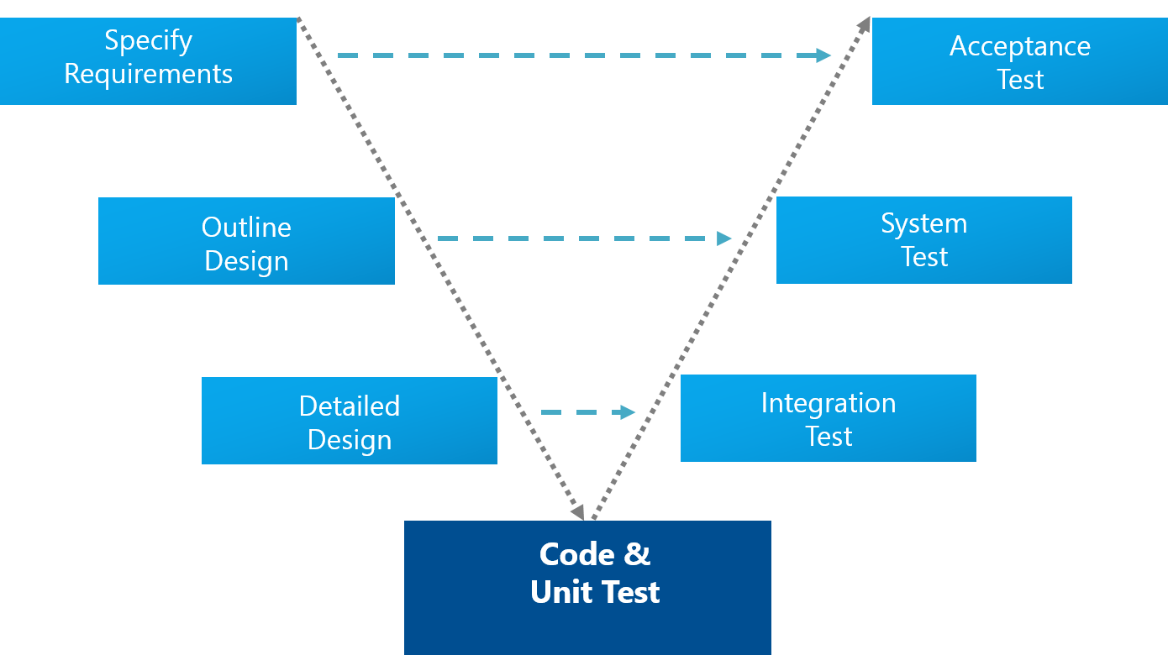The V-Model demonstrates the relationships between each phase of the development life cycle and its associated phase of testing. The horizontal and vertical axes represent time or project completeness (left-to-right) and level of abstraction. Advances in the production of executable requirements, architectures, and designs enable testing to begin much earlier on the left side of the V so that requirements, architecture, and design defects can be found and fixed early before they can propagate into downstream work products.

*Figure 5-4: V-Model*

#### **5.2.3.2. Test Types**

Testing Aloha Project will be carrying out in each release package as defined in project plan and depends on internal delivery by development side. Critical test will be defined as any new or modified test for the Aloha system. Project Manager will decide which closed defects which the test team cannot determine.

The different types of testing that will be carry out this project are.

* **Function Test:**
* Testing of all implemented functions on the Aloha system.
* The testing that will be covered for those functions in function test is verification the validation of the behavior according to requirements.
* Test cases will have to be designed to cover all the above and executed.
* Implemented function’s error message will be included under this test.
* **GUI Test**
* Graphical User Interface (GUI) Testing verifies a user’s interaction with the software. The goal of GUI testing is to ensure that the GUI provides the user with the appropriate access and navigation through the functions of the target-of-test. In addition, GUI testing ensures that the objects within the GUI function as expected and conform to requirement.
* GUI test will be performed fully on all screens.
* This test is targeted to cover the verification of the overall look and feel of the Aloha system including initial position, font, text size, color, focus, initial button, tab order, label, screen sizes and sentences width.
* Check all the GUI elements for size, position, width, length and acceptance of characters or numbers. For instance, it must be able to provide inputs to the input fields.
* Check Error Messages are displayed correctly.
* Check Font used in application is readable.
* Check the alignment of the text is proper.
* Check the Color of the font and warning messages is aesthetically pleasing.
* Check that the images have good clarity.
* Check that the images are properly aligned.
* Check the positioning of GUI elements for different screen resolution.
* **Performance Test:**
* The testing that will be covered for response time for Aloha system.
* **Regression test:**
* The testing is confirmed that the bug was removed including the extent of the impact.
* **Acceptance test:**
* The testing is a test conducted to determine if the requirements of a specification or contract are met.
* It involves alpha testing and beta testing. Alpha testing takes place at developers' sites, and involves testing of the operational system by internal member, before it is released to external users. Beta testing takes place at user’s sites, and involves testing by a group of users who use the system at their own locations and provide feedback, before the system is released to all users.

#### **5.2.3.3. Test Stage**

Table below are the stages in which common test are executed:

|  |  |  |  |
| --- | --- | --- | --- |
| **Type of Tests** | **Stage of Test** | | |
| **Unit** | **Integration** | **System** |
| Function Tests | X | x | x |
| GUI Tests |  | x | x |
| Regression Tests |  | x | x |
| Performance Tests |  |  | x |
| Acceptance Tests |  |  | x |

*Tale 5-4: Test Stage*

#### **5.2.3.4. Test Schedule**

Table below are the Test Schedule for Aloha Project. That consist of 4 phases:

|  |  |  |
| --- | --- | --- |
| **Test Schedule** | **Start Date** | **End Date** |
| Phase 1: Pilot project |  |  |
| Unit Testing | 25/06/2015 | 10/07/2015 |
| Phase 2: Main features  (version 1.0) |  |  |
| User Interface Testing | 10/07/2015 | 25/07/2015 |
| Functional Testing | 10/07/2015 | 25/07/2015 |
| Performance Tests | 10/07/2015 | 25/05/2015 |
| Regression Tests | 10/07/2015 | 25/07/2015 |
| Phase 3: Other features and optimization  (version 2.0) |  |  |
| User Interface Testing | 25/07/2015 | 15/08/2015 |
| Functional Testing | 25/07/2015 | 15/08/2015 |
| Performance Tests | 25/07/2015 | 15/08/2015 |
| Scenario Tests | 25/07/2015 | 15/08/2015 |
| Regression Tests | 25/07/2015 | 15/08/2015 |
| Phase 4: Deployment  (version 10.0) |  |  |
| Acceptance testing  *Tale 5-5: Test Schedule* | 15/08/2015 | 25/08/2015 🡪 then |

#### **5.2.3.5. Deliverables**

Table below are the Deliverables for Aloha Project:

|  |  |  |
| --- | --- | --- |
| **Deliverables** | **Responsibilities** | **Completion date** |
| Test Plan | Tester | 15/06/2015 |
| Test Cases | Tester | 05/07/2015 |
| Test case review | Tester + PM | 10/07/2015 |
| Test Data (Data Set) | Tester | 20/07/2015 |
| Defect report | All members | 01/08/2015 |
| Final test Summary report | PM | 25/08/2015 |

*Tale 5-6: Deliverables*

### **5.2.4. Feature to be tested**

|  |  |  |
| --- | --- | --- |
| **Components** | | **Description** |
| **Group** | Function |
| **Guest** | Register | Register account |
| Login | Login to Aloha |
| Question/ Answer | Send questions or inquiries to Aloha |
| Forgot Password | Recover password |
| **Registered User** | Logout | Logout Aloha |
| Request confirm account | Request confirm account |
| Update personal information | Update personal information |
| Answer suitable questions | Answer suitable questions |
| Search friend | Search friend |
| View user profile | View user profile |
| View other user profile | View other user profile |
| View following list | View following list |
| Add Following | Add Following |
| Remove Following | Remove Following |
| Chat private | Chat private |
| Chat Room | Chat Room |
| View photo | View photo |
| Upload photo | Upload photo |
| Delete photo | Delete photo |
| Upload Avatar | Upload Avatar |
| **Member** | Report User | Report User |
| View block list | View block list |
| Add user to block list | Add user to block list |
| Remove user to block list | Remove user to block list |
| View list follower | View list follower |
| Chat private | Chat private |
| **Advance member** | Request add new question | Request add new question |
| Match suitable people | Match suitable people |
| **Administrator** | Verify User | Verify User |
| Ban user | Ban user |
| Unban user | Unban user |
| Manage report | Manage report |
| Manage Question | Manage Question |
| Manage feedback | Manage feedback |
| Manage profile | Manage profile |

*Tale 5-7: Feature to be tested*

**5.2.5. Feature not to be tested**

* Out of scope features will not to be tested.

## **5.3. Test Approach**

### **5.3.1 Test use case**

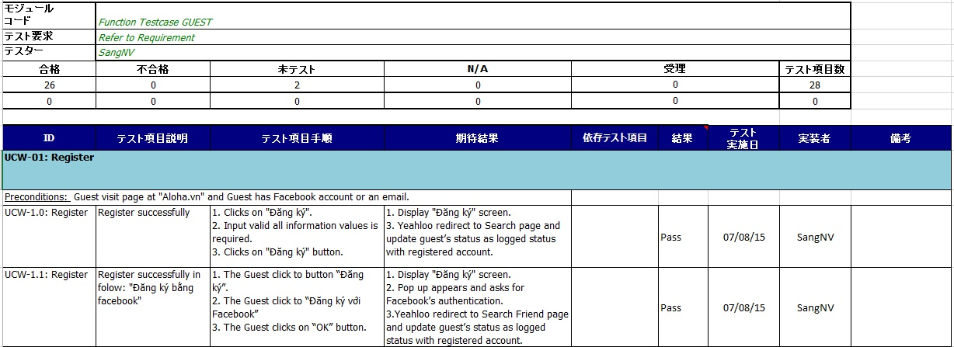

*Figure 5.6 GUEST use case test case*

### **5.3.2 GUI test case**

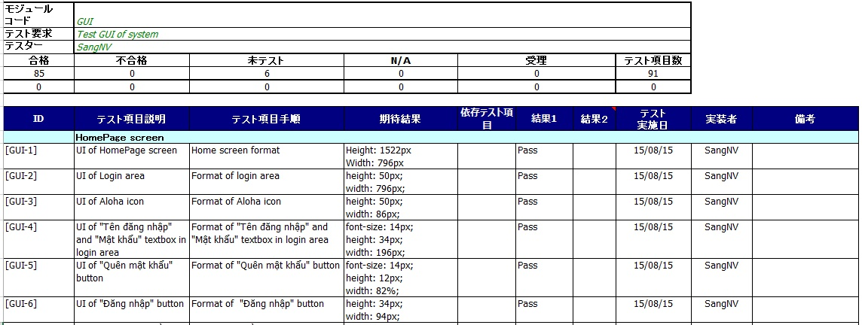

*figure 5.7 gui test case*

### **5.3.3 Performance test case**

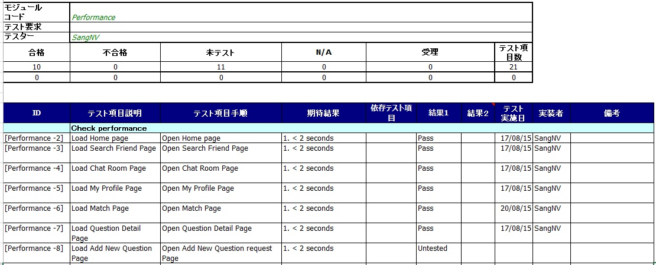

*Figure 5.8 Performance test case*

### **5.3.4 Defect log**

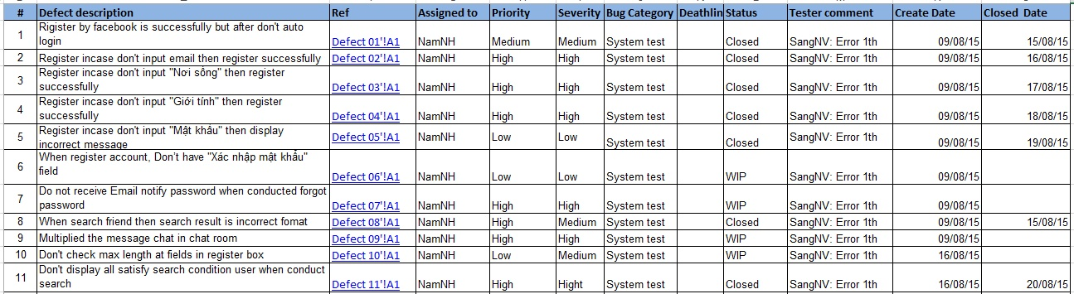

*Figure 5-9: Defect log*

## **5.4. Test Report**

* **Test coverage**: ([number of test cases pass] + [number of test cases Fail] ) / ([number of test cases] - [number of test cases N/A] )
* **Test successful coverage:** [number of test cases pass] / ([number of test cases] - [number of test cases N/A] )
* **Round 1**

|  |  |  |  |  |  |  |  |
| --- | --- | --- | --- | --- | --- | --- | --- |
| No | Module code | Pass | Fail | Untested | | N/A | Number of test cases |
|  | Test case admin | 0 | 0 | | 30 | 0 | 30 |
|  | Test case GUEST | 26 | 0 | | 2 | 0 | 28 |
|  | Test case Registered User | 18 | 4 | | 21 | 10 | 53 |
|  | Test case Member | 20 | 1 | | 26 | 10 | 57 |
|  | Test case Advance Member | 25 | 9 | | 16 | 10 | 60 |
|  | Common | 35 | 8 | | 0 | 15 | 58 |
|  | Performance | 10 | 0 | | 12 | 0 | 22 |
|  | GUI | 60 | 0 | | 31 | 0 | 91 |
|  | **Sub total** | 194 | 22 | | 138 | 45 | **399** |

*Tale 5-8: Report*

* **Round 2**

|  |  |  |  |  |  |  |  |
| --- | --- | --- | --- | --- | --- | --- | --- |
| No | Module code | Pass | Fail | Untested | | N/A | Number of test cases |
|  | Test case admin | 6 | 1 | | 23 | 0 | 30 |
|  | Test case GUEST | 26 | 0 | | 2 | 0 | 28 |
|  | Test case Registered User | 27 | 5 | | 11 | 10 | 53 |
|  | Test case Member | 28 | 5 | | 14 | 10 | 57 |
|  | Test case Advance Member | 28 | 6 | | 16 | 10 | 60 |
|  | Common | 40 | 3 | | 0 | 15 | 58 |
|  | Performance | 10 | 0 | | 12 | 0 | 22 |
|  | GUI | 85 | 0 | | 6 | 0 | 91 |
|  | **Sub total** | 250 | 20 | | 84 | 45 | **399** |

*Tale 5-9: Report*

# **6**. **User Manual**

## **6.1 Installation guide**

### **6.1.1 English version**

#### **6.1.1.1 Prerequisites**

- Node.js - Download & Install Node.js and the npm package manager (<http://www.nodejs.org/download/>), if you encounter any problems, you can also use this GitHub Gist to install Node.js (<https://gist.github.com/isaacs/579814>).

- MongoDB - Download & Install MongoDB (<http://www.mongodb.org/downloads>).

- Bower – Using the Bower Package Manager to manage front-end packages, in order to install it make sure installed Node.js and npm, then install bower globally using npm:



- Grunt – Using the Grunt Task Runner to automate development process, in order to install it make sure you've installed Node.js and npm, then install grunt globally using npm:



#### **6.1.1.2 Installation Procedures**

Step 1: Copy source code from CD to your server.

Step 2: Open Command Prompt on Windows or Terminal on Ubuntu, Linux.

Step 3: To install Node.js dependencies you're going to use npm again, go to the source code folder and run this:



Step 4: Go to Mongodb folder and run:



Step 5: Go to source code folder and run command:



### **6.1.2 Japanese version**

#### **6.1.2.1 環境**

- Window

#### **6.1.2.2 展開**

* 「Github」のインストール：ダウンロード: <https://desktop.github.com>
* 「Node.js」のインストール：ダウンロード: <http://www.nodejs.org/download/>
* 「Mongodb」 のインストール：ダウンロード: <https://www.mongodb.org/downloads>
* 「Bower」 のインストール：$ npm install -g bower
* 「Grunt」のインストール：　$ npm install –g grunt-cli

**インストール手順**

工程１:　「CD」からユーザのサーバにソースコードをコピーします。

工程２:　「Ubuntu」か「Linux」のターミナルかウインドーのコマンドプロンプトを開けます。

工程３:　「Node.js」の依存関係をインストールするために、まだ「npm」を使用する 。ソースコードのフォルダを開けて、これを実行します。

* $ npm install

工程４:　「Mongodb」のフォルダを開けて、これを実行します。

* \Server\3.0\bin\mongod.exe

工程５:　 ソースコードのフォルダを開けて、コマンドを実行します

* $ grunt

## **6.2 User guidelines**

### **6.2.1 Register**

When user accesses to Aloha at the first time, he/she must register.

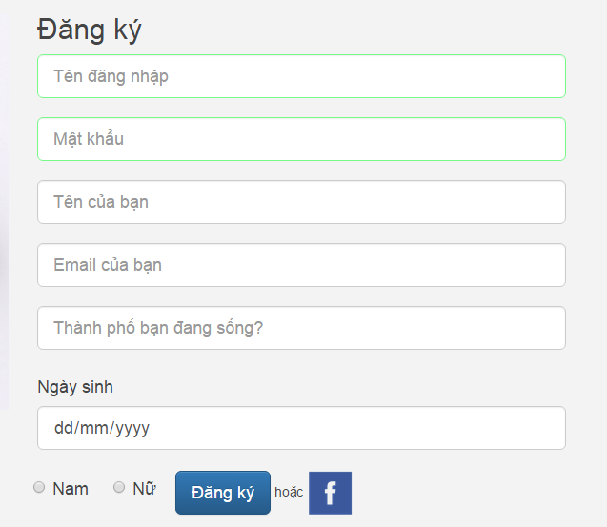

Fill information and click on “Đăng ký” button

After that, user can login into Aloha by this account (Fill information and click on “Đăng nhập” button) or facebook account (The “F” icon)



If user forgot his/her account, he/she can click on “Quên mật khẩu?” button.

Aloha will show form for user to request to recover password.

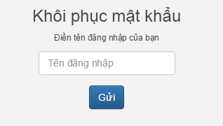

Fill user name and click on “Gửi” button.

### **6.2.2 View Aloha**

1. User logins.

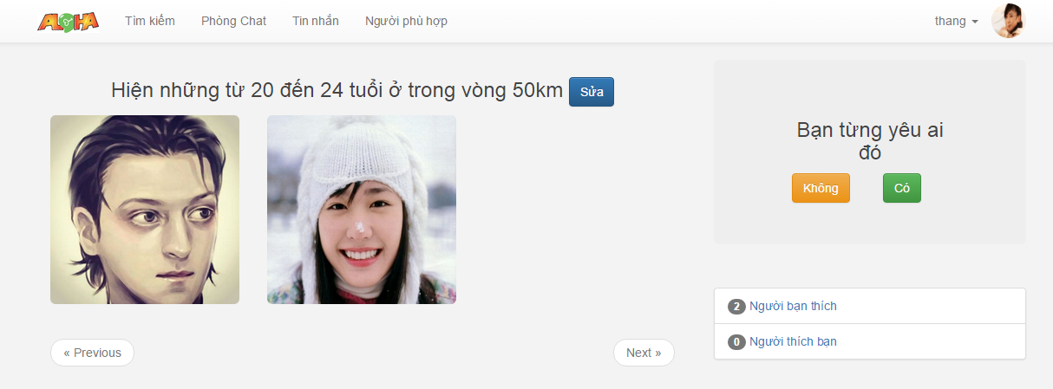

At main screen. User will see

* Search friend: User just fill search condition and click “Đồng ý” button after click on “Sửa” button
* Question: User should answer question to find suitable people.
* People that user like (follow): when user click on “Người bạn thích”, Aloha will show the list.

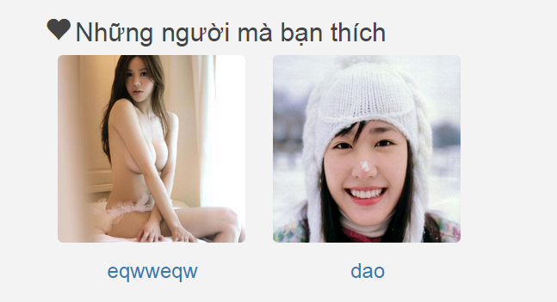

* Likewise is list of “people who like you”.

### **6.2.3 Chat room**

When user click on “Phòng chat” button, Aloha will show chat room and user can choose area to chat

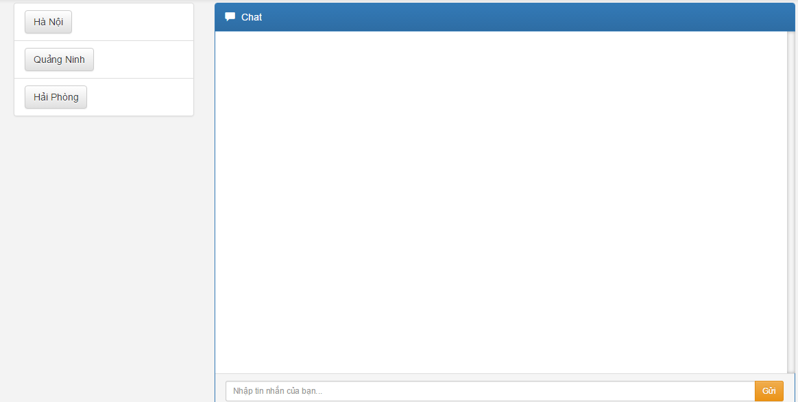

### **6.2.4 Suitable people**

When user click on “Người phù hợp” button, Aloha will show all people whose have more than 70% suitable with user.

### **6.2.5 User page**

1. User logins.
2. User clicks on avatar on top right of screen.
3. Aloha display user page

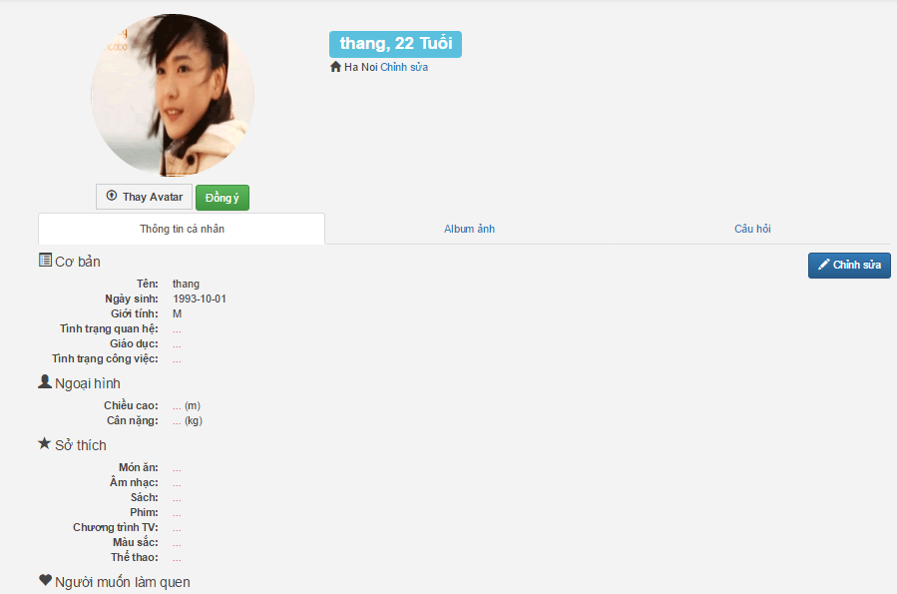

User can view other people profile by click on avatar of that user

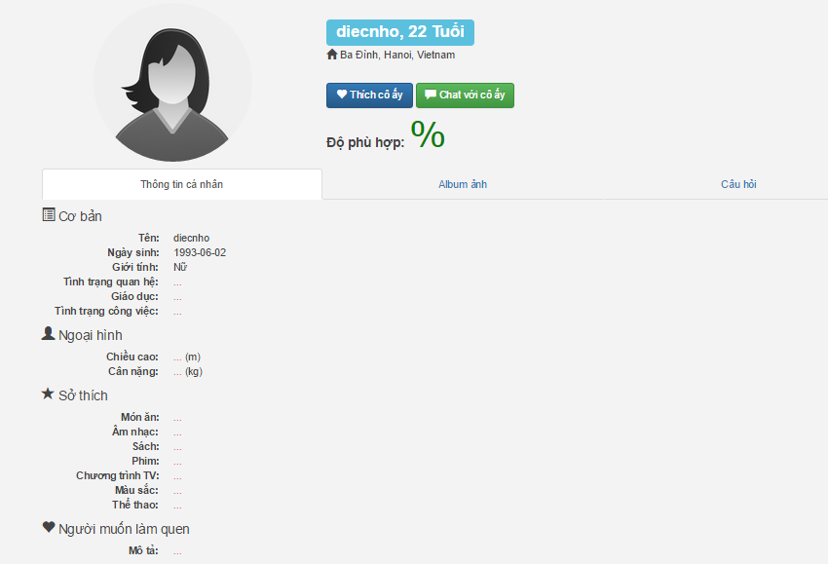

* User can follow other people by click on “Thích cô ấy (if user is women)” or “Thích anh ấy (if user is men)”.
* User can see own album photo or other people by click on “Album ảnh”.



* User can view answer that he/she answered or answer of other user by click on “Câu hỏi” tab

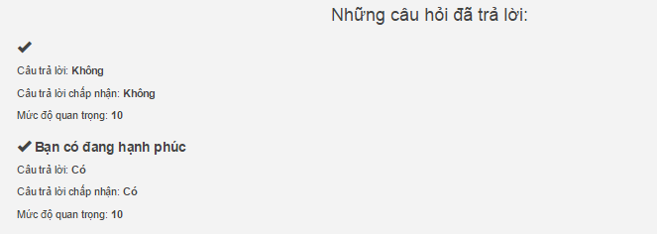

### **6.2.6 Admin login**

1. Admin access to admin’s website.
2. Admin click on to *“Login”* button to log in system.

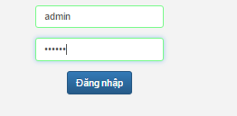

### **6.2.7 Admin add question**

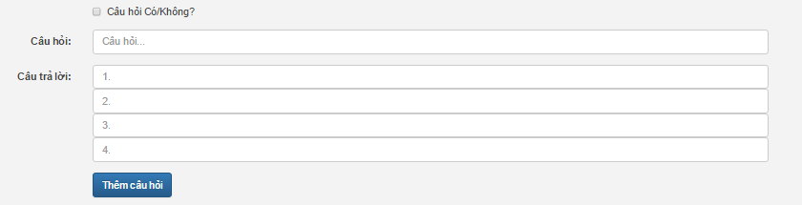

* Fill question and answer and click on “Thêm câu hỏi” button.
* Admin can creates the Yes/ No question by click on “Câu hỏi Có/Không?” button.

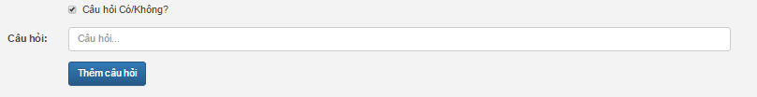

# **7. Appendixes**

## **7.1 Meeting minutes**

|  |  |  |  |
| --- | --- | --- | --- |
| MEETING MINUTES 1 | | | |
| Project Name | ALOHA | **Project Code** | ALOHA |
| Project Manager | NamNH | **Secretary** | NamNH |
| Date | 22/05/2015 | **Time** | 12h50 – 13h30 |
| Venue | 103 Lecture Hall, FPT University, Hoa Lac, HN | | |
| Subject | Kick off capstone project team | | |

**Attendees**

|  |  |  |  |
| --- | --- | --- | --- |
| No | Name | Position | Attendance |
| 1 | NamNH | PM |  |
| 2 | CuongNV | Technical Leader |  |
| 3 | SangNV | Test Leader |  |
| 4 | ThangDD | Business Analyst |  |

**Agenda**

|  |
| --- |
| 1. Team member’s introduction 2. Raise idea and discuss |

**Content**

|  |
| --- |
| 1. Team member’s introduction 2. Raise idea and discuss  * Raise ideas about system connecting people, matching people, chatting server. * Discuss: analyze pros and cons of each idea, how system work, availability on Internet. |

**Conclusion**

|  |  |
| --- | --- |
| Discuss Items | Decisions |
| Choose idea to develop | People Connecting Website |
| Define how to teamwork | Contact: face to face, phone, facebook, skype. |
| Set roles and responsibility | NamNH: Project Manager  CuongNV: Developer  ThangDD: Developer  SangNV: Test Leader |
| Plan to meeting supervisor | Friday every week. Nam will contact with supervisor and inform to the others |
| Plan to research some technologies | Nodejs, Javascript |

|  |  |  |  |
| --- | --- | --- | --- |
| MEETING MINUTES 2 | | | |
| Project Name | ALOHA | **Project Code** | ALOHA |
| Project Manager | NamNH | **Secretary** | NamNH |
| Date | 03/06/20 | **Time** | 13h00 |
| Venue | 103 Lecture Hall, FPT University, Hoa Lac, HN | | |
| Subject | Report completed work and update requirement | | |

**Attendees**

|  |  |  |  |
| --- | --- | --- | --- |
| No | Name | Position | Attendance |
| 1 | NamNH | PM |  |
| 2 | CuongNV | Technical Leader |  |
| 3 | SangNV | Test Leader |  |
| 4 | ThangDD | Business Analyst |  |

**Agenda**

|  |
| --- |
| 1. Report completed work  2. Plan for the next week |

**Content**

|  |
| --- |
| 1. Report completed work: take advice from supervisor about Introduction, Project Plan, Work Breakdown Structure document.  2. Plan for the next week |

|  |  |  |  |
| --- | --- | --- | --- |
| MEETING MINUTES 3 | | | |
| Project Name | ALOHA | **Project Code** | ALOHA |
| Project Manager | NamNH | **Secretary** | NamNH |
| Date | 10/06/20 | **Time** | 13h00 |
| Venue | 103 Lecture Hall, FPT University, Hoa Lac, HN | | |
| Subject | Report completed work and review screen design | | |

**Attendees**

|  |  |  |  |
| --- | --- | --- | --- |
| No | Name | Position | Attendance |
| 1 | NamNH | PM |  |
| 2 | CuongNV | Technical Leader |  |
| 3 | SangNV | Test Leader |  |
| 4 | ThangDD | Business Analyst |  |

**Agenda**

|  |
| --- |
| 1. Report completed work  2. Plan for the next week |

**Content**

|  |
| --- |
| 1. Report completed work: some advice from supervisor:  - Progress report need have additional information like: Amount of work completed, how many day, resources, name of writer.  - Introduction document need have consistent of compare table.  - Remove all “<>” content in document, content of table content must be black.  - Provide more screen to use case description.  2. Plan for the next week: some advice from supervisor:  - Using Mongodb need object oriented diagram, class diagram to present ERD model.  - Concern to Data Integrity of mongodb.  - What to do after matching function complete.  - Have picture privacy of user.  - Read some report about Badoo, Twoo system. |

## **7.2 Progress report**

|  |  |  |  |  |  |
| --- | --- | --- | --- | --- | --- |
| |  |  | | --- | --- | |  | プロジェクト進捗報告書1 | | | | |
| プロジェクト名 | Aloha | プロジェクトコード | ALOHA |
| 作成者 |  | プロジェクトリーダ | Nguyen Hoang Nam |
| 日付 | 28/05/2015 | 受領者 | Tran Binh Duong |
| 報告期間 | <21/05/2015 – 28/05/2015> |  |

進捗詳細

|  |  |  |
| --- | --- | --- |
| 項目 | 情報 | 備考 |
| プロジェクト開始日 | <Defined in Project Plan> |  |
| 終了予定日 | <Defined in Project Plan> |  |
| チームサイズ | <Defined in Project Plan> | Nguyễn Hoàng Nam  Đào Duy Thắng  Nguyễn Văn Sáng  Nguyễn Văn Cường |
| 工数合計（予定） | <Defined in Project Plan> |  |

タスク実行の状況（進捗度、遅延など）

|  |  |  |  |  |  |
| --- | --- | --- | --- | --- | --- |
| タスク | 責任者 | 納品物 | ステータス | 詳細 | スケジュール 変更 |
| Create Introduction report | Team member | RL\_intro.docx | Done |  |  |
| Create Project Plan | Nguyen Hoang Nam | RL\_PP.docx | Done |  |  |

次期の予定タスク

|  |  |  |
| --- | --- | --- |
| タスク | 詳細 | 終了予定日 |
| Create SRS |  | 04/06/2015 |
| Q&A |  | 04/06/2015 |
| Report 1 | Include SRS, project plan, Q&A, and progress report 1 | 04/06/2015 |
| Meeting minutes | Report task to supervisors | 05/06/2015 |

問題、提案

***作成者***

NamNH

|  |  |  |  |  |  |
| --- | --- | --- | --- | --- | --- |
| |  |  | | --- | --- | |  | プロジェクト進捗報告書2 | | | | |
| プロジェクト名 | Aloha | プロジェクトコード | Aloha |
| 作成者 | NamNH | プロジェクトリーダ | Nguyen Hoang Nam |
| 日付 | 05/06/2015 | 受領者 | Tran Binh Duong |
| 報告期間 | 31/05/2015 – 06/06/2015 |  |

進捗詳細

|  |  |  |
| --- | --- | --- |
| 項目 | 情報 | 備考 |
| SRS文書を作成 | - 機能要求仕様  - ソフトウェアシステム属性  - 成功基準 |  |

タスク実行の状況（進捗度、遅延など）

|  |  |  |  |  |  |
| --- | --- | --- | --- | --- | --- |
| タスク | 責任者 | 納品物 | ステータス | 詳細 | スケジュール 変更 |
| Create SRS document | Team Aloha | Aloha\_SRS.docx | Done |  |  |

次期の予定タスク

|  |  |  |
| --- | --- | --- |
| タスク | 詳細 | 終了予定日 |
| Create Architecture design |  | 12/06/2015 |
| Create Database design |  | 12/06/2015 |
| Create Screen design |  | 12/06/2015 |
| Q&A |  | 12/06/2015 |
| Report 2 | Architecture design, Database design, Screen design | 04/06/2015 |
| Meeting minutes | Report task to supervisors | 05/06/2015 |

問題、提案

***作成者***

NamNH

|  |  |  |  |  |  |
| --- | --- | --- | --- | --- | --- |
| |  |  | | --- | --- | |  | プロジェクト進捗報告書3 | | | | |
| プロジェクト名 | Aloha | プロジェクトコード | Aloha |
| 作成者 | NamNH | プロジェクトリーダ | Nguyen Hoang Nam |
| 日付 | 14/06/2015 | 受領者 | Tran Binh Duong |
| 報告期間 | 07/06/2015 – 13/06/2015 |  |

進捗詳細

|  |  |  |
| --- | --- | --- |
| 項目 | 情報 | 備考 |
| すべてのドキュメント | - より多くの機能を更新 |  |
| 画面設計のドキュメント | - 画面のプレビューを作成します  - 画面記述を作成 |  |

タスク実行の状況（進捗度、遅延など）

|  |  |  |  |  |  |
| --- | --- | --- | --- | --- | --- |
| タスク | 責任者 | 納品物 | ステータス | 詳細 | スケジュール 変更 |
| Create Screen Design document | Team Aloha | Aloha\_SD.docx | Done |  |  |

次期の予定タスク

|  |  |  |
| --- | --- | --- |
| タスク | 詳細 | 終了予定日 |
| Create Architecture design |  | 20/06/2015 |
| Create Database design |  | 23/06/2015 |
| Report 2 | Architecture design, Database design, Screen design | 24/06/2015 |
| Meeting minutes | Report task to supervisors | 24/06/2015 |

問題、提案

|  |  |  |
| --- | --- | --- |
| 項目 | 情報 | 備考 |
|  |  |  |

***作成者***

NamNH

## **7.3 Q&A**

1. <http://www.statista.com/statistics/278414/number-of-worldwide-social-network-users/> [↑](#footnote-ref-1)
2. [http://www.slideshare.net/lehoangha304/facebook-market?related=1](http://www.slideshare.net/lehoangha304/facebook-market?related=1http://www.slideshare.net/lehoangha304/facebook-market?related=1) [↑](#footnote-ref-2)
3. comScore, January 2014  [↑](#footnote-ref-3)